


User Interface
For all Add, Amend, Delete and Nav Screens

- Layout: The system uses a structured and consistent card-based layout across all screens to organize content clearly. Each screen is divided into sections such as headers, forms, and tables, allowing users to easily understand the flow of actions. Forms are grouped logically, guiding the user step by step when entering or modifying data. Tables are used where appropriate to display structured information such as stock items or order details. This layout improves usability and ensures a smooth interaction with the system.
- Background: A consistent light background colour is applied across all screens to create a clean and professional appearance. This helps reduce visual strain and improves readability when interacting with the system for extended periods. The background contrasts effectively with the content containers, ensuring that forms and data are clearly visible and easy to focus on
- Logo: The system includes a logo positioned at the top of the interface within the header section. This provides branding and gives the application a more professional and realistic look, similar to commercial systems such as Specsavers. The logo also helps users quickly identify the system and reinforces consistency across all screens.
4. Font and font size: A modern, sans-serif font is used in the entire system to ensure clarity and readability. Font sizes are applied consistently, with larger sizes used for headings and sizes
5. Text Colour: A consistent colour scheme for text is applied across all screens. The default body text uses a dark charcoal (#333) for strong readability against white backgrounds. Secondary and supporting text, such as labels and descriptions, use a muted grey (#666) to visually distinguish them from primary content. The primary brand colour, a deep crimson red (#8B000F), is used for headings, links, form titles, and interactive elements to draw attention and reinforce the brand identity. Navigation text is white (rgba(255,255,255,0.92)) to contrast clearly against the dark red navbar.
6. Headings: Headings are styled using the Poppins font in bold weights to create a clear visual hierarchy. The main hero heading uses 38px at weight 700, while card and section headings use 22–26px at weight 700. Each card heading includes a decorative underline — a short 50px wide, 3px tall red gradient bar centred beneath the text — which reinforces the brand identity and visually separates the heading from the form content below. Headings on cards and forms are coloured in the brand crimson red (#8B000F), making them immediately recognisable as section titles.

7. Forms and Input Fields: Forms are presented inside centred white card containers with 16px rounded corners, a subtle box shadow, and a maximum width of 580px to keep content focused. Input fields, select dropdowns, and text areas share a uniform style with a light grey background (#fafafa), a 1.5px light grey border, and 8px rounded corners. On focus, the border changes to brand red and a soft red glow appears around the field, clearly signalling the active input to the user. Labels are displayed in small, uppercase, bold text directly above each field to guide data entry. Required fields with invalid input display a red border, while valid entries display a green border, providing instant visual feedback.

8. Buttons: Action buttons are positioned at the bottom of each form, following the natural top-to-bottom flow of data entry. Submit and save buttons use a bold crimson red gradient with white text, a drop shadow, and a subtle upward lift on hover to signal interactivity. Reset and cancel buttons use a neutral light grey background with a faint border, clearly distinguishing secondary actions from primary ones. On smaller screens, buttons stack vertically to remain accessible and easy to tap.
9. Dropdown Lists: Select elements in forms share the same consistent styling as text inputs — light grey background, red focus border, and Poppins font — so they integrate seamlessly into the form layout. Navigation dropdowns in the navbar appear on hover with a smooth fade-and-slide animation. Each dropdown panel is white with a 3px red top border and rounded bottom corners. Individual items highlight with a pink background tint, a red left border, and slight text indentation on hover, making the available options clear and easy to navigate.
10. Tables: Data tables are presented within card containers using a clean, border-collapse style with 1px grey cell borders and 10px padding per cell. Column headers are bold to distinguish them from data rows. On smaller screens, tables become horizontally scrollable within their container to prevent data from being cut off or the layout from breaking.
11. Navigation Bar: The navigation bar sits directly below the header and spans the full-page width. It uses a deep red gradient background with white uppercase text at 13px and bold weight, creating strong contrast and a professional appearance. Items are spaced evenly with generous padding and include a white bottom-border underline on hover or when active. Items with sub-menus display a small chevron indicator that rotates on hover to signal the presence of a dropdown.
12. Footer: The footer mirrors the header by using the same soft teal gradient background, visually framing each page consistently. Text is centred, displayed in a muted teal grey at 13px, and typically contains copyright or system identification information. This consistent footer reinforces the overall design language of the Spec Savvy system.

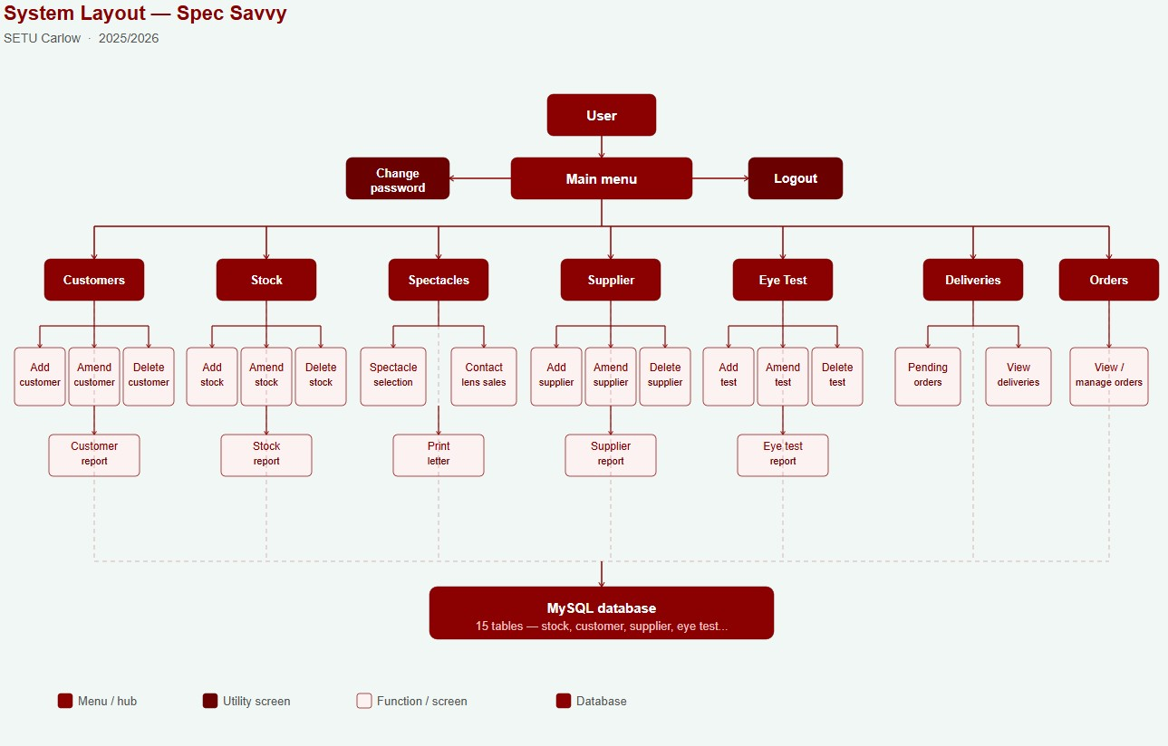

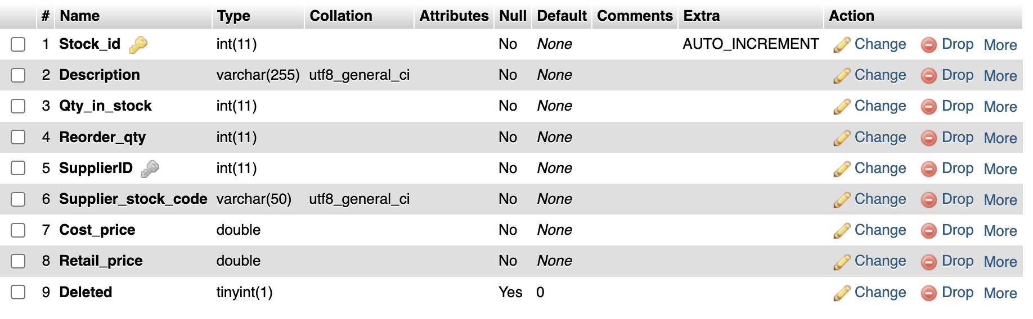
Stock Table Structure

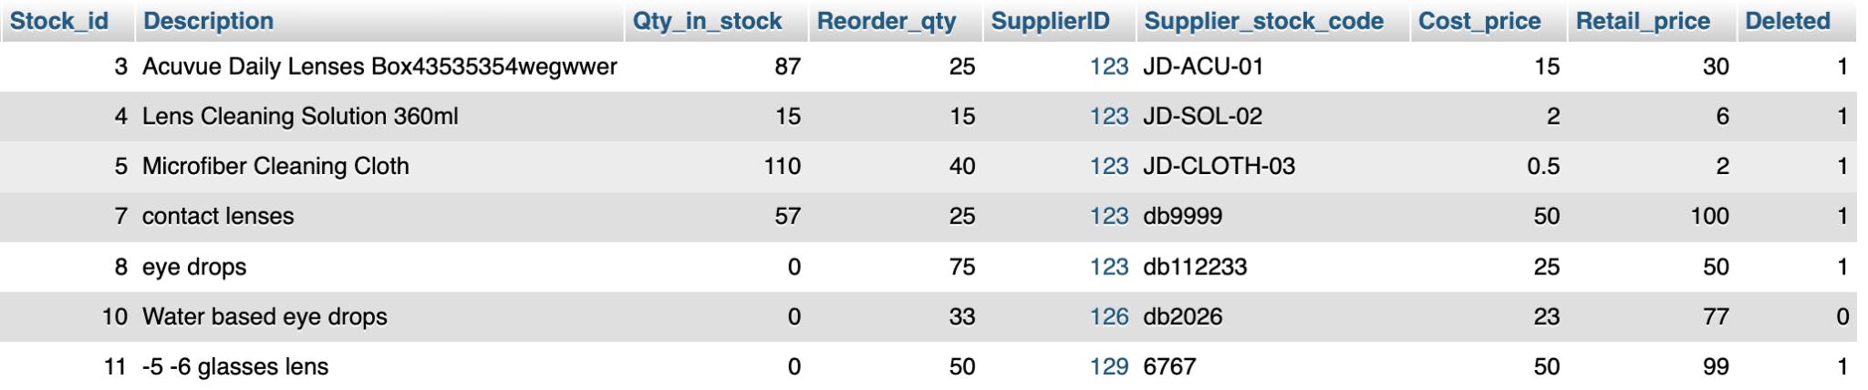
Stock Table with sample data
Customer Table
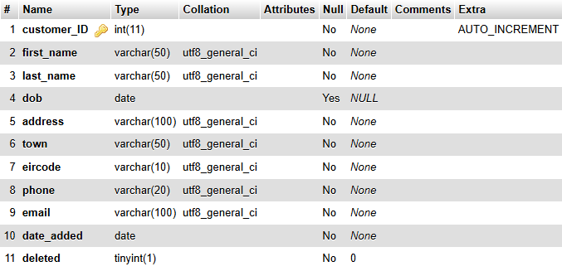
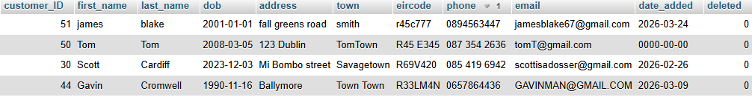
Customer Table with sample data

Spectacles Table
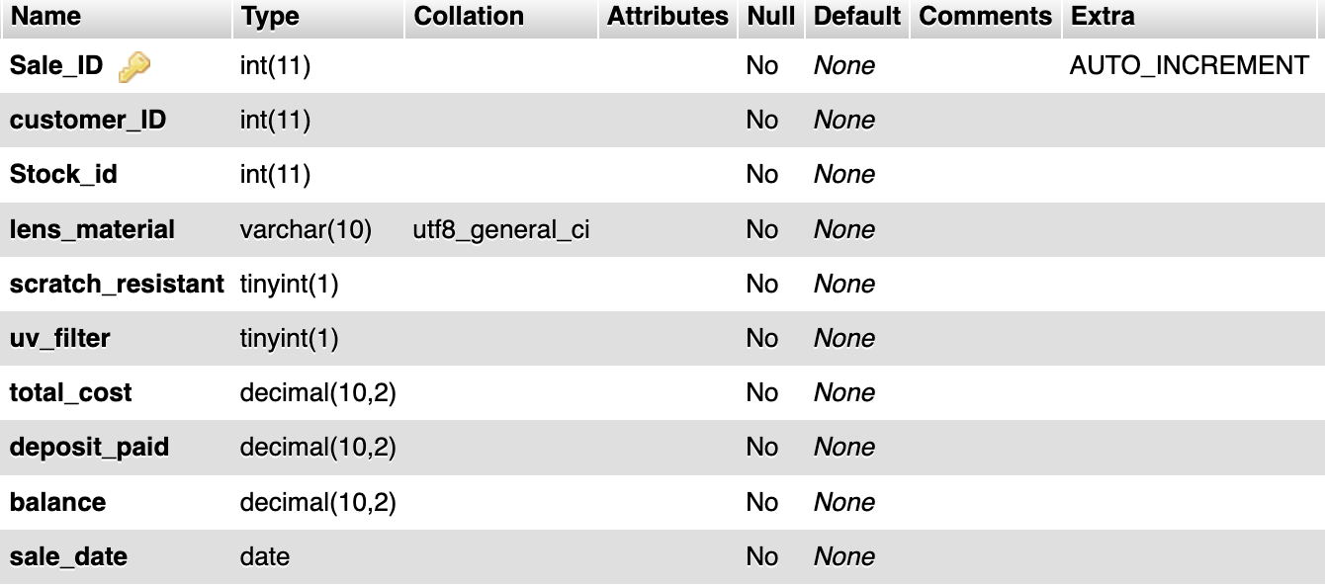
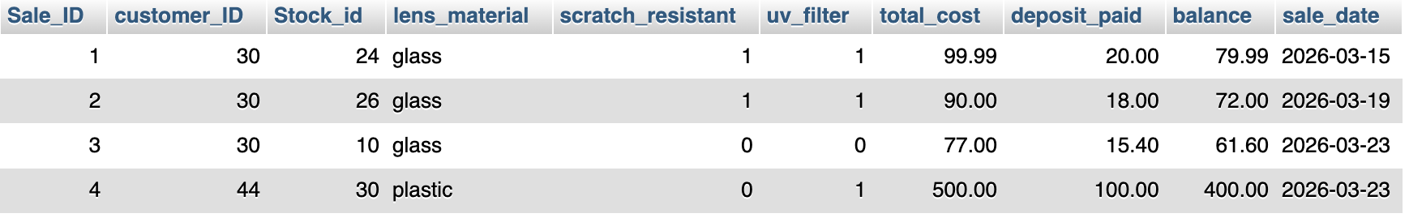
Spectacles table with sample data
Supplier Table
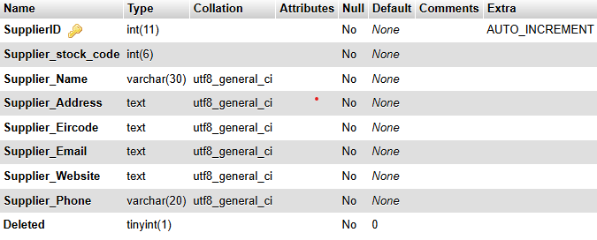
Supplier table with sample data
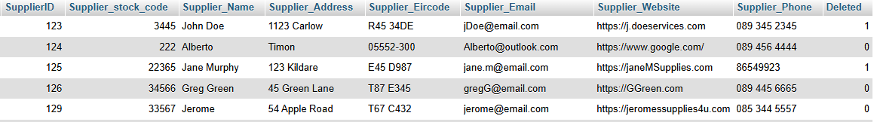
Eye Test Table
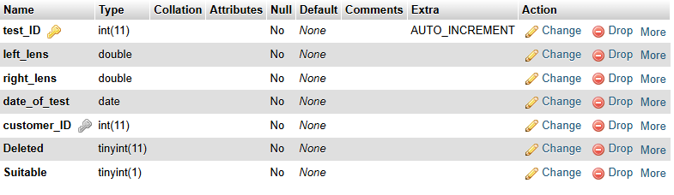
Eye test table with sample data

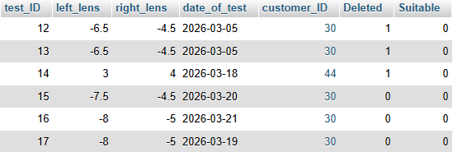

Orders Table

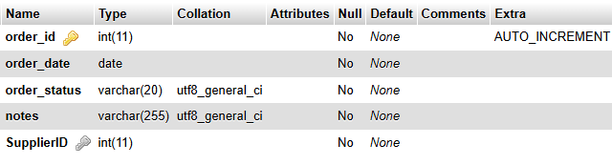
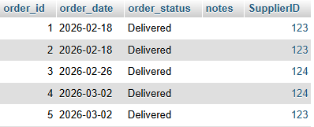
Orders table with sample data
Order item table
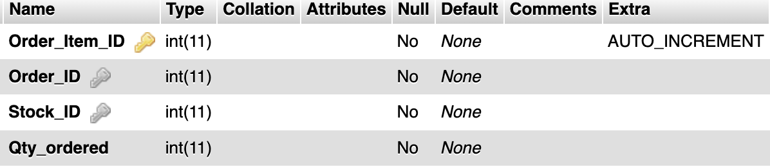
Order Item table with sample data
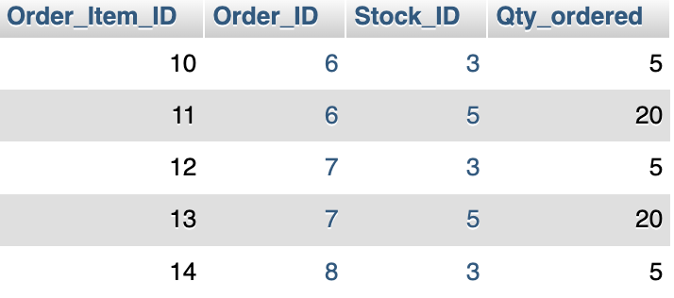
Sales Table
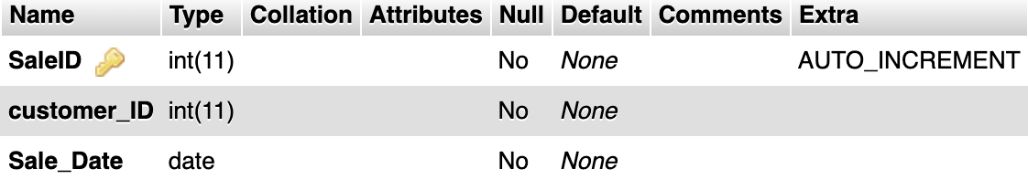
Sales table with sample data
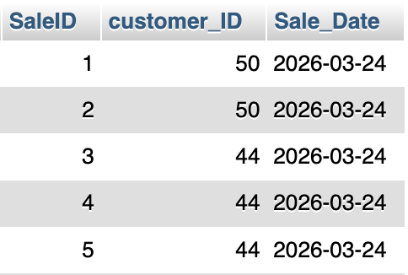
SalesItem table
SalesItem table with sample data
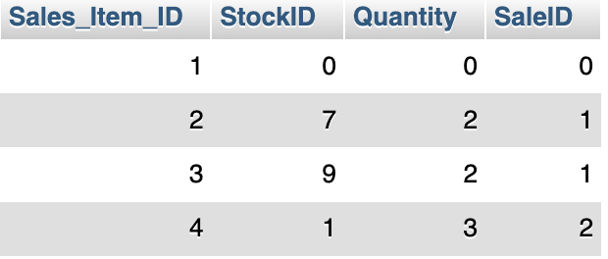
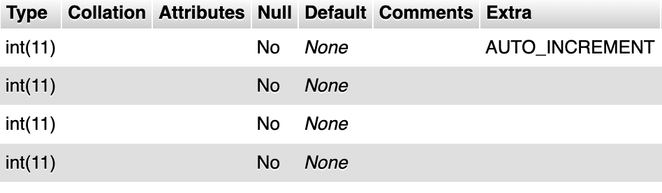
Contact lens table
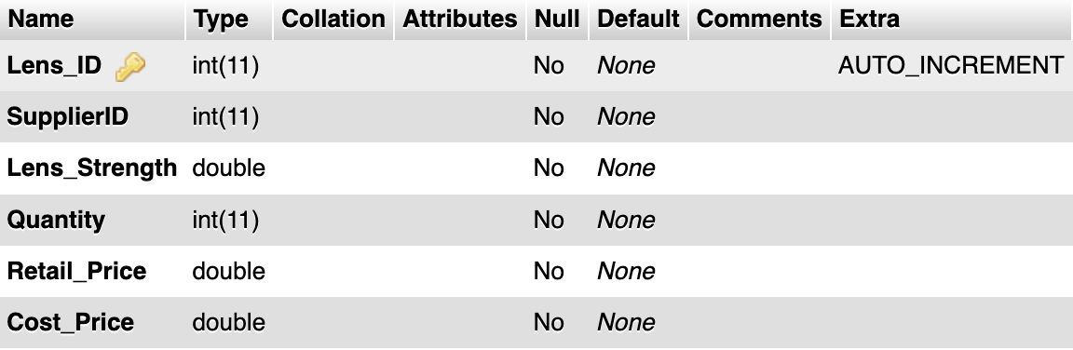
Contact lens table with sample data
Group css

/* ================= GOOGLE FONT IMPORT ================= */
/* Importing the 'Poppins' font from Google Fonts with multiple weights */
@import url('https://fonts.googleapis.com/css2?family=Poppins:wght@300;400;500;600;700&display=swap');
/* ================= GENERAL RESET ================= */
/* Resetting margin, padding, box-sizing, and setting default font */
*{
margin:0;
padding:0;
box-sizing:border-box; /* Ensures padding/border doesn't affect element size */
font-family:'Poppins', Arial, sans-serif; /* Default font with fallbacks */
}
/* ================= CSS VARIABLES ================= */
/* Root variables for colors and theme management */
:root{
--bg:#f4f6f4; /* Page background */
--card:#ffffff; /* Card/form background */
--brand:#8B000F; /* Primary brand color (dark red) */
--brand-dark:#6e000c; /* Darker variant for hover/gradient effects */
--muted:#666; /* Secondary text */
--text:#333; /* Default text color */
--border:#e0e0e0; /* Border color for inputs and cards */
--header-a:#c8deda; /* Header gradient start */
--header-b:#a8c8c3; /* Header gradient end */
}
/* ================= BODY & HTML ================= */
html, body { height:100%; } /* Ensure body occupies full height */
body{
background-color: var(--bg);
color: var(--text); /* Default font color */
}
/* ================= LAYOUT WRAPPER ================= */
.app{
display:flex; /* Flex layout for vertical stacking */
min-height:100vh; /* Fill viewport height */
flex-direction:column; /* Stack header, main, footer vertically */
}
.main{
flex:1; /* Take remaining space */
display:flex;
flex-direction:column; /* Stack main content vertically */
}
/* ================= HEADER ================= */
/* Styles for new header structure and fallback old sidebar */
.main-header,
.sidebar{
background: linear-gradient(135deg, var(--header-a) 0%, var(--header-b) 100%);
padding: 30px 25px;
text-align:center;
box-shadow: 0 2px 10px rgba(0,0,0,0.08);
position:relative;
border-bottom: none; /* Override old bottom border if any */
height:auto; /* Flexible height for responsiveness */
display:block; /* Ensure block display (overrides old flex bar) */
}
/* Logo image styling */
.logo-area img,
.sidebar .logo{
max-width: 320px;
max-height: 170px;
filter: drop-shadow(0 2px 6px rgba(0,0,0,0.12)); /* subtle shadow */
transition: transform 0.3s ease; /* smooth hover scaling */
}
/* Slight scaling effect on hover */
.logo-area img:hover,
.sidebar .logo:hover{
transform: scale(1.02);
}
/* Hide old text-based brand if logo is used */
.sidebar .brand{ display:none; }
/* ================= NAVIGATION ================= */
/* Main nav bar gradient, shadow, and layout */
.navbar{
background: linear-gradient(90deg, #7a000d 0%, var(--brand) 50%, #7a000d 100%);
width:100%;
display:flex;
justify-content:center; /* Center the menu items horizontally */
padding:0;
box-shadow: 0 3px 12px rgba(139,0,15,0.35);
}
/* Old menu fallback */
.menu{
background: linear-gradient(90deg, #7a000d 0%, var(--brand) 50%, #7a000d 100%);
width:100%;
display:flex;
justify-content:center;
gap:0;
padding:0;
box-shadow: 0 3px 12px rgba(139,0,15,0.35);
}
/* Remove bullets from lists */
.navbar ul,
.menu{
list-style:none;
margin:0;
}
/* Flex layout for top nav items */
.navbar ul{
display:flex;
padding:0;
}
.navbar > ul > li{ position:relative; } /* needed for dropdown positioning */
/* ================= TOP LINKS ================= */
.navbar > ul > li > a,
.menu-item{
display:flex;
align-items:center;
gap:6px; /* Small space between icon/text */
text-decoration:none;
color: rgba(255,255,255,0.92);
font-weight:600;
font-size:13px;
text-transform:uppercase;
letter-spacing:1px;
padding:18px 26px 15px;
border-bottom:3px solid transparent; /* underline effect on hover/active */
border-radius:0;
cursor:pointer;
transition: all 0.25s ease;
}
/* Hover / active state for links */
.navbar > ul > li > a:hover,
.navbar > ul > li > a.active,
.menu-item:hover,
.menu-item.active{
border-bottom:3px solid #ffffff;
color:#ffffff;
background-color: rgba(255,255,255,0.10); /* subtle highlight */
}
/* Dropdown chevron indicators */
.navbar > ul > li.dropdown > a::after{
content:'▾';
font-size:11px;
opacity:0.75;
transition: transform 0.2s ease;
}
.navbar > ul > li.dropdown:hover > a::after{
transform: rotate(180deg);
}
/* Old dropdown toggle */
.menu-dropdown .dd-toggle::after{
content:'▾';
margin-left:6px;
font-size:11px;
opacity:0.75;
transition: transform 0.2s ease;
}
.menu-dropdown:hover .dd-toggle::after{ transform: rotate(180deg); }
/* ================= DROPDOWNS ================= */
/* New dropdown panel hidden by default */
.navbar .dropdown-menu{
display:none !important;
position:absolute;
top:100%;
left:0;
background:#ffffff;
min-width:200px;
border-top:3px solid var(--brand);
border-radius:0 0 10px 10px;
box-shadow: 0 8px 24px rgba(0,0,0,0.12);
z-index:999;
padding:8px 0;
list-style:none;
}
/* Show dropdown on hover with animation */
.navbar .dropdown:hover > .dropdown-menu{
display:block !important;
animation: fadeSlideDown 0.18s ease;
}
/* Slide down fade animation */
@keyframes fadeSlideDown{
from{ opacity:0; transform: translateY(-6px); }
to { opacity:1; transform: translateY(0); }
}
/* Dropdown links style */
.dropdown-menu li a{
display:block;
color:#444;
font-size:13.5px;
font-weight:500;
text-decoration:none;
padding:11px 20px;
border-left:3px solid transparent;
transition: all 0.15s ease;
}
.dropdown-menu li a:hover{
background-color:#fdf0f1;
border-left:3px solid var(--brand);
color: var(--brand);
padding-left:24px; /* extra padding for hover effect */
}
/* Old dropdown panel styling to match new one */
.menu-dropdown{ position:relative; }
.dd-menu{
display:none !important;
position:absolute;
top:100%;
left:0;
min-width:200px;
background:#ffffff;
border-top:3px solid var(--brand);
border-radius:0 0 10px 10px;
box-shadow: 0 8px 24px rgba(0,0,0,0.12);
z-index:999;
padding:8px 0;
}
.menu-dropdown:hover > .dd-menu,
.menu-dropdown.open > .dd-menu{
display:block !important;
animation: fadeSlideDown 0.18s ease;
}
.dd-item{
display:block;
width:100%;
text-align:left;
padding:11px 20px;
color:#444;
font-size:13.5px;
font-weight:500;
text-decoration:none;
border-left:3px solid transparent;
transition: all 0.15s ease;
}
.dd-item:hover{
background-color:#fdf0f1;
border-left:3px solid var(--brand);
color: var(--brand);
padding-left:24px;
}
/* ================= HERO SECTION ================= */
.hero,
.main-header + .hero{
text-align:center;
padding:65px 20px;
background: linear-gradient(160deg, #eef4ec 0%, #f5f9f4 100%);
border-bottom:1px solid #e0e8df;
}
.hero h1{
font-size:38px;
font-weight:700;
color: var(--brand);
margin-bottom:12px;
letter-spacing:-0.5px;
}
.hero p{
font-size:17px;
color: var(--muted);
margin-bottom:35px;
font-weight:300;
}
/* Call-to-action buttons */
.cta-buttons a{
display:inline-block;
background-color: var(--brand);
color:white;
padding:14px 32px;
font-size:15px;
font-weight:600;
text-decoration:none;
border-radius:50px;
margin:8px;
box-shadow: 0 4px 14px rgba(139,0,15,0.30);
transition: all 0.25s ease;
letter-spacing:0.3px;
}
.cta-buttons a:hover{
background-color: var(--brand-dark);
transform: translateY(-2px);
box-shadow: 0 6px 20px rgba(139,0,15,0.40);
}
/* ================= CONTENT AREA ================= */
.page-container,
.content{
padding:50px 20px;
display:flex;
justify-content:center;
}
.content > h2,
.content > p,
.content .muted{
max-width:580px;
width:100%;
}
/* ================= CARDS / FORMS ================= */
.card,
.card-form{
background: white;
padding: 40px 45px;
width:100%;
max-width:580px;
border-radius:16px;
box-shadow: 0 10px 40px rgba(0,0,0,0.07);
border:1px solid rgba(0,0,0,0.05);
margin: 0 auto;
}
.card h2,
.card-form h2{
margin-bottom:8px;
color: var(--brand);
text-align:center;
font-size:22px;
font-weight:700;
}
.card h2::after,
.card-form h2::after{
content:'';
display:block;
width:50px;
height:3px;
background: linear-gradient(90deg, var(--brand), #c0392b);
border-radius:2px;
margin:10px auto 24px;
}
/* ================= FORM ELEMENTS ================= */
form{ display:flex; flex-direction:column; }
label{
margin-top:18px;
font-weight:600;
font-size:13px;
color:#555;
text-transform:uppercase;
letter-spacing:0.4px;
}
input, select, textarea{
margin-top:7px;
padding:11px 14px;
border-radius:8px;
border:1.5px solid var(--border);
font-size:14px;
color:#333;
background-color:#fafafa;
transition: all 0.25s ease;
width:100%;
}
input:focus, select:focus, textarea:focus{
border-color: var(--brand);
outline:none;
background-color:#fff;
box-shadow: 0 0 0 3px rgba(139,0,15,0.08);
}
/* ================= BUTTONS ================= */
.button-group,
.form-actions,
.form-action{
margin-top:30px;
display:flex;
gap:12px;
}
input[type="submit"],
input[type="reset"],
.form-actions button{
flex:1;
padding:12px;
border-radius:8px;
font-size:14px;
font-weight:600;
cursor:pointer;
border:none;
transition: all 0.25s ease;
letter-spacing:0.3px;
margin:0;
}
/* Submit / Save styling */
input[type="submit"],
.btn-save{
background: linear-gradient(135deg, var(--brand), #a80012);
color:white;
box-shadow: 0 4px 12px rgba(139,0,15,0.25);
}
input[type="submit"]:hover,
.form-actions button.btn-save:hover{
background: linear-gradient(135deg, var(--brand-dark), var(--brand));
transform: translateY(-1px);
box-shadow: 0 6px 16px rgba(139,0,15,0.35);
}
/* Reset / Cancel styling */
input[type="reset"],
.btn-cancel{
background-color:#f0f0f0;
color:#555;
border:1.5px solid #ddd;
}
input[type="reset"]:hover,
.form-actions button.btn-cancel:hover{
background-color:#e5e5e5;
color:#333;
}
/* Required fields styling */
.req{ color:#c08; font-weight:bold; margin-left:4px; }
input:required:invalid{ border:1.5px solid #c00; }
input:required:valid{ border:1.5px solid #4CAF50; }
/* ================= TABLES ================= */
.table-wrap{
width:100%;
overflow-x:auto;
-webkit-overflow-scrolling:touch;
margin: 0 -45px; /* counteract card padding */
padding: 0 45px; /* restore padding inside scroll area */
max-width: calc(100% + 90px); /* allow it to use full card width */
}
.simple-table{
width:100%;
min-width:760px; /* prevents table from shrinking too small */
border-collapse:collapse;
margin-top:10px;
background:#fff;
}
.simple-table th,
.simple-table td{
border:1px solid #ddd;
padding:10px;
white-space:normal;
word-break:break-word;
}
/* ================= FEATURES ================= */
.features{
padding:60px 20px;
background: linear-gradient(160deg, #f9faf8 0%, #f2f6f0 100%);
text-align:center;
border-top:1px solid #e5ece4;
}
.features h2{
font-size:26px;
font-weight:700;
margin-bottom:10px;
color:#2c2c2c;
}
.features h2::after{
content:'';
display:block;
width:40px;
height:3px;
background: var(--brand);
border-radius:2px;
margin:10px auto 35px;
}
.card{
overflow: hidden;
}
.feature-cards{
display:flex;
justify-content:center;
gap:24px;
flex-wrap:wrap;
}
.feature-card{
background:#fff;
padding:28px 22px;
width:240px;
border-radius:12px;
box-shadow: 0 4px 16px rgba(0,0,0,0.07);
border:1px solid rgba(0,0,0,0.05);
transition: transform 0.25s ease, box-shadow 0.25s ease;
}
.feature-card:hover{
transform: translateY(-4px);
box-shadow: 0 8px 28px rgba(0,0,0,0.11);
}
.feature-card p{
font-size:15px;
color:#555;
margin-bottom:16px;
line-height:1.5;
}
.feature-card a{
text-decoration:none;
color: var(--brand);
font-weight:600;
font-size:13.5px;
border-bottom:1.5px solid rgba(139,0,15,0.25);
padding-bottom:2px;
transition: border-color 0.2s ease;
}
.feature-card a:hover{
border-color: var(--brand);
}
/* ================= FOOTER ================= */
footer,
.main-footer{
background: linear-gradient(135deg, var(--header-a) 0%, #b7d3cf 100%);
text-align:center;
padding:24px 20px;
border-top:none;
color:#4a5e5c;
font-size:13px;
font-weight:500;
letter-spacing:0.2px;
}
/* ================= MOBILE RESPONSIVE ================= */
@media (max-width: 700px){
.navbar > ul{
flex-wrap:wrap;
justify-content:center;
}
.navbar > ul > li > a,
.menu-item{
padding:16px 16px 13px;
}
.card, .card-form{
padding:28px 20px;
}
.table-wrap{
margin: 0 -20px;
padding: 0 20px;
max-width: calc(100% + 40px);
}
.button-group, .form-actions, .form-action{
flex-direction:column;
}
}

Group Logo


I (Konrad Skoczylas ) created this logo in Canva to give the brand/project a fresh and approachable look. I kept the colors and fonts simple so it’s easy to recognize and works well anywhere. The shapes and layout were chosen to feel professional but still welcoming. This logo is implemented into all of our screens and it feels like it flows and looks professional enough with how we designed the website.
Shared database connection
db.inc.php
<?php
$hostname='localhost:3306';
$username='opticians';
$password='18Z%i1OVlqfehh#v';
$dbname='opticalcare_';
$con=mysqli_connect($hostname, $username, $password, $dbname);
if (!$con) {
die("Connection failed: " . mysqli_connect_error());
}
Navigation/Connection between each of our screen
We store it inside of a includes folder which has a nav.php file inside which we use alongside this piece if code
<?php require_once 'Includes/nav.php'; // Include navigation bar ?> to connect to that includes and nav file which all of our paths are listed

<nav class="navbar" aria-label="Main menu">
<ul>
<li class="dropdown">
<a href="#">Customers</a>
<ul class="dropdown-menu">
<li><a href="/Opticians/Opticians/Customer-Orders(Lucas)/customer_add.php">Add Customer</a></li>
<li><a href="/Opticians/Opticians/Customer-Orders(Lucas)/customer_amend.php">Amend / View Customer</a></li>
<li><a href="/Opticians/Opticians/Customer-Orders(Lucas)/customer_delete.php">Delete Customer</a></li>
</ul>
</li>
<li class="dropdown">
<a href="#">Stock</a>
<ul class="dropdown-menu">
<li><a href="/Opticians/Opticians/stock website(konrad)/addStockitem.php">Add Stock</a></li>
<li><a href="/Opticians/Opticians/stock website(konrad)/amendStockItem.php">Amend Stock</a></li>
<li><a href="/Opticians/Opticians/stock website(konrad)/deleteStockItem.php">Delete Stock</a></li>
</ul>
</li>
<li>
<li class="dropdown">
<a href="#">Spectacles</a>
<ul class="dropdown-menu">
<li><a href="/Opticians/Opticians/stock website(konrad)/selectSpectacles.php">Select Spectacles</a></li>
<li><a href="/Opticians/Opticians/Contact Lens Sales (Kamile)/ContactLensSales.html.php">Lens Sales</a></li>
</ul>
</li>
<li>
</li>
<li class="dropdown">
<a href="#">Supplier</a>
<ul class="dropdown-menu">
<li><a href="/Opticians/Opticians/Supplier Separated (Kamile)/AddSupplier.html.php">Add Supplier</a></li>
<li><a href="/Opticians/Opticians/Supplier Separated (Kamile)/AmendViewSupplier.html.php">Amend Supplier</a></li>
<li><a href="/Opticians/Opticians/Supplier Separated (Kamile)/DeleteSupplier.html.php">Delete supplier</a></li>
</ul>
</li>
<li>
<li class="dropdown">
<a href="#">Eye Test</a>
<ul class="dropdown-menu">
<li><a href="/Opticians/Opticians/Eye Test(Scott)/add_eye_test.php">Add Eye Test</a></li>
<li><a href="/Opticians/Opticians/Eye Test(Scott)/amend_eye_test.php">Amend Eye test</a></li>
<li><a href="/Opticians/Opticians/Eye Test(Scott)/delete_eye_test.php">Delete Eye test</a></li>
</ul>
</li>
<li class="dropdown">
<a href="#">Deliveries</a>
<ul class="dropdown-menu">
<li><a href="/Opticians/Opticians/Delivery(Scott)/deliveries.php">pending deliveries</a></li>
</ul>
</li>
<li>
<a href="/Opticians/Opticians/PageConstruction/Page Under Construction/construction.php">Orders</a>
</li>
<li>
<a href="/Opticians/Opticians/PageConstruction/Page Under Construction/construction.php">Logout</a>
</li>
<li>
<a href="/Opticians/Opticians/PageConstruction/Page Under Construction/construction.php">Change Password Form</a>
</li>
<li>
<a href="/Opticians/Opticians/PageConstruction/Page Under Construction/construction.php">Counter Sales</a>
</li>
<li>
<a href="/Opticians/Opticians/PageConstruction/Page Under Construction/construction.php">Spectacles Collection</a>
</li>
<li>
<a href="/Opticians/Opticians/PageConstruction/Page Under Construction/construction.php">Spectacles Receipt</a>
</li>
<li>
<a href="/Opticians/Opticians/PageConstruction/Page Under Construction/construction.php">File Maintenance</a>
</li>
</ul>
</nav>

Group name : Spec Savvy
Project name: Opticians
Student name: Konrad Skoczylas
Student ID: C00309030
Date: 3/24/26

Konrad Skoczylas Screens

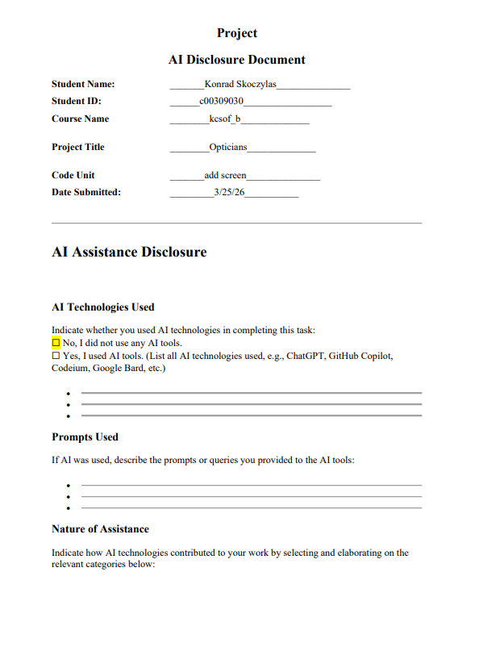

addStockitem.php
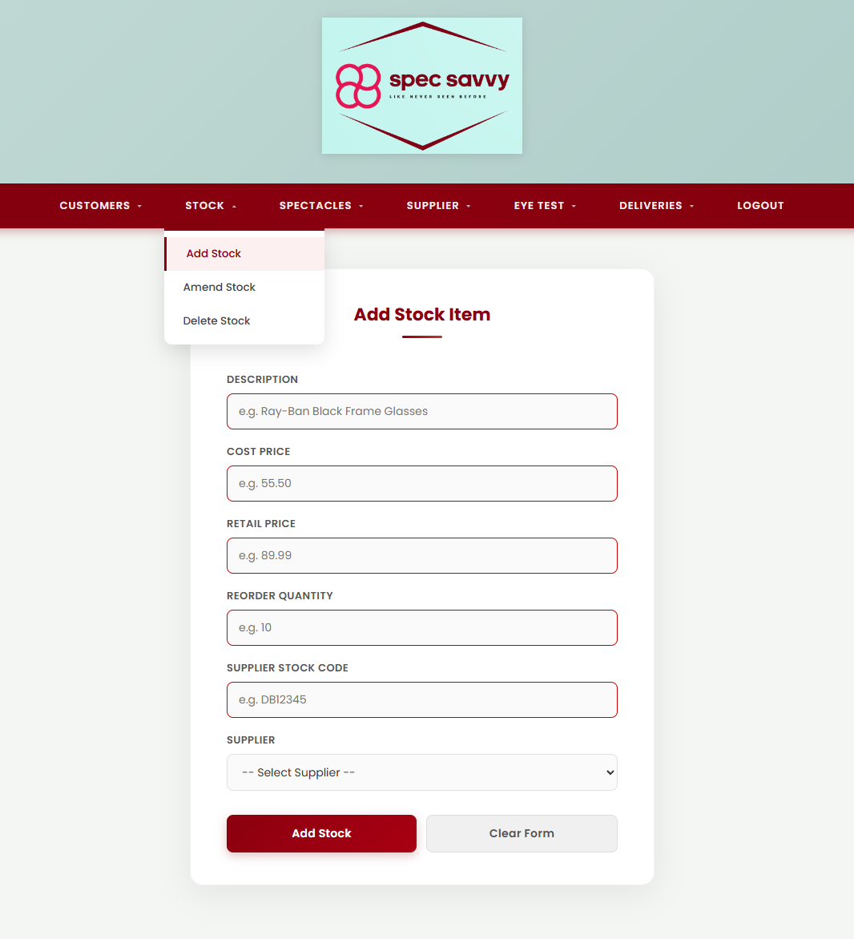
Displays the add-stock form and triggers a success alert after a successful insert.

<?php
// Screen: addStockitem.php
// Purpose: Displays a form allowing the user to add a new stock item.
// Retrieves the list of suppliers from the database to populate
// the supplier dropdown. After a successful insert, redirects here
// with URL parameters that trigger a JavaScript success popup.
// Name: Konrad Skoczylas
// ID: C00309030
// Date: March 2026
include 'db.inc.php'; // Include database connection
// Fetch all suppliers ordered alphabetically for the dropdown
$result = mysqli_query($con, "SELECT SupplierID, Supplier_Name FROM Supplier ORDER BY Supplier_Name");
if (!$result) {
die("Error retrieving suppliers: " . mysqli_error($con)); // Stop if query fails
}
// Grab success message and allocated stock number from URL if redirected back after insert
$added_description = isset($_GET['added']) ? htmlspecialchars($_GET['added']) : '';
$stock_no = isset($_GET['stock_no']) ? (int)$_GET['stock_no'] : 0;
?>
<!DOCTYPE html>
<html lang="en">
<head>
<meta charset="UTF-8">
<title>Spec Savvy | Add Stock</title>
<link rel="stylesheet" href="style.css">
</head>
<body>
<header class="main-header">
<div class="logo-area">
<img src="spec savvy logo.png" alt="Spec Savvy Logo">
</div>
</header>
<?php require_once 'Includes/nav.php'; // Include navigation bar ?>
<?php if ($added_description): ?>
<!-- Success popup -- triggered when redirected back with ?added=Description&stock_no=X -->
<script>
window.onload = function () {
alert('Stock item added successfully!\n\nItem: <?php echo $added_description; ?>\nStock No: <?php echo $stock_no; ?>');
};
</script>
<?php endif; ?>
<div class="page-container">
<div class="card">
<h2>Add Stock Item</h2>
<!-- Stock item form -- submits to insertStock.php via POST -->
<form action="insertStock.php" method="POST" autocomplete="off">
<!-- Description: letters, numbers, basic punctuation only -->
<label for="Description">Description</label>
<input type="text"
id="Description"
name="Description"
placeholder="e.g. Ray-Ban Black Frame Glasses"
minlength="5"
maxlength="50"
pattern="[A-Za-z0-9 .,\-]+"
title="5-50 characters. Letters, numbers, spaces, commas, dots and hyphens only."
required>
<!-- Cost Price: decimal value between 1 and 5000 -->
<label for="Cost_price">Cost Price</label>
<input type="number"
id="Cost_price"
name="Cost_price"
placeholder="e.g. 55.50"
min="1"
max="5000"
step="0.01"
title="Enter a valid price between 1 and 5000"
required>
<!-- Retail Price: decimal value between 1 and 10000 -->
<label for="Retail_price">Retail Price</label>
<input type="number"
id="Retail_price"
name="Retail_price"
placeholder="e.g. 89.99"
min="1"
max="10000"
step="0.01"
title="Enter a valid price between 1 and 10000"
required>
<!-- Reorder Quantity: whole number between 1 and 500 -->
<label for="Reorder_qty">Reorder Quantity</label>
<input type="number"
id="Reorder_qty"
name="Reorder_qty"
placeholder="e.g. 10"
min="1"
max="500"
step="1"
title="Must be a whole number between 1 and 500"
required>
<!-- Supplier Stock Code: alphanumeric and hyphens only -->
<label for="Supplier_Stock_Code">Supplier Stock Code</label>
<input type="text"
id="Supplier_Stock_Code"
name="Supplier_Stock_Code"
placeholder="e.g. DB12345"
maxlength="15"
pattern="[A-Za-z0-9\-]+"
title="Letters, numbers and hyphens only (max 15 characters)"
required>
<!-- Supplier Dropdown: populated from database, user selects rather than types -->
<label for="SupplierID">Supplier</label>
<select name="SupplierID" id="SupplierID" required>
<option value="">-- Select Supplier --</option>
<?php
// Loop through suppliers and output each as a dropdown option
while ($row = mysqli_fetch_assoc($result)) {
echo "<option value='" . $row['SupplierID'] . "'>" . $row['Supplier_Name'] . "</option>";
}
?>
</select>
<!-- Submit and reset buttons -->
<div class="button-group">
<input type="submit" value="Add Stock">
<input type="reset" value="Clear Form">
</div>
</form>
</div>
</div>
</body>
</html>
<?php mysqli_close($con); // Close database connection ?>

insertStock.php
Processes the POST from addStockitem.php and inserts a new record into the Stock table.
<?php
// Screen: insertStock.php
// Purpose: Receives POST data from addStockitem.php and inserts a new stock
// item into the Stock table using a prepared statement. On success,
// redirects back to the add form with a URL parameter that triggers
// a JavaScript success alert showing the item name and new stock number.
// Name: Konrad Skoczylas
// ID: C00309030
// Date: March 2026
include 'db.inc.php'; // Include database connection
// Only process if the form was submitted via POST
if ($_SERVER['REQUEST_METHOD'] === 'POST') {
// Retrieve form values from POST
// Stock_no is NOT collected here -- it is auto-allocated by the database as AUTO_INCREMENT
$Description = $_POST['Description'];
$Cost_price = $_POST['Cost_price'];
$Retail_price = $_POST['Retail_price'];
$Reorder_qty = $_POST['Reorder_qty'];
$Supplier_Stock_Code = $_POST['Supplier_Stock_Code'];
$SupplierID = $_POST['SupplierID'];
// Prepare INSERT statement -- Stock_no excluded, DB assigns it automatically
$stmt = mysqli_prepare($con,
"INSERT INTO Stock (Description, Cost_price, Retail_price, Reorder_qty, Supplier_Stock_Code, SupplierID)
VALUES (?, ?, ?, ?, ?, ?)"
);
if (!$stmt) {
die("Prepare failed: " . mysqli_error($con)); // Stop if prepare fails
}
// Bind parameters: s = string, d = double (decimal), i = integer
mysqli_stmt_bind_param($stmt, "sddisi",
$Description, $Cost_price, $Retail_price, $Reorder_qty, $Supplier_Stock_Code, $SupplierID
);
// Execute the statement -- insert the new stock record into the database
if (mysqli_stmt_execute($stmt)) {
// Retrieve the auto-allocated stock number assigned by the database
$new_stock_no = mysqli_insert_id($con);
mysqli_stmt_close($stmt);
mysqli_close($con);
// Redirect back to the add form with description and stock number for success alert
header("Location: addStockitem.php?added=" . urlencode($Description) . "&stock_no=" . $new_stock_no);
exit();
} else {
// Display error if execution fails
echo "Error: " . mysqli_stmt_error($stmt);
mysqli_stmt_close($stmt);
}
}
mysqli_close($con); // Close database connection
?>
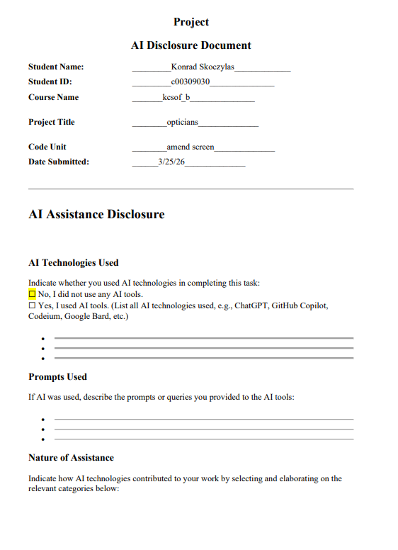

amendStockItem.php
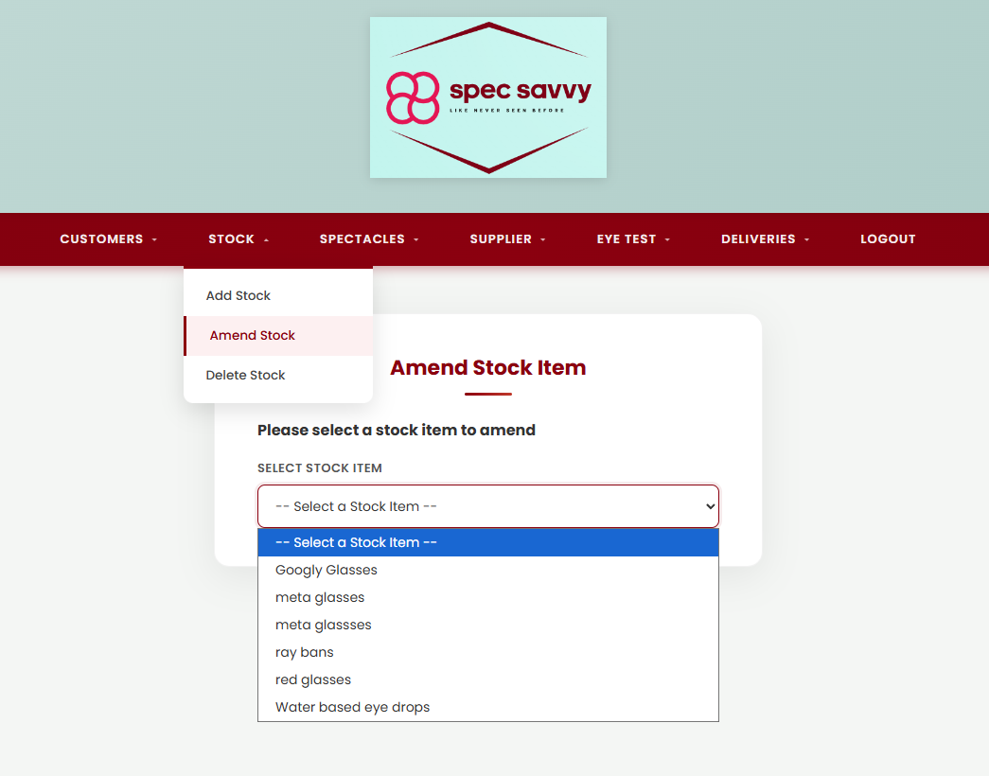

Displays a dropdown of all active stock items for the user to select one to amend. Selecting an item auto-submits the form to confirmAmend.php. Shows a success alert after a successful update.
<?php
// Screen: amendStockItem.php
// Purpose: Displays a dropdown of all active stock items for the user to
// select one to amend. Selecting an item auto-submits the form
// to confirmAmend.php. If redirected back after a successful
// update, triggers a JavaScript alert showing the item name.
// Name: Konrad Skoczylas
// ID: C00309030
// Date: March 2026
include 'db.inc.php'; // Include database connection
// Fetch all non-deleted stock items from the database, ordered alphabetically
$result = mysqli_query($con, "
SELECT s.Stock_id, s.Description
FROM Stock s
WHERE s.Deleted = 0
ORDER BY s.Description
");
// Check if redirected back after a successful amend -- used to trigger the success popup
$amended = isset($_GET['amended']) ? htmlspecialchars($_GET['amended']) : '';
?>
<!DOCTYPE html>
<html lang="en">
<head>
<meta charset="UTF-8">
<title>Spec Savvy | Amend Stock</title>
<link rel="stylesheet" href="style.css">
</head>
<body>
<header class="main-header">
<div class="logo-area">
<img src="spec savvy logo.png" alt="Spec Savvy Logo">
</div>
</header>
<?php require_once 'Includes/nav.php'; // Include navigation bar ?>
<?php if ($amended): ?>
<!-- If an item was just amended, show a success popup with the item name -->
<script>
window.onload = function() {
alert('Stock item amended successfully!\n\nItem updated: <?php echo $amended; ?>');
};
</script>
<?php endif; ?>
<div class="page-container">
<div class="card">
<h2>Amend Stock Item</h2>
<h4>Please select a stock item to amend</h4>
<!-- Form submits automatically when the user selects an item from the dropdown -->
<form method="POST" action="confirmAmend.php">
<label for="stock_id">Select Stock Item</label>
<!-- Dropdown populated from the Stock table -- onchange auto-submits the form -->
<select name="stock_id" id="stock_id" required onchange="this.form.submit()">
<option value="">-- Select a Stock Item --</option>
<?php while ($row = mysqli_fetch_assoc($result)): ?>
<!-- Each option value is the Stock_id, display text is the Description -->
<option value="<?php echo $row['Stock_id']; ?>">
<?php echo htmlspecialchars($row['Description']); ?>
</option>
<?php endwhile; ?>
</select>
</form>
</div>
</div>
</body>
</html>
<?php mysqli_close($con); // Close the database connection ?>

confirmAmend.php
Fetches the selected item's current values and presents an editable form with a confirm() guard.

<?php
// Screen: confirmAmend.php
// Purpose: Receives the stock number selected on amendStockItem.php, fetches
// the full item details from the database, and displays an editable
// form pre-filled with the current values. Description, cost price,
// retail price and reorder quantity can be changed. Stock number and
// supplier are displayed as read-only. A confirm() dialog prompts the
// user before the form posts to finalAmend.php.
// Name: Konrad Skoczylas
// ID: C00309030
// Date: March 2026
include 'db.inc.php'; // Include database connection
// Redirect back if no stock number was posted
if (!isset($_POST['stock_no'])) {
header("Location: amendStockItem.php");
exit();
}
$stock_no = $_POST['stock_no']; // Get the stock number from the form
// Fetch the selected stock item details along with the supplier name
$stmt = mysqli_prepare($con,
"SELECT s.Stock_no, s.Description, s.Cost_price, s.Retail_price, s.Reorder_qty, sup.Supplier_Name
FROM Stock s
JOIN Supplier sup ON s.SupplierID = sup.SupplierID
WHERE s.Stock_no = ? AND s.Deleted = 0"
);
mysqli_stmt_bind_param($stmt, "i", $stock_no); // Bind stock number as integer
mysqli_stmt_execute($stmt);
$result = mysqli_stmt_get_result($stmt);
$row = mysqli_fetch_assoc($result); // Fetch the row as an associative array
mysqli_stmt_close($stmt);
// If no item was found, redirect back to the selection page
if (!$row) {
header("Location: amendStockItem.php");
exit();
}
mysqli_close($con); // Close the database connection
?>
<!DOCTYPE html>
<html lang="en">
<head>
<meta charset="UTF-8">
<title>Spec Savvy | Confirm Amend</title>
<link rel="stylesheet" href="style.css">
</head>
<body>
<header class="main-header">
<div class="logo-area">
<img src="spec savvy logo.png" alt="Spec Savvy Logo">
</div>
</header>
<?php require_once 'Includes/nav.php'; // Include navigation bar ?>
<div class="page-container">
<div class="card">
<h2>Amend Stock Item</h2>
<p>Update the fields below and click Save Changes when done.</p>
<!-- Form posts updated values to finalAmend.php -->
<!-- onsubmit confirm() dialog double-checks before saving -- satisfies spec requirement -->
<form method="POST" action="finalAmend.php"
onsubmit="return confirm('Please confirm that the details are correct. Save changes?');">
<!-- Hidden field carries the stock number through to finalAmend.php -->
<input type="hidden" name="stock_no" value="<?php echo $row['Stock_no']; ?>">
<!-- Stock number is displayed but not editable -->
<label>Stock Number (not editable)</label>
<p><?php echo $row['Stock_no']; ?></p>
<!-- Description -- must be 5 to 50 characters, letters/numbers/spaces/commas/dots/hyphens only -->
<label for="description">Description</label>
<input type="text"
id="description"
name="description"
value="<?php echo htmlspecialchars($row['Description']); ?>"
minlength="5"
maxlength="50"
pattern="[A-Za-z0-9 .,\-]+"
title="5 to 50 characters. Letters, numbers, spaces, commas, dots and hyphens only."
required>
<!-- Cost price -- must be between 1 and 5000 -->
<label for="cost_price">Cost Price</label>
<input type="number"
id="cost_price"
name="cost_price"
value="<?php echo $row['Cost_price']; ?>"
min="1"
max="5000"
step="0.01"
title="Enter a price between 1 and 5000"
required>
<!-- Retail price -- must be between 1 and 10000 -->
<label for="retail_price">Retail Price</label>
<input type="number"
id="retail_price"
name="retail_price"
value="<?php echo $row['Retail_price']; ?>"
min="1"
max="10000"
step="0.01"
title="Enter a price between 1 and 10000"
required>
<!-- Reorder quantity -- must be a whole number between 1 and 500 -->
<label for="reorder_qty">Reorder Quantity</label>
<input type="number"
id="reorder_qty"
name="reorder_qty"
value="<?php echo $row['Reorder_qty']; ?>"
min="1"
max="500"
step="1"
title="Enter a whole number between 1 and 500"
required>
<!-- Supplier is displayed but not editable -->
<label>Supplier (not editable)</label>
<p><?php echo htmlspecialchars($row['Supplier_Name']); ?></p>
<div class="button-group">
<input type="submit" value="Save Changes">
<a href="amendStockItem.php"><input type="button" value="Cancel"></a>
</div>
</form>
</div>
</div>
</body>
</html>

finalAmend.php
Applies the amended values to the Stock table and redirects back with a success alert.
<?php
// Screen: finalAmend.php
// Purpose: Receives the updated stock item values from confirmAmend.php and
// updates the matching record in the Stock table using a prepared
// statement. On success, redirects to amendStockItem.php with a URL
// parameter that triggers a JavaScript success alert.
// Name: Konrad Skoczylas
// ID: C00309030
// Date: March 2026
include 'db.inc.php'; // Include database connection
// Retrieve posted values from confirmAmend.php
$stock_no = $_POST['stock_no'];
$description = $_POST['description'];
$cost_price = $_POST['cost_price'];
$retail_price = $_POST['retail_price'];
$reorder_qty = $_POST['reorder_qty'];
// Prepare UPDATE statement to amend the stock item
$stmt = mysqli_prepare($con,
"UPDATE Stock SET Description = ?, Cost_price = ?, Retail_price = ?, Reorder_qty = ?
WHERE Stock_no = ?"
);
if (!$stmt) {
die("Prepare failed: " . mysqli_error($con)); // Stop if prepare fails
}
// Bind all values -- s = string, MySQL handles type conversion for numeric columns
mysqli_stmt_bind_param($stmt, "sssss", $description, $cost_price, $retail_price, $reorder_qty, $stock_no);
// Execute the UPDATE -- stop and display error if execution fails
if (!mysqli_stmt_execute($stmt)) {
echo "Error: " . mysqli_stmt_error($stmt);
mysqli_stmt_close($stmt);
mysqli_close($con);
exit();
}
mysqli_stmt_close($stmt); // Close the statement
mysqli_close($con); // Close the database connection
// Redirect back with description in URL to trigger the success popup
header("Location: amendStockItem.php?amended=" . urlencode($description));
exit();
?>

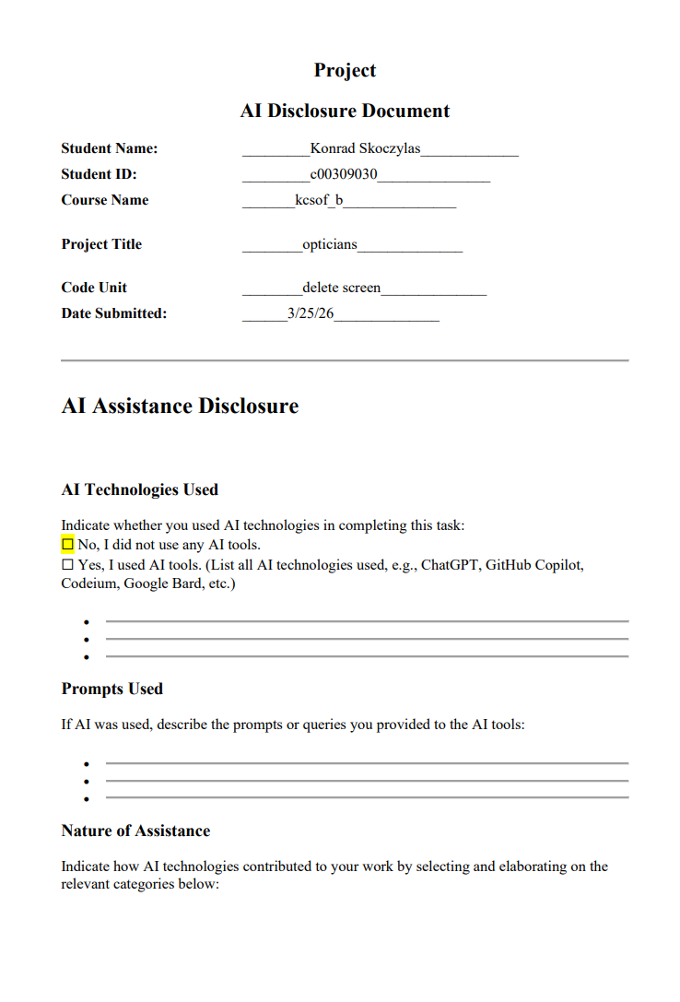

deleteStockItem.php
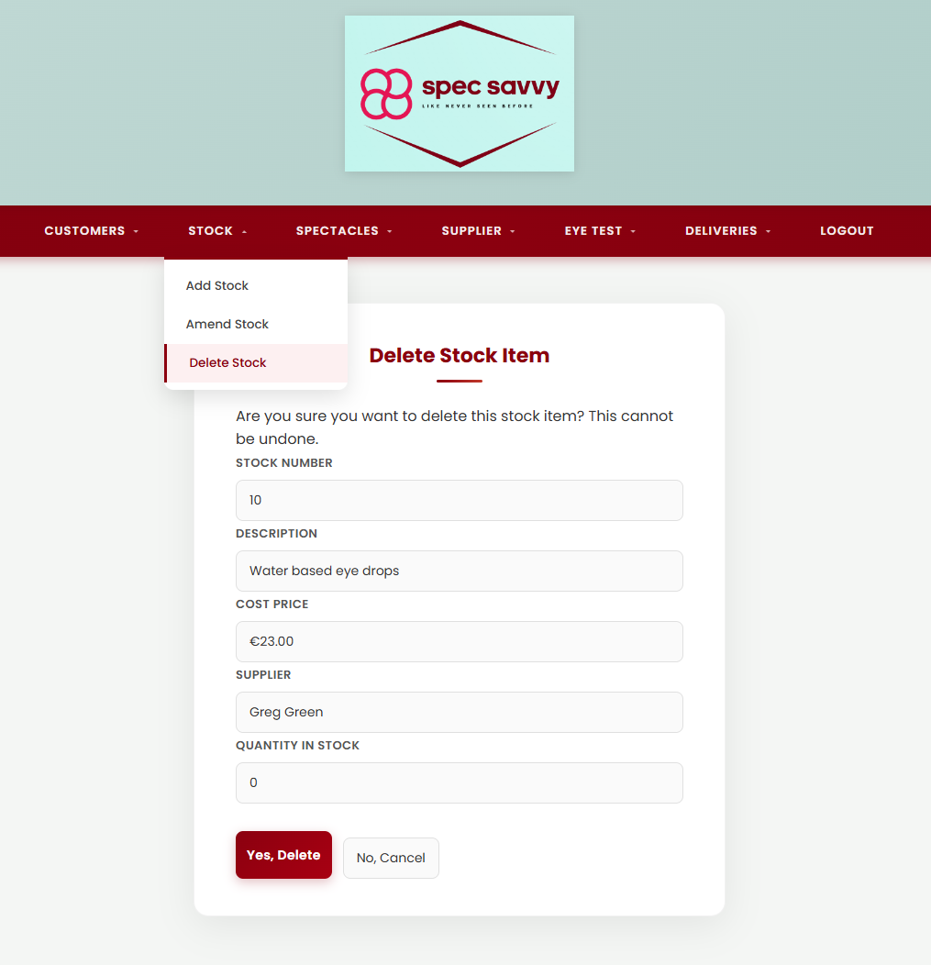
Displays the delete-selection dropdown and triggers a success alert after a confirmed deletion.
<?php
// Screen: deleteStockItem.php
// Purpose: Displays a dropdown of all active (non-deleted) stock items.
// Selecting an item auto-submits the form to confirmDelete.php.
// If redirected back after a successful deletion, a JavaScript alert
// confirms the item that was removed.
// Name: Konrad Skoczylas
// ID: C00309030
// Date: March 2026
include 'db.inc.php'; // Include database connection
// Fetch all non-deleted stock items ordered alphabetically for the dropdown
$result = mysqli_query($con,
"SELECT Stock_no, Description FROM Stock WHERE Deleted = 0 ORDER BY Description"
);
// Check if redirected back after a successful delete -- used to trigger the success popup
$deleted = isset($_GET['deleted']) ? htmlspecialchars($_GET['deleted']) : '';
?>
<!DOCTYPE html>
<html lang="en">
<head>
<meta charset="UTF-8">
<title>Spec Savvy | Delete Stock</title>
<link rel="stylesheet" href="style.css">
</head>
<body>
<header class="main-header">
<div class="logo-area">
<img src="spec savvy logo.png" alt="Spec Savvy Logo">
</div>
</header>
<?php require_once 'Includes/nav.php'; // Include navigation bar ?>
<?php if ($deleted): ?>
<!-- Success popup -- shown after a successful deletion -->
<script>
window.onload = function () {
alert('Stock item deleted successfully!\n\nItem deleted: <?php echo $deleted; ?>');
};
</script>
<?php endif; ?>
<div class="page-container">
<div class="card">
<h2>Delete Stock Item</h2>
<h4>Please select a stock item to delete</h4>
<!-- Selecting an item from the dropdown auto-submits the form to confirmDelete.php -->
<form method="POST" action="confirmDelete.php">
<label for="stock_no">Select Stock Item</label>
<select name="stock_no" id="stock_no" required onchange="this.form.submit()">
<option value="">-- Select a Stock Item --</option>
<?php while ($row = mysqli_fetch_assoc($result)): ?>
<!-- Each option value is Stock_no, display text is the Description -->
<option value="<?php echo $row['Stock_no']; ?>">
<?php echo htmlspecialchars($row['Description']); ?>
</option>
<?php endwhile; ?>
</select>
</form>
</div>
</div>
</body>
</html>
<?php mysqli_close($con); // Close database connection ?>

confirmDelete.php
Validates that the item can be deleted and presents read-only details for confirmation.
<?php
// Screen: confirmDelete.php
// Purpose: Receives the selected stock number from deleteStockItem.php.
// Checks whether the item can be deleted (quantity in stock must be
// zero and item must not be on any active order). If checks pass,
// displays the item details in read-only fields and asks the user to
// confirm. If checks fail, displays an appropriate error message.
// Name: Konrad Skoczylas
// ID: C00309030
// Date: March 2026
include 'db.inc.php'; // Include database connection
// Redirect back if no stock number was posted
if (!isset($_POST['stock_no'])) {
header("Location: deleteStockItem.php");
exit();
}
$stock_no = $_POST['stock_no']; // Get stock number from the form
$error = null; // Initialise error variable
// Check if quantity in stock is greater than zero -- cannot delete if so
$stmt = mysqli_prepare($con, "SELECT Qty_in_stock FROM Stock WHERE Stock_no = ?");
mysqli_stmt_bind_param($stmt, "i", $stock_no);
mysqli_stmt_execute($stmt);
$r = mysqli_fetch_assoc(mysqli_stmt_get_result($stmt));
mysqli_stmt_close($stmt);
if (!$r) {
$error = "Stock item not found.";
} elseif ($r['Qty_in_stock'] > 0) {
$error = "Cannot delete: Quantity in stock is greater than zero.";
} else {
// Check if the item is on any order -- cannot delete if it is
$stmt2 = mysqli_prepare($con, "SELECT COUNT(*) as order_count FROM OrderItem WHERE Stock_ID = ?");
mysqli_stmt_bind_param($stmt2, "i", $stock_no);
mysqli_stmt_execute($stmt2);
$r2 = mysqli_fetch_assoc(mysqli_stmt_get_result($stmt2));
mysqli_stmt_close($stmt2);
if ($r2['order_count'] > 0) {
$error = "Cannot delete: Item is currently on order.";
}
}
// If no errors, fetch full item details to display on the confirmation page
$row = null;
if (!$error) {
$stmt3 = mysqli_prepare($con,
"SELECT s.Stock_no, s.Description, s.Cost_price, sup.Supplier_Name, s.Qty_in_stock
FROM Stock s
JOIN Supplier sup ON s.SupplierID = sup.SupplierID
WHERE s.Stock_no = ? AND s.Deleted = 0"
);
mysqli_stmt_bind_param($stmt3, "i", $stock_no);
mysqli_stmt_execute($stmt3);
$row = mysqli_fetch_assoc(mysqli_stmt_get_result($stmt3));
mysqli_stmt_close($stmt3);
}
mysqli_close($con); // Close database connection
?>
<!DOCTYPE html>
<html lang="en">
<head>
<meta charset="UTF-8">
<title>Spec Savvy | Confirm Delete</title>
<link rel="stylesheet" href="style.css">
</head>
<body>
<header class="main-header">
<div class="logo-area">
<img src="spec savvy logo.png" alt="Spec Savvy Logo">
</div>
</header>
<?php require_once 'Includes/nav.php'; // Include navigation bar ?>
<div class="page-container">
<div class="card">
<h2>Delete Stock Item</h2>
<?php if ($error): ?>
<!-- Show error if item cannot be deleted -->
<p style="color: red;"><?php echo $error; ?></p>
<div class="button-group">
<a href="deleteStockItem.php"><input type="button" value="Go Back"></a>
</div>
<?php elseif ($row): ?>
<!-- Display item details and ask user to confirm deletion -->
<p>Are you sure you want to delete this stock item? This cannot be undone.</p>
<!-- Readonly fields show the item details -->
<label>Stock Number</label>
<input type="text" value="<?php echo $row['Stock_no']; ?>" readonly>
<label>Description</label>
<input type="text" value="<?php echo htmlspecialchars($row['Description']); ?>" readonly>
<label>Cost Price</label>
<input type="text" value="€<?php echo number_format($row['Cost_price'], 2); ?>" readonly>
<label>Supplier</label>
<input type="text" value="<?php echo htmlspecialchars($row['Supplier_Name']); ?>" readonly>
<label>Quantity In Stock</label>
<input type="text" value="<?php echo $row['Qty_in_stock']; ?>" readonly>
<div class="button-group">
<!-- Yes -- posts stock number and description to finalDelete.php -->
<form method="POST" action="finalDelete.php">
<input type="hidden" name="stock_no" value="<?php echo $row['Stock_no']; ?>">
<input type="hidden" name="description" value="<?php echo htmlspecialchars($row['Description']); ?>">
<input type="submit" value="Yes, Delete">
</form>
<!-- No -- returns user to the selection page -->
<a href="deleteStockItem.php"><input type="button" value="No, Cancel"></a>
</div>
<?php endif; ?>
</div>
</div>
</body>
</html>

finalDelete.php
Displays a customer selection dropdown. Selecting a customer auto-submits to spectaclesDetails.php. After a successful sale, shows the sale reference and buttons to print the lab letter or start a new sale.
<?php
// Screen: selectSpectacles.php
// Purpose: Displays a dropdown of all active customers for the user to
// select one to begin a spectacle sale. Selecting a customer
// auto-submits the form to spectaclesDetails.php. After a
// successful sale, shows the sale reference number and buttons
// to print the lab letter or start a new sale.
// Name: Konrad Skoczylas
// ID: C00309030
// Date: March 2026
include 'db.inc.php'; // Include database connection
// Fetch all non-deleted customers ordered alphabetically
$customers = mysqli_query($con, "
SELECT customer_ID, first_name, last_name
FROM Customer
WHERE deleted = 0
ORDER BY last_name
");
// Check if redirected back after a successful sale
$added = isset($_GET['added']) ? htmlspecialchars($_GET['added']) : '';
$sale_id = isset($_GET['sale_id']) ? (int)$_GET['sale_id'] : 0;
$left = isset($_GET['left']) ? htmlspecialchars($_GET['left']) : '';
$right = isset($_GET['right']) ? htmlspecialchars($_GET['right']) : '';
$lens = isset($_GET['lens']) ? htmlspecialchars($_GET['lens']) : '';
$uv = isset($_GET['uv']) ? (int)$_GET['uv'] : 0;
$scratch = isset($_GET['scratch']) ? (int)$_GET['scratch'] : 0;
?>
<!DOCTYPE html>
<html lang="en">
<head>
<meta charset="UTF-8">
<title>Spec Savvy | Select Spectacles</title>
<link rel="stylesheet" href="style.css">
</head>
<body>
<header class="main-header">
<div class="logo-area">
<img src="spec savvy logo.png" alt="Spec Savvy Logo">
</div>
</header>
<?php require_once 'Includes/nav.php'; ?>
<?php if ($added): ?>
<!-- Success popup after sale saved -->
<script>
window.onload = function() {
alert('Spectacle sale saved successfully!\n\nSale reference: <?php echo $added; ?>');
};
</script>
<!-- Print button shown after successful sale -->
<div class="page-container">
<div class="card">
<h2>Sale Saved</h2>
<p>Sale reference: <strong><?php echo $sale_id; ?></strong></p>
<!-- Print button opens the lab letter in a new tab -->
<a href="printLetter.php?sale_id=<?php echo $sale_id; ?>&left=<?php echo urlencode($left); ?>&right=<?php echo urlencode($right); ?>&lens=<?php echo urlencode($lens); ?>&uv=<?php echo $uv; ?>&scratch=<?php echo $scratch; ?>" target="_blank">
<input type="button" value="Print Lab Letter">
</a>
<br><br>
<a href="selectSpectacles.php"><input type="button" value="New Sale"></a>
</div>
</div>
<?php else: ?>
<div class="page-container">
<div class="card">
<h2>Select Spectacles</h2>
<h4>Please select a customer</h4>
<!-- Selecting a customer auto-submits to spectaclesDetails.php -->
<form method="POST" action="spectaclesDetails.php">
<label for="customer_ID">Select Customer</label>
<select name="customer_ID" id="customer_ID" required onchange="this.form.submit()">
<option value="">-- Select a Customer --</option>
<?php while ($row = mysqli_fetch_assoc($customers)): ?>
<option value="<?php echo $row['customer_ID']; ?>">
<?php echo htmlspecialchars($row['first_name'] . ' ' . $row['last_name']); ?>
</option>
<?php endwhile; ?>
</select>
</form>
</div>
</div>
<?php endif; ?>
</body>
</html>
<?php mysqli_close($con); // Close database connection ?>
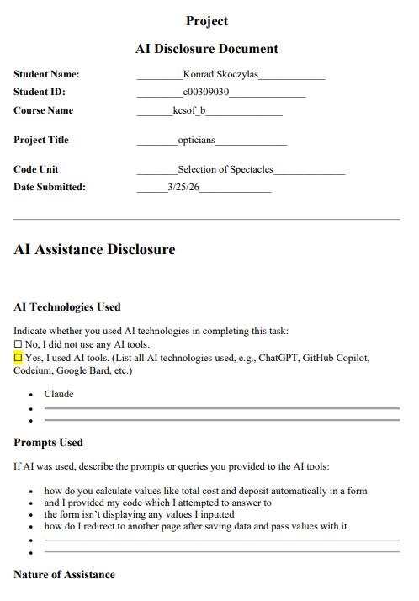

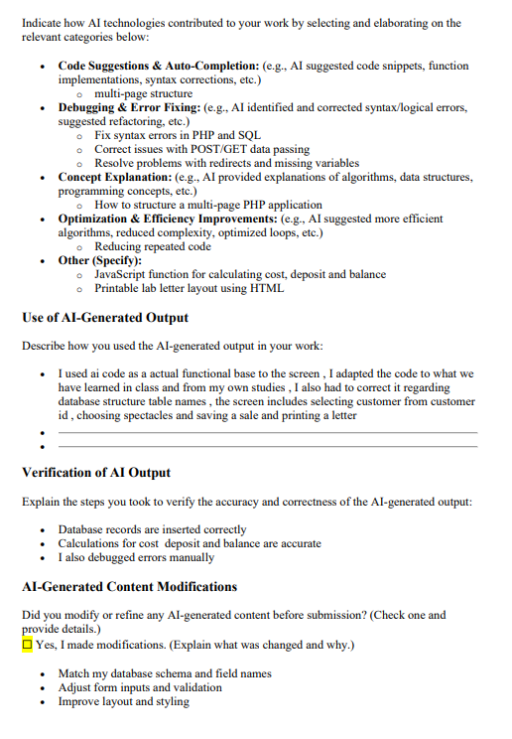

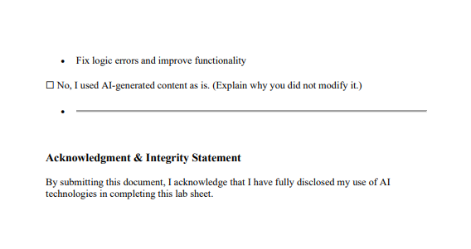

selectSpectacles.php
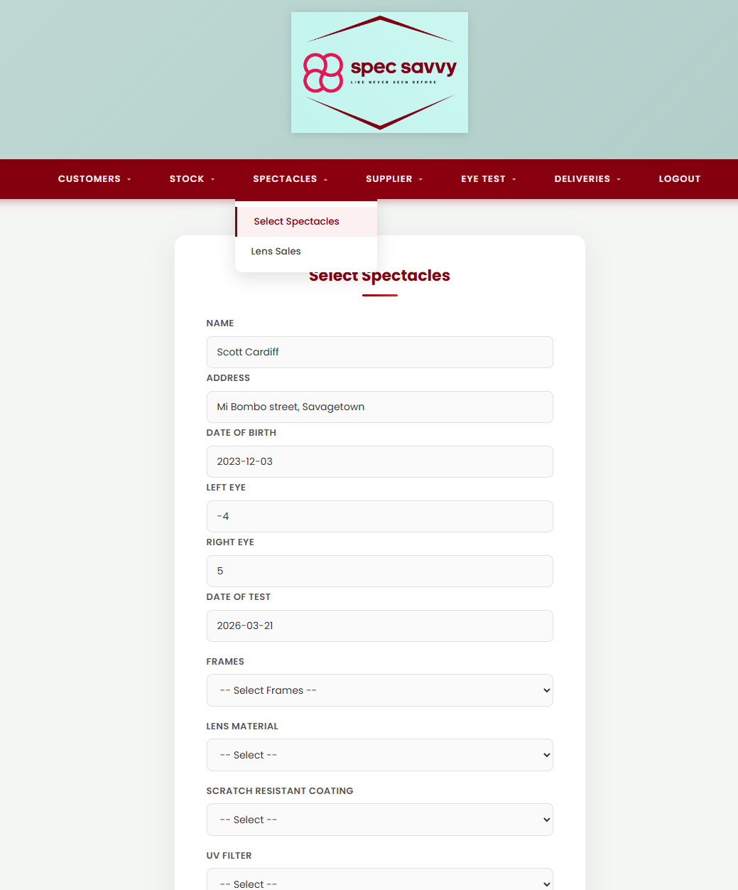

Displays a customer selection dropdown. Selecting a customer auto-submits to spectaclesDetails.php. After a successful sale, shows the sale reference and buttons to print the lab letter or start a new sale.
<?php
// Screen: selectSpectacles.php
// Purpose: Displays a dropdown of all active customers for the user to
// select one to begin a spectacle sale. Selecting a customer
// auto-submits the form to spectaclesDetails.php. After a
// successful sale, shows the sale reference number and buttons
// to print the lab letter or start a new sale.
// Name: Konrad Skoczylas
// ID: C00309030
// Date: March 2026
include 'db.inc.php'; // Include database connection
// Fetch all non-deleted customers ordered alphabetically
$customers = mysqli_query($con, "
SELECT customer_ID, first_name, last_name
FROM Customer
WHERE deleted = 0
ORDER BY last_name
");
// Check if redirected back after a successful sale
$added = isset($_GET['added']) ? htmlspecialchars($_GET['added']) : '';
$sale_id = isset($_GET['sale_id']) ? (int)$_GET['sale_id'] : 0;
$left = isset($_GET['left']) ? htmlspecialchars($_GET['left']) : '';
$right = isset($_GET['right']) ? htmlspecialchars($_GET['right']) : '';
$lens = isset($_GET['lens']) ? htmlspecialchars($_GET['lens']) : '';
$uv = isset($_GET['uv']) ? (int)$_GET['uv'] : 0;
$scratch = isset($_GET['scratch']) ? (int)$_GET['scratch'] : 0;
?>
<!DOCTYPE html>
<html lang="en">
<head>
<meta charset="UTF-8">
<title>Spec Savvy | Select Spectacles</title>
<link rel="stylesheet" href="style.css">
</head>
<body>
<header class="main-header">
<div class="logo-area">
<img src="spec savvy logo.png" alt="Spec Savvy Logo">
</div>
</header>
<?php require_once 'Includes/nav.php'; ?>
<?php if ($added): ?>
<!-- Success popup after sale saved -->
<script>
window.onload = function() {
alert('Spectacle sale saved successfully!\n\nSale reference: <?php echo $added; ?>');
};
</script>
<!-- Print button shown after successful sale -->
<div class="page-container">
<div class="card">
<h2>Sale Saved</h2>
<p>Sale reference: <strong><?php echo $sale_id; ?></strong></p>
<!-- Print button opens the lab letter in a new tab -->
<a href="printLetter.php?sale_id=<?php echo $sale_id; ?>&left=<?php echo urlencode($left); ?>&right=<?php echo urlencode($right); ?>&lens=<?php echo urlencode($lens); ?>&uv=<?php echo $uv; ?>&scratch=<?php echo $scratch; ?>" target="_blank">
<input type="button" value="Print Lab Letter">
</a>
<br><br>
<a href="selectSpectacles.php"><input type="button" value="New Sale"></a>
</div>
</div>
<?php else: ?>
<div class="page-container">
<div class="card">
<h2>Select Spectacles</h2>
<h4>Please select a customer</h4>
<!-- Selecting a customer auto-submits to spectaclesDetails.php -->
<form method="POST" action="spectaclesDetails.php">
<label for="customer_ID">Select Customer</label>
<select name="customer_ID" id="customer_ID" required onchange="this.form.submit()">
<option value="">-- Select a Customer --</option>
<?php while ($row = mysqli_fetch_assoc($customers)): ?>
<option value="<?php echo $row['customer_ID']; ?>">
<?php echo htmlspecialchars($row['first_name'] . ' ' . $row['last_name']); ?>
</option>
<?php endwhile; ?>
</select>
</form>
</div>
</div>
<?php endif; ?>
</body>
</html>
<?php mysqli_close($con); // Close database connection ?>

spectaclesDetails.php
Displays the selected customer's details and most recent eye test results in read-only fields. Provides dropdowns for frames, lens material, scratch coating and UV filter. JavaScript automatically calculates the total cost, deposit (20%) and balance (80%) when frames are selected.

<?php
// Screen: spectaclesDetails.php
// Purpose: Displays the selected customer's details and most recent eye
// test results in read-only fields. Provides dropdowns for frames,
// lens material, scratch resistant coating and UV filter. JavaScript
// calculates the total cost, deposit (20%) and balance (80%)
// automatically when frames are selected. A confirm() dialog
// prompts the user before the form posts to finalSpectacles.php.
// Name: Konrad Skoczylas
// ID: C00309030
// Date: March 2026
include 'db.inc.php'; // Include database connection
// Redirect back if no customer_ID was posted
if (!isset($_POST['customer_ID'])) {
header("Location: selectSpectacles.php"); // redirect to selection page
exit(); // stop script execution
}
$customer_ID = $_POST['customer_ID']; // get customer ID from POST
// Fetch customer details
$stmt = mysqli_prepare($con, "SELECT first_name, last_name, address, town, dob FROM Customer WHERE customer_ID = ?"); // prepare query
mysqli_stmt_bind_param($stmt, "i", $customer_ID); // bind customer ID
mysqli_stmt_execute($stmt); // execute query
$customer = mysqli_fetch_assoc(mysqli_stmt_get_result($stmt)); // fetch associative array
mysqli_stmt_close($stmt); // close statement
// Fetch most recent eye test for this customer
$stmt2 = mysqli_prepare($con, "SELECT left_lens, right_lens, date_of_test FROM `Eye Test` WHERE customer_ID = ? AND Deleted = 0 ORDER BY date_of_test DESC LIMIT 1"); // prepare query
mysqli_stmt_bind_param($stmt2, "i", $customer_ID); // bind customer ID
mysqli_stmt_execute($stmt2); // execute query
$eyetest = mysqli_fetch_assoc(mysqli_stmt_get_result($stmt2)); // fetch latest eye test
mysqli_stmt_close($stmt2); // close statement
// Fetch all non-deleted stock items for frames dropdown
$frames = mysqli_query($con, "SELECT Stock_id,Description, Retail_price FROM Stock WHERE Deleted = 0 ORDER BY Description"); // stock list
mysqli_close($con); // close DB connection
?>
<!DOCTYPE html>
<html lang="en">
<head>
<meta charset="UTF-8">
<title>Spec Savvy | Spectacles Details</title>
<link rel="stylesheet" href="style.css"> <!-- main stylesheet -->
</head>
<body>
<header class="main-header">
<div class="logo-area">
<img src="spec savvy logo.png" alt="Spec Savvy Logo"> <!-- logo -->
</div>
</header>
<?php require_once 'Includes/nav.php'; ?> <!-- navigation menu -->
<div class="page-container">
<div class="card">
<h2>Select Spectacles</h2>
<!-- Customer details -- readonly fields -->
<label>Name</label>
<input type="text" value="<?php echo htmlspecialchars($customer['first_name'] . ' ' . $customer['last_name']); ?>" readonly> <!-- full name -->
<label>Address</label>
<input type="text" value="<?php echo htmlspecialchars($customer['address'] . ', ' . $customer['town']); ?>" readonly> <!-- address -->
<label>Date of Birth</label>
<input type="text" value="<?php echo $customer['dob']; ?>" readonly> <!-- DOB -->
<!-- Eye test details -- readonly fields -->
<label>Left Eye</label>
<input type="text" value="<?php echo $eyetest ? $eyetest['left_lens'] : 'No eye test found'; ?>" readonly> <!-- left lens -->
<label>Right Eye</label>
<input type="text" value="<?php echo $eyetest ? $eyetest['right_lens'] : 'No eye test found'; ?>" readonly> <!-- right lens -->
<label>Date of Test</label>
<input type="text" value="<?php echo $eyetest ? $eyetest['date_of_test'] : 'N/A'; ?>" readonly> <!-- test date -->
<!-- Order form -->
<form method="POST" action="finalSpectacles.php" onsubmit="return confirm('Please confirm the order details are correct. Save sale?');">
<input type="hidden" name="customer_ID" value="<?php echo $customer_ID; ?>"> <!-- hidden customer ID -->
<!-- Frames dropdown -- retail price in data-price for JS -->
<label for="Stock_id">Frames</label>
<select name="Stock_id" id="Stock_id" required onchange="calculateCost()"> <!-- calculate cost when changed -->
<option value="" data-price="0">-- Select Frames --</option>
<?php while ($row = mysqli_fetch_assoc($frames)): ?>
<option value="<?php echo $row['Stock_id']; ?>" data-price="<?php echo $row['Retail_price']; ?>">
<?php echo htmlspecialchars($row['Description']); ?> (No: <?php echo $row['Stock_id']; ?>)
</option>
<?php endwhile; ?>
</select>
<!-- Lens options -->
<label for="lens_material">Lens Material</label>
<select name="lens_material" id="lens_material" required>
<option value="">-- Select --</option>
<option value="glass">Glass</option>
<option value="plastic">Plastic</option>
</select>
<label for="scratch_resistant">Scratch Resistant Coating</label>
<select name="scratch_resistant" id="scratch_resistant" required>
<option value="">-- Select --</option>
<option value="1">Yes</option>
<option value="0">No</option>
</select>
<label for="uv_filter">UV Filter</label>
<select name="uv_filter" id="uv_filter" required>
<option value="">-- Select --</option>
<option value="1">Yes</option>
<option value="0">No</option>
</select>
<!-- Cost fields -- auto calculated by JS -->
<label>Total Cost</label>
<input type="text" id="total_cost" name="total_cost" readonly> <!-- total cost -->
<label>Deposit Required (20%)</label>
<input type="text" id="deposit" name="deposit" readonly> <!-- deposit -->
<label>Remaining Balance</label>
<input type="text" id="balance" name="balance" readonly> <!-- balance -->
<div class="button-group">
<input type="submit" value="Save Sale"> <!-- submit button -->
<a href="selectSpectacles.php"><input type="button" value="Cancel"></a> <!-- cancel button -->
</div>
</form>
</div>
</div>
<script>
// Calculate cost, deposit and balance when frames are selected
function calculateCost() {
var select = document.getElementById('Stock_id'); // get frames dropdown
var price = parseFloat(select.options[select.selectedIndex].getAttribute('data-price')) || 0; // get price
document.getElementById('total_cost').value = '€' + price.toFixed(2); // set total
document.getElementById('deposit').value = '€' + (price * 0.20).toFixed(2); // set 20% deposit
document.getElementById('balance').value = '€' + (price * 0.80).toFixed(2); // set remaining balance
}
</script>
</body>
</html>

printLetter.php
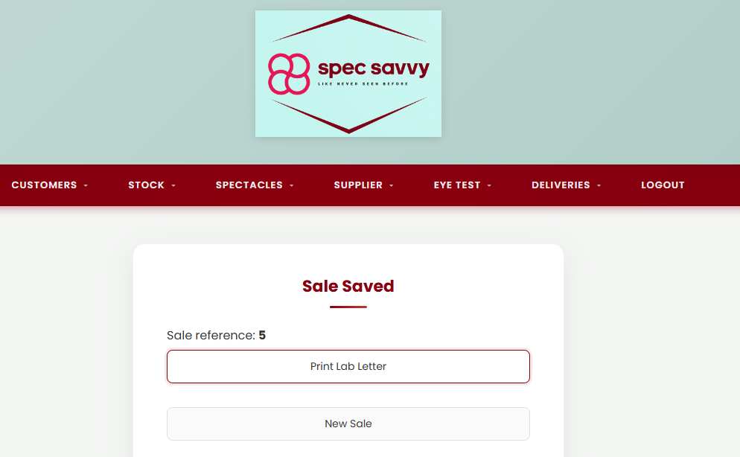
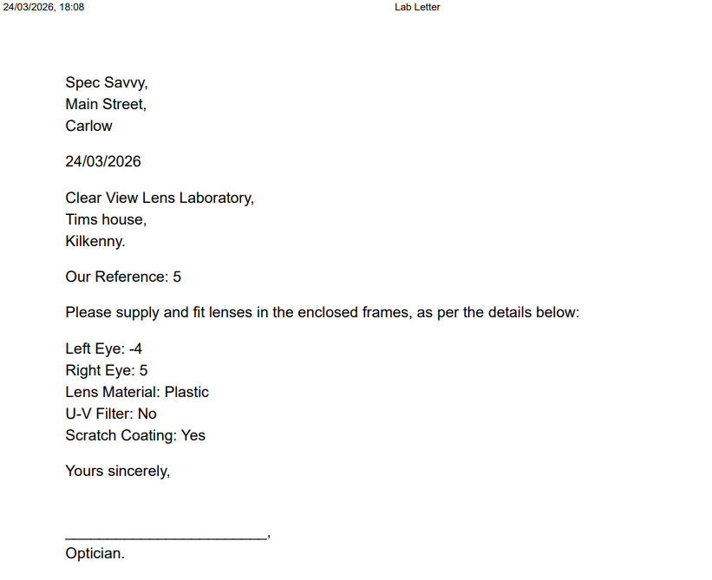
Generates a formatted lens lab letter using details passed in the URL. Has its own minimal inline CSS — no shared stylesheet, header or navigation bar. The browser print dialog opens automatically on page load via body onload="window.print()".

<?php
// Screen: printLetter.php
// Purpose: Generates a formatted lens lab letter using prescription and
// sale details passed as URL parameters from selectSpectacles.php.
// Uses its own minimal inline CSS -- no shared stylesheet, header
// or navigation bar. The browser print dialog opens automatically
// on page load via body onload="window.print()".
// Name: Konrad Skoczylas
// ID: C00309030
// Date: March 2026
$sale_id = isset($_GET['sale_id']) ? (int)$_GET['sale_id'] : ''; // get sale ID and cast to int
$left = isset($_GET['left']) ? htmlspecialchars($_GET['left']) : ''; // left lens (escaped)
$right = isset($_GET['right']) ? htmlspecialchars($_GET['right']) : ''; // right lens (escaped)
$lens = isset($_GET['lens']) ? htmlspecialchars($_GET['lens']) : ''; // lens material
$uv = isset($_GET['uv']) ? ((int)$_GET['uv'] ? 'Yes' : 'No') : 'No'; // convert 1/0 to Yes/No
$scratch = isset($_GET['scratch']) ? ((int)$_GET['scratch'] ? 'Yes' : 'No') : 'No'; // convert 1/0 to Yes/No
$date = date('d/m/Y'); // current date
?>
<!DOCTYPE html>
<html lang="en">
<head>
<meta charset="UTF-8">
<title>Lab Letter</title>
<style>
body { font-family: Arial, sans-serif; margin: 60px; } /* basic print styling */
p { margin: 5px 0; } /* spacing between lines */
.section { margin-bottom: 20px; } /* spacing between sections */
</style>
</head>
<body onload="window.print()"> <!-- auto open print dialog -->
<div class="section">
<p>Spec Savvy,</p> <!-- sender -->
<p>Main Street,</p>
<p>Carlow</p>
</div>
<div class="section">
<p><?php echo $date; ?></p> <!-- print current date -->
</div>
<div class="section">
<p>Clear View Lens Laboratory,</p> <!-- recipient -->
<p>Tims house,</p>
<p>Kilkenny.</p>
</div>
<div class="section">
<p>Our Reference: <?php echo $sale_id; ?></p> <!-- sale reference -->
</div>
<div class="section">
<p>Please supply and fit lenses in the enclosed frames, as per the details below:</p>
</div>
<div class="section">
<p>Left Eye: <?php echo $left; ?></p> <!-- left lens value -->
<p>Right Eye: <?php echo $right; ?></p> <!-- right lens value -->
<p>Lens Material: <?php echo ucfirst($lens); ?></p> <!-- capitalise first letter -->
<p>U-V Filter: <?php echo $uv; ?></p> <!-- UV option -->
<p>Scratch Coating: <?php echo $scratch; ?></p> <!-- scratch option -->
</div>
<div class="section">
<p>Yours sincerely,</p>
<br><br> <!-- space for signature -->
<p>________________________,</p>
<p>Optician.</p>
</div>
</body>
</html>

finalSpectacles.php
Receives the order details from spectaclesDetails.php, fetches the customer's latest eye test prescription, and inserts a new record into the SpectacleSale table using a prepared statement. Redirects to selectSpectacles.php with the sale reference and prescription details.
<?php
// Screen: finalSpectacles.php
// Purpose: Receives the order details posted from spectaclesDetails.php,
// fetches the customer's most recent eye test prescription, and
// inserts a new record into the SpectacleSale table using a
// prepared statement. On success, redirects to selectSpectacles.php
// with the sale reference and prescription details in the URL so
// the lab letter can be printed.
// Name: Konrad Skoczylas
// ID: C00309030
// Date: March 2026
include 'db.inc.php'; // Include database connection
// Redirect back if form was not submitted via POST
if ($_SERVER['REQUEST_METHOD'] !== 'POST') {
header("Location: selectSpectacles.php"); // redirect to selection page
exit(); // stop execution
}
// Get all posted values from spectaclesDetails.php
$customer_ID = $_POST['customer_ID']; // hidden field
$Stock_id = $_POST['Stock_id']; // selected frame
$lens_material = $_POST['lens_material']; // lens type
$scratch = $_POST['scratch_resistant']; // scratch coating option
$uv = $_POST['uv_filter']; // UV filter option
// Remove euro symbol from cost fields before storing
$total_cost = str_replace('€', '', $_POST['total_cost']);
$deposit = str_replace('€', '', $_POST['deposit']);
$balance = str_replace('€', '', $_POST['balance']);
$sale_date = date('Y-m-d'); // today's date in YYYY-MM-DD format
// Fetch most recent eye test for this customer
$stmt0 = mysqli_prepare($con, "
SELECT left_lens, right_lens
FROM `Eye Test`
WHERE customer_ID = ? AND Deleted = 0
ORDER BY date_of_test DESC
LIMIT 1
");
mysqli_stmt_bind_param($stmt0, "i", $customer_ID); // bind customer ID
mysqli_stmt_execute($stmt0); // execute query
$eyetest = mysqli_fetch_assoc(mysqli_stmt_get_result($stmt0)); // get latest eye test
mysqli_stmt_close($stmt0); // close statement
$left_lens = $eyetest['left_lens']; // store left lens
$right_lens = $eyetest['right_lens']; // store right lens
// Insert new sale record into SpectacleSale table
$stmt = mysqli_prepare($con, "
INSERT INTO SpectacleSale
(customer_ID, Stock_id, lens_material, scratch_resistant, uv_filter, total_cost, deposit_paid, balance, sale_date)
VALUES (?, ?, ?, ?, ?, ?, ?, ?, ?)
");
if (!$stmt) {
die("Prepare failed: " . mysqli_error($con)); // stop if query preparation fails
}
// Bind all values to the prepared statement
mysqli_stmt_bind_param($stmt, "iisisddds",
$customer_ID, $Stock_id, $lens_material, $scratch, $uv, $total_cost, $deposit, $balance, $sale_date
);
// Execute insert
if (mysqli_stmt_execute($stmt)) {
$sale_id = mysqli_insert_id($con); // get auto-incremented sale ID
mysqli_stmt_close($stmt); // close statement
mysqli_close($con); // close DB connection
// Redirect back to selection page with all necessary details for printing
header("Location: selectSpectacles.php?added=" . $sale_id
. "&sale_id=" . $sale_id
. "&left=" . urlencode($left_lens)
. "&right=" . urlencode($right_lens)
. "&lens=" . urlencode($lens_material)
. "&uv=" . $uv
. "&scratch=" . $scratch
);
exit();
} else {
// Display error if insert failed
echo "Error: " . mysqli_stmt_error($stmt);
mysqli_stmt_close($stmt); // close statement
}
mysqli_close($con); // close DB connection if not already closed
?>

Group name : Spec Savvy
Project name: Opticians
Student name: Kamile Kacinskaite
Student ID: C00312390
Date Submitted: 26/03/2026

Kamile Kacinskaite Screens
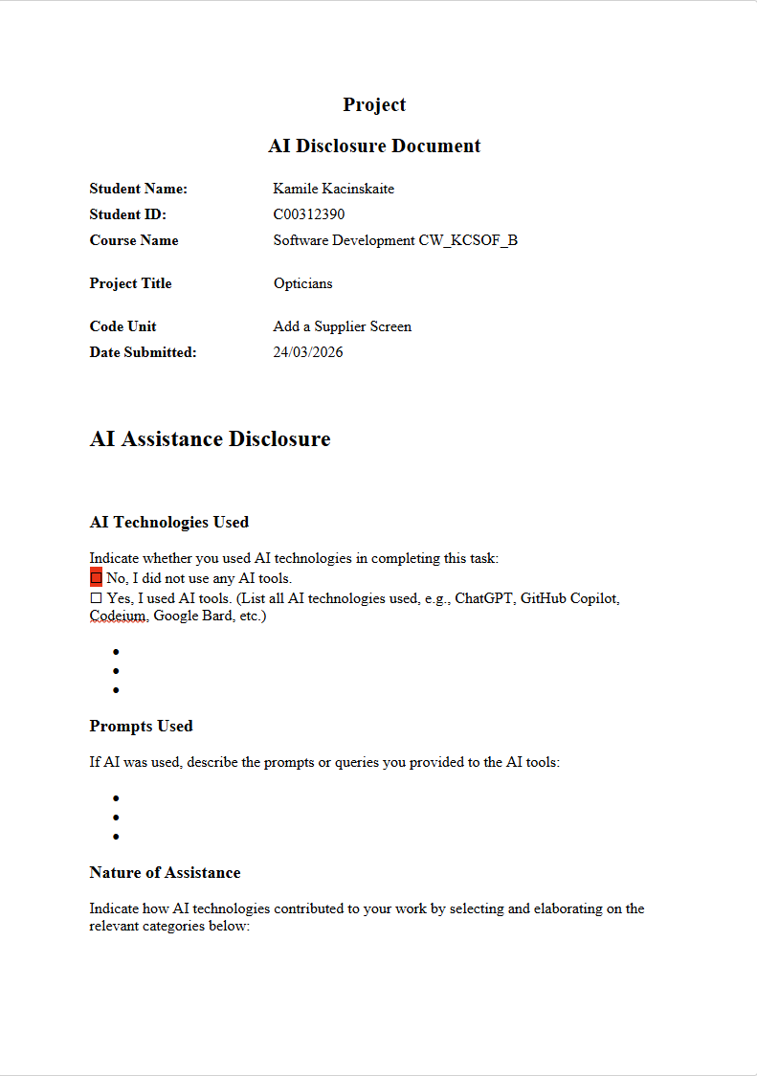

Add Supplier Screen

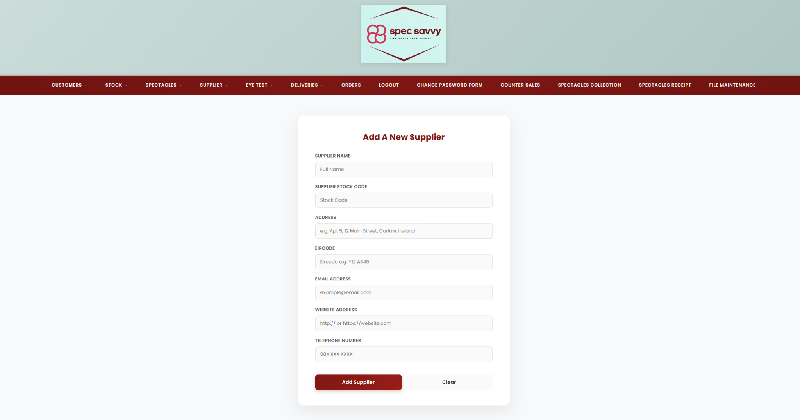
Displays the Add a Supplier form. The user enters in all the correct data for a new supplier and when the user confirms that the details are correct, a unique supplier number is allocated and displayed on form, and a new record is added to the Supplier Table. Success message and confirmation message gets displayed also making sure the user is happy with what they have entered and that it submitted successfully to the database table : Supplier.
AddSupplier.html.php
<!-- Kamile Kacinskaite -->
<!-- C00312390 -->
<!-- Project Add New Supplier Screen -->
<!-- 12/02/26 -->
<?php session_start(); ?>
<!DOCTYPE html>
<html lang="en">
<head>
<meta charset="UTF-8">
<title>Spec Savvy | Add A Supplier</title>
<!-- link to the css file that styles the page -->
<link rel="stylesheet" href="supplier.css">
</head>
<body>
<!-- header section that shows the company logo -->
<header class="main-header">
<div class="logo-area">
<!-- logo image for the website -->
<img src="spec savvy logo.png" alt="Spec Savvy Logo">
</div>
</header>
<!-- navigation bar that lets users move around the website -->
<nav class="navbar">
<ul>
<!-- dropdown menu for adding suppliers -->
<li class="dropdown">
<!-- main menu link -->
<a href="AddSupplier.html.php" class="active">Add Supplier</a>
<!-- submenu options -->
<ul class="dropdown-menu">
<li><a href="AddSupplier.html.php">Add A New Supplier</a></li>
</ul>
</li>
<!-- dropdown menu to view supplier records -->
<li class="dropdown">
<a href="#">View Supplier</a>
<ul class="dropdown-menu">
<!-- view all suppliers -->
<li><a href="viewStock.php">All Suppliers</a></li>
<!-- view suppliers and delete them -->
<li><a href="viewDeleteStock.php">View / Delete Supplier</a></li>
<!-- view and amend supplier details -->
<li><a href="viewAmendStock.php">Amended Supplier</a></li>
</ul>
</li>
<!-- dropdown menu for managing suppliers -->
<li class="dropdown">
<a href="#">Manage</a>
<ul class="dropdown-menu">
<!-- page to delete suppliers -->
<li><a href="deleteStockItem.php">Delete Supplier</a></li>
<!-- page to amend supplier details -->
<li><a href="viewAmendStock.php">Amended Supplier</a></li>
</ul>
</li>
</ul>
</nav>
<!-- container that holds the supplier form -->
<body>
<div class="page-container"> <div class="card">
<?php
session_start();
if (isset($_SESSION['success_message'])) {
echo "<div class='success-banner'>";
echo "<strong>Success!</strong> " . $_SESSION['success_message'];
echo "</div>";
unset($_SESSION['success_message']);
}
?>
<h2>Add A New Supplier</h2>
<!-- form that sends data to insert_supplier.php using post method -->
<form id="supplierForm" method="post" action="insert_supplier.php" onsubmit="return confirm('Are you sure you want to insert this supplier record?');">
<label for="suppliername">Supplier Name</label> <!-- name validation -->
<input type="text" name="suppliername" id="suppliername" placeholder="Full Name"
pattern="[A-Za-z ]{2,30}" title="Name must be 2-30 letters and spaces only"required> <!-- full name no less than 2 no more than 30 characters -->
<label for="supplierstockcode">Supplier Stock Code</label> <!-- stock code validation -->
<input type="text" name="supplierstockcode" id="supplierstockcode" placeholder="Stock Code"
pattern="\d{2,6}" title="Please enter between 2 and 6 digits only"required>
<!-- address validation -->
<label for="supplieraddress">Address</label>
<input type="text" name="supplieraddress" id="supplieraddress"
placeholder="e.g. Apt 5, 12 Main Street, Carlow, Ireland"
maxlength="150"
pattern="^[A-Za-z0-9\s.,/-]{5,150}$"
title="Enter a valid address including street, city, and optionally apartment or country."
required>
<label for="eircode">Eircode</label> <!-- eircode validation -->
<input type="text" name="eircode" id="eircode" placeholder="Eircode e.g. Y12 A345"
pattern="[A-Za-z][0-9]{2}\s?[A-Za-z][0-9]{3}"title="Eircode must be in the format: Letter + 2 numbers, space optional, Letter + 3 numbers (e.g. Y12 A345)"
required> <!-- must be like what the placeholder asks for -->
<!-- email validation, javascript file holds the validation -->
<label for="supplieremail">Email Address</label>
<input type="supplieremail" name="supplieremail" id="supplieremail" placeholder="example@email.com" required
pattern="^[A-Za-z]{1,40}(@([A-Za-z]+\.)*[A-Za-z]+)\.(com|ie|org|net|co\.uk|edu)$"
title="Enter a valid email address like example@email.com, example@outlook.ie">
<!-- website validation, javascript file holds the validation -->
<label for="websiteaddress">Website Address</label>
<input type="url" name="websiteaddress" id="websiteaddress" placeholder="http:// or https://website.com" required
pattern="https?://.+"
title="Enter a valid website URL starting with http:// or https://">
<!-- supplier phone number with format validation -->
<label for="phonenumber">Telephone Number</label>
<input type="text" name="phonenumber" id="phonenumber" placeholder="08X XXX XXXX"
pattern="^08\d \d{3} \d{4}$"
title="Phone number must be in the format 08X XXX XXXX"
required>
<!-- buttons for submitting and clearing the form -->
<div class="button-group">
<input type="submit" value="Add Supplier">
<input type="reset" value="Clear">
</div>
</form>
</div>
</div>
</body>
<!-- page footer-->
<footer>
<p>&copy; 2026 Spec Savvy. All rights reserved.</p> <!-- text displayed at the bottom/footer -->
</footer>
<script src="script.js"></script> <!-- java script file link to the form -->
</body>
</html>

Insert_supplier.php
This works with AddSupplier.html.php to insert the form into the database table correctly.

<!-- Kamile Kacinskaite -->
<!-- C00312390 -->
<!-- Project Add New Supplier Screen -->
<!-- The user supplies details about a new supplier and when they confirm all details are correct a new record is added to the Supplier Table -->
<!-- 12/02/26 -->
<?php
session_start();
include 'success.php';
date_default_timezone_set("UTC");
if (!$con) // db connection error handling
{
die("Connection failed: " . mysqli_connect_error()); // connection error message
}
// direct insertion using the post values
$sql = "INSERT INTO Supplier
(Supplier_Name, Supplier_stock_code, Supplier_Address, Supplier_Phone, Supplier_Eircode, Supplier_Email, Supplier_Website)
VALUES (
'{$_POST['suppliername']}',
'{$_POST['supplierstockcode']}',
'{$_POST['supplieraddress']}',
'{$_POST['phonenumber']}',
'{$_POST['eircode']}',
'{$_POST['supplieremail']}',
'{$_POST['websiteaddress']}'
)";
if ($con->query($sql))
{
// set the message that will show up in the green box
$_SESSION['success_message'] = "Supplier '" . $_POST['suppliername'] . "' has been added to the system.";
header("Location: AddSupplier.html.php");
exit();
}
else
{
echo "Error: " . $sql . "<br>" . $con->error;
}

script.js
This is the JavaScript validation file that handles the pop up message asking if the user wants to insert the supplier record.

// Kamile Kacinskaite
// C00312390
// Project Add New Supplier Screen
// The user supplies details about a new supplier and when they confirm all details are correct a new record is added to the Supplier Table
// 12/02/26
window.onload = function() // command that runs when the page is fully loaded
{
const form = document.getElementById("supplierForm");
if (form)
{
form.onsubmit = function()
{
// this creates the browser pop-up
return confirm("Are you sure you want to insert this supplier record?");
};
}
};

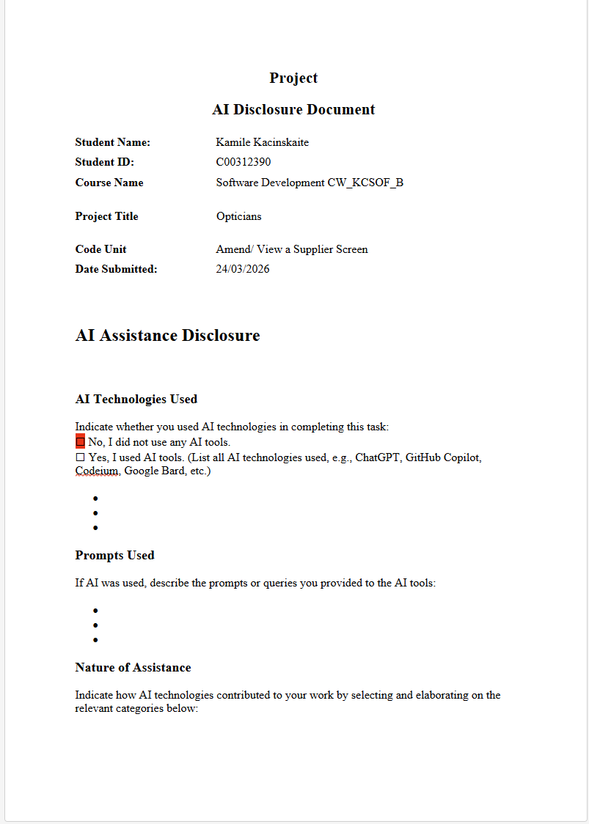

Amend/ View a Supplier Screen

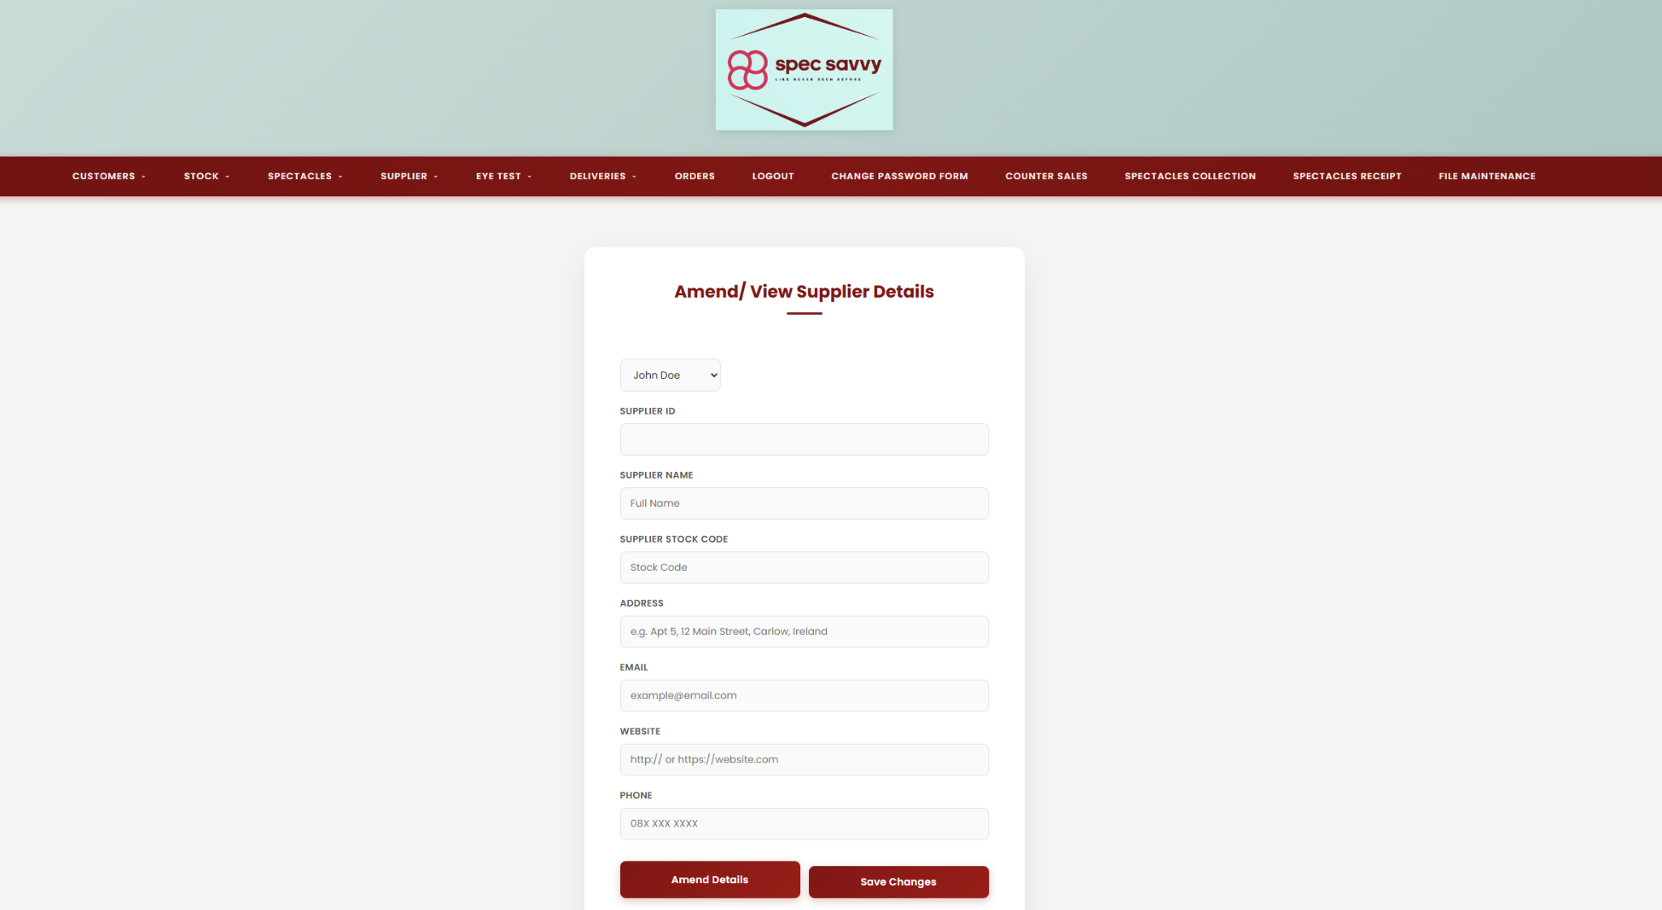
Firstly, the user identifies the appropriate supplier. This is done by selecting the supplier from a list box of all suppliers then all the details are displayed of the supplier chosen. I have used address instead of town, street and county so it matches with my add screen and also my delete. If the user then decides to amend certain details they must click the amend button that is used using a toggle lock function. Once they click that and amend any details the user indicates that they are to be saved. Then a standard double check pop up message appears asking the user if they are sure, and assuming the response is positive the amended details get updated to the Supplier table in the database.

AmendViewSupplier.html.php
<!-- Kamile Kacinskaite -->
<!-- C00312390 -->
<!-- Project Amend/ View A Supplier Screen -->
<!-- firstly user identifies the appropriate supplier. If the user decides to alter some details, he / she must choose the Amend option. Having all the changes, the user indicates that they are to be saved -->
<!-- a double check has popped up to ensure the user is sure they want to save the changes. Assuming that a positive response is given, the Supplier Table is updated. -->
<!-- in the amend/ view supplier specification i changed it to match the add screen address fields -->
<!-- 17/02/26 -->
<?php session_start(); ?> <!-- start the session to allow for success messages to be displayed after form submission -->
<!DOCTYPE html>
<html lang="en">
<head>
<meta charset="UTF-8">
<title>Spec Savvy | Amend/ View A Supplier</title> <!-- page title -->
<link rel="stylesheet" href="style.css">
<script defer> // js function to populate form fields -->
function populate()
{
let listbox = document.getElementById("listbox"); // select the listbox element by its ID
if (!listbox.value) return; // if no value is selected, exit the function to prevent errors
let data = listbox.value.split(","); // split the selected value by commas to get an array of supplier details
document.getElementById("amendSupplierID").value = data[0];
document.getElementById("amendSupplier_Name").value = data[1];
document.getElementById("amendSupplier_stock_code").value = data[2];
document.getElementById("amendSupplier_Address").value = data[3];
document.getElementById("amendSupplier_Phone").value = data[4];
document.getElementById("amendSupplier_Email").value = data[5];
document.getElementById("amendSupplier_Website").value = data[6];
// ensure fields are locked every time a new supplier is picked
let fields = document.querySelectorAll(".editable");
fields.forEach(f => f.disabled = true);
document.getElementById("toggleLockBtn").innerText = "Amend Details";
}
function toggleLock()
{
// select only the inputs you want to be editable
let fields = document.querySelectorAll("#amendSupplier_Name, #amendSupplier_stock_code, #amendSupplier_Address, #amendSupplier_Email, #amendSupplier_Website, #amendSupplier_Phone");
let btn = document.getElementById("toggleLockBtn");
// check if the first field is currently disabled
let isLocked = fields[0].disabled;
fields.forEach(f =>
{
f.disabled = !isLocked; // if locked enable it if enabled lock it.
});
// button text to give user feedback
btn.innerText = isLocked ? "View Details (Lock)" : "Amend Details";
}
function confirmCheck() // function to confirm with the user before submitting the form, ensuring they have clicked "Amend Details" to enable the fields and are sure they want to save the changes
{
let idField = document.getElementById("amendSupplierID"); // select the ID field to check if it's still disabled (which would indicate that the user hasn't clicked "Amend Details")
// if the fields are still locked prevent submission and alert user
if (document.getElementById("amendSupplier_Name").disabled)
{
alert("Please click 'Amend Details' before trying to save."); // alert the user to click "Amend Details" first
return false;
}
if (confirm("Are you sure you want to save these changes?")) // show a confirmation dialog to the user before submitting the form
{
// enable ID field so it gets sent in the POST array
idField.disabled = false;
return true;
}
else
{
return false; // if user cancels, prevent form submission
}
}
</script>
</head>
<body>
<header class="main-header">
<div class="logo-area">
<img src="spec savvy logo.png" alt="Spec Savvy Logo"> <!-- website logo -->
</div>
</header>
<nav class="navbar"> <!-- navigation bar with dropdown menus for different sections of the website -->
<ul>
<li class="dropdown">
<a href="AmendViewSupplier.html.php" class="active">Amend/ View A Supplier</a>
<ul class="dropdown-menu">
<li><a href="AmendView.html.php">Amend/ View A Supplier</a></li>
</ul>
</li>
<li class="dropdown"> <!-- dropdown menu for viewing suppliers with options to view all, view/delete, and view amended suppliers -->
<a href="#">View Supplier</a>
<ul class="dropdown-menu">
<li><a href="viewStock.php">All Suppliers</a></li>
<li><a href="viewDeleteStock.php">View / Delete Supplier</a></li>
<li><a href="viewAmendStock.php">Amended Supplier</a></li>
</ul>
</li>
<li class="dropdown"> <!-- dropdown menu for managing suppliers with options to delete and amend suppliers -->
<a href="#">Manage</a>
<ul class="dropdown-menu">
<li><a href="deleteStockItem.php">Delete Supplier</a></li>
<li><a href="viewAmendStock.php">Amended Supplier</a></li>
</ul>
</li>
</ul>
</nav>
<div class="page-container">
<div class="card">
<h2>Supplier Details</h2>
<?php
if (isset($_SESSION['success_message'])) // check if there is a success message in the session to display after form submission
{
echo "<div class='success-banner'>";
echo "<strong>Success!</strong> " . $_SESSION['success_message'];
echo "</div>";
unset($_SESSION['success_message']); // clear the message after displaying it once to prevent it from showing on page refresh
}
?>
<?php include 'AmendViewSupplierListbox.php'; ?> <!-- include the listbox file to display the list of suppliers for selection -->
<form action="AmendViewSupplier.php" method="post" onsubmit="return confirmCheck()">
<label for="amendSupplierID">Supplier ID</label> <!-- id only readable and cannot be altered, so it is disabled and will not be sent in the POST array unless enabled in the confirmCheck() function -->
<input type="text" name="amendSupplierID" id="amendSupplierID" readonly disabled>
<label for="amendSupplier_Name">Supplier Name</label> <!-- full name no less than 2 no more than 30 characters, letters and spaces only -->
<input type="text" name="amendSupplier_Name" id="amendSupplier_Name" placeholder="Full Name"
pattern="[A-Za-z ]{2,30}" title="Name must be 2-30 letters and spaces only" required disabled> <!-- full name no less than 2 no more than 30 characters -->
<label for="amendSupplier_stock_code">Supplier Stock Code</label> <!-- stock code must be between 2 and 6 digits -->
<input type="text" name="amendSupplier_stock_code" id="amendSupplier_stock_code" placeholder="Stock Code"
pattern="\d{2,6}" title="Please enter between 2 and 6 digits only"required disabled>
<!-- address validation -->
<label for="amendSupplier_Address">Address</label>
<input type="text" name="amendSupplier_Address" id="amendSupplier_Address"
placeholder="e.g. Apt 5, 12 Main Street, Carlow, Ireland"
maxlength="150"
pattern="^[A-Za-z0-9\s.,/-]{5,150}$"
title="Enter a valid address including street, city, and optionally apartment or country." required disabled>
<label for="amendSupplier_Email">Email</label> <!-- email should be in a valid format with specific domain extensions allowed -->
<input type="email" name="amendSupplier_Email" id="amendSupplier_Email" placeholder="example@email.com"
pattern="^[A-Za-z]{1,40}(@([A-Za-z]+\.)*[A-Za-z]+)\.(com|ie|org|net|co\.uk|edu)$"
title="Enter a valid email address like example@email.com, example@outlook.ie" required disabled>
<label for="amendSupplier_Website">Website</label> <!-- website should start with http:// or https:// and be followed by a valid URL format -->
<input type="url" name="amendSupplier_Website" id="amendSupplier_Website" placeholder="http:// or https://website.com"
pattern="https?://.+" title="Enter a valid website URL starting with http:// or https://" required disabled>
<label for="amendSupplier_Phone">Phone</label> <!-- phone number must be in the format 08X XXX XXXX where X is a digit -->
<input type="text" name="amendSupplier_Phone" id="amendSupplier_Phone" placeholder="08X XXX XXXX"
pattern="^08\d \d{3} \d{4}$"
title="Phone number must be in the format 08X XXX XXXX" required disabled>
<div class="button-group"> <!-- button group containing the "Amend Details" button to toggle the form fields and the "Save Changes" button to submit the form -->
<button type="button" id="toggleLockBtn" onclick="toggleLock()">Amend Details</button>
<input type="submit" value="Save Changes">
</div>
</form>
</div>
</div>
</body>
</html>

AmendViewSupplier.php
This file connects with the Amend html file to correctly amend and locate the data from the Supplier table.

// Kamile Kacinskaite
// C00312390
// Project Amend/ View A Supplier Screen
// firstly user identifies the appropriate supplier. If the user decides to alter some details, he / she must choose the Amend option. Having all the changes, the user indicates that they are to be saved
// a double check has popped up to ensure the user is sure they want to save the changes. Assuming that a positive response is given, the Supplier Table is updated.
// 17/02/26
document.getElementById("supplierList").addEventListener("change", function () // load supplier details when a supplier is selected
{
let id = this.value; // get the selected supplier ID
if (id === "") return; // if no supplier is selected do nothing
fetch("load_supplier.php?id=" + id) // fetch supplier details from the server
.then(response => response.json()) // parse the response as JSON (format for storing and transporting data)
.then(data =>
{
document.getElementById("SupplierID").value = data.supplier_id;
document.getElementById("Supplier_Name").value = data.supplier_name;
document.getElementById("Supplier_stock_code").value = data.supplier_stock_code;
document.getElementById("Supplier_Address").value = data.supplier_address;
document.getElementById("Supplier_Phone").value = data.supplier_phone;
document.getElementById("Supplier_Email").value = data.supplier_email;
document.getElementById("Supplier_Website").value = data.supplier_website;
});
});
// enable form fields for editing when the "Edit" button is clicked
document.getElementById("editBtn").addEventListener("click", function ()
{
document.querySelectorAll("#supplierForm input").forEach(input => // loop through all input fields in the form
{
if (input.id !== "SupplierID")
{
input.disabled = false;
}
});
document.getElementById("saveBtn").disabled = false;
});
if (!confirm("Are you sure you want to save these changes?")) // confirm before submitting the form
{
e.preventDefault(); // prevent form submission if the user cancels
}
function toggleLock()
{
const fields = [
'amend_Supplier_Name',
'amend_Supplier_Address',
'amend_Supplier_Email',
'amend_Supplier_Website',
'amend_Supplier_Phone'
];
const btn = document.getElementById('toggleLockBtn');
const submitBtn = document.getElementById('submitBtn');
// check current state of first field to determine action
const isLocked = document.getElementById(fields[0]).readOnly;
fields.forEach(id => {
document.getElementById(id).readOnly = !isLocked; // toggle readOnly state of each field based on current state
});
if (isLocked) {
btn.innerText = "Lock Fields";
submitBtn.disabled = false; // enable save button when editing
} else {
btn.innerText = "Amend Details";
submitBtn.disabled = true; // disable save button when locked
}
}
// confirm before submitting the form to save changes
function confirmAmend() {
let name = document.getElementById("amend_Supplier_Name").value;
return confirm("Are you sure you want to save changes for: " + name + "?");
}

AmendViewSupplierListbox.php
This file is my listbox for the html amend file. It selects all the supplier data and creates a drop down listbox for access to all current suppliers for easier access when amending any details.
<!-- Kamile Kacinskaite -->
<!-- C00312390 -->
<!-- Project Amend/ View A Supplier Screen -->
<!-- firstly user identifies the appropriate supplier. If the user decides to alter some details, he / she must choose the Amend option. Having all the changes, the user indicates that they are to be saved -->
<!-- a double check has popped up to ensure the user is sure they want to save the changes. Assuming that a positive response is given, the Supplier Table is updated. -->
<!-- 17/02/26 -->
<?php
include "success.php"; // database connection
date_default_timezone_set('UTC');
/* select query to retrieve all supplier records from the database */
$sql = "
SELECT
SupplierID,
Supplier_Name,
Supplier_stock_code,
Supplier_Address,
Supplier_Email,
Supplier_Website,
Supplier_Phone
FROM Supplier
";
if (!$result = mysqli_query($con, $sql)) // execute the query and check for errors
{
die('Error querying the database: ' . mysqli_error($con));
}
/* create a dropdown menu (listbox) to display the supplier names, with the value of each option containing all the supplier details separated by commas */
echo "<br><select name='listbox' id='listbox' onclick='populate()'>";
/* while loop through records and build options */
while ($row = mysqli_fetch_array($result))
{
$id = $row['SupplierID'];
$name = $row['Supplier_Name'];
$code = $row['Supplier_stock_code'];
$address = $row['Supplier_Address'];
$email = $row['Supplier_Email'];
$website = $row['Supplier_Website'];
$phone = $row['Supplier_Phone'];
/* Match the order expected by populate() in the HTML file */
$allText = "$id,$name,$code,$address,$phone,$email,$website";
echo "<option value='$allText'>$name</option>";
}
echo "</select>";
mysqli_close($con);
?>

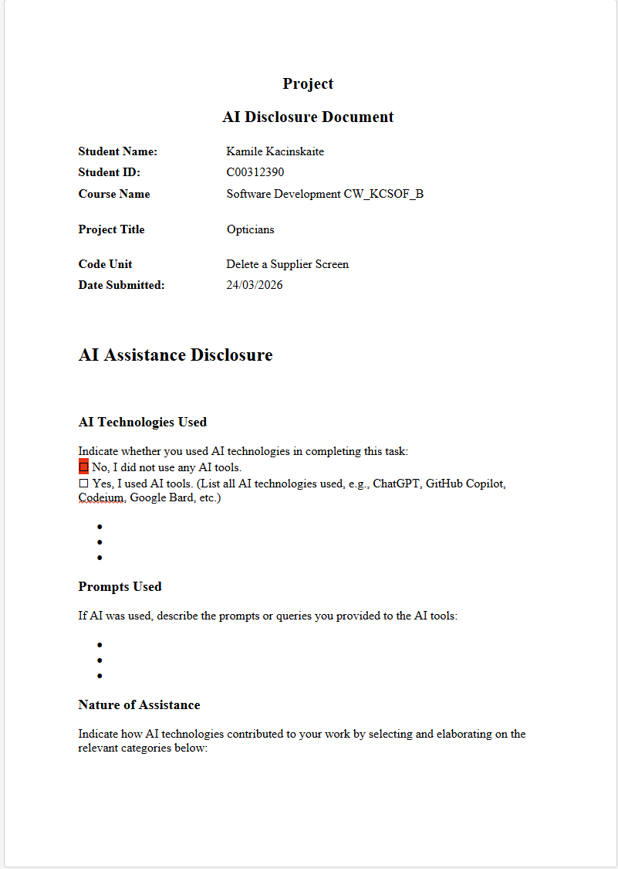

Delete A Supplier Screen
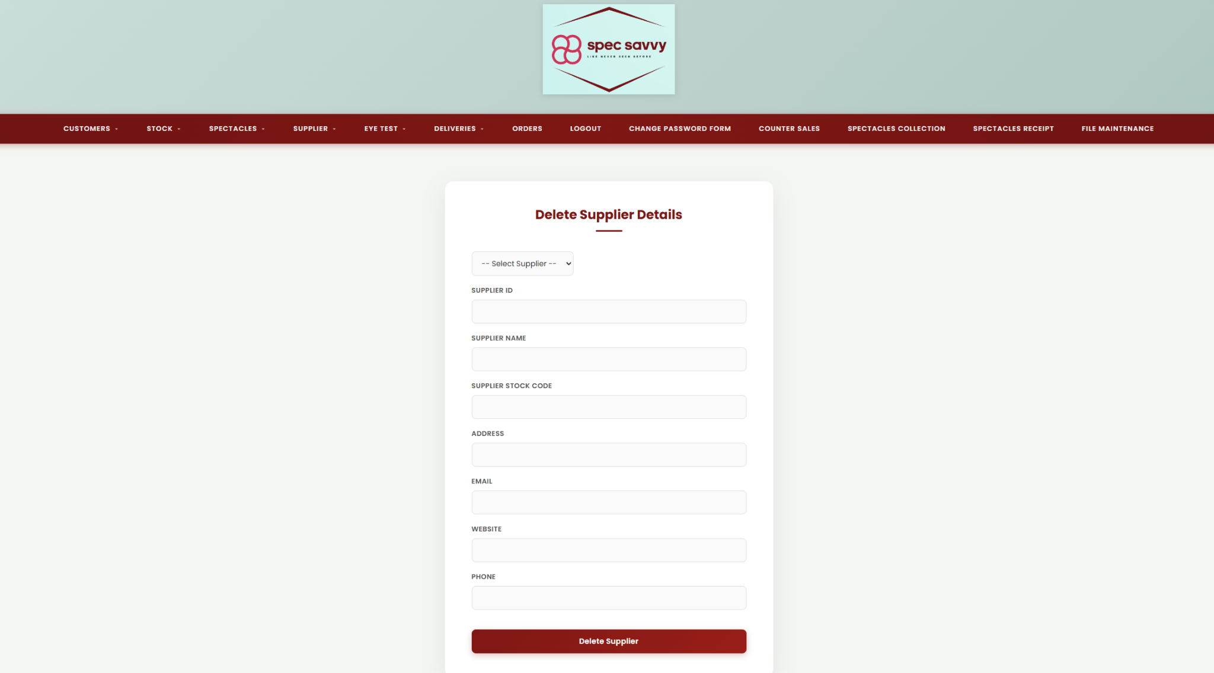
Firstly, the user identifies the appropriate supplier. This is done by selecting a supplier from a dropdown list then all the supplier details get displayed in a form style. Once the correct supplier has been found, the user clicks the delete button, but the system refuses the deletion of any supplier who currently supplies any items of stock. If that situation does not arise then the system performs a simple double check method which is a pop up message asking if the user is sure they want to delete the supplier. Once the user responds positively, the appropriate record is flagged as ‘deleted’ in the Supplier Table and a message is displayed confirming that the deletion has taken place.
DeleteSupplier.html.php

<!-- Kamile Kacinskaite -->
<!-- C00312390 -->
<!-- Delete A Supplier Screen -->
<!-- user identifies the appropriate supplier. Details get displayed and once supplier is found user clicks the delete button and system should refuse to delete any supplier who -->
<!-- currently supplies any stock, assuming this situation should not arise system should double check the deletion, once user responds positively the record is flagged as "deleted"-->
<!-- in the Supplier Table and a message is displayed confirming the decision has taken place.-->
<!-- 16/02/26 -->
<?php session_start(); ?> <!-- start session to store messages for user feedback -->
<!DOCTYPE html>
<html lang="en">
<head>
<meta charset="UTF-8">
<title>Spec Savvy | Delete A Supplier</title> <!-- title -->
<link rel="stylesheet" href="style.css">
<script defer> // function to populate form fields based on selected supplier from listbox
function populate()
{
let listbox = document.getElementById("listbox");
if (!listbox.value) return;
// split data string
let data = listbox.value.split(",");
document.getElementById("SupplierID").value = data[0];
document.getElementById("Supplier_Name").value = data[1];
document.getElementById("Supplier_stock_code").value = data[2];
document.getElementById("Supplier_Address").value = data[3];
document.getElementById("Supplier_Email").value = data[4];
document.getElementById("Supplier_Website").value = data[5];
document.getElementById("Supplier_Phone").value = data[6];
}
// updated confirmation logic matching the lab style but using supplier name
function confirmDelete()
{
let name = document.getElementById("Supplier_Name").value;
if (name === "") // if no supplier is selected prevent submission and alert user
{
alert("Please select a supplier first.");
return false;
}
return confirm("Are you sure you want to delete supplier: " + name + "?"); // confirmation dialog with supplier name for clarity
}
</script>
</head>
<body>
<header class="main-header">
<div class="logo-area">
<img src="spec savvy logo.png" alt="Spec Savvy Logo"> <!-- website logo -->
</div>
</header>
<nav class="navbar"> <!-- navigation bar with dropdown menus for different sections of the website -->
<ul>
<li class="dropdown">
<a href="DeleteSupplier.html.php" class="active">Delete Supplier</a>
<ul class="dropdown-menu">
<li><a href="DeleteSupplier.html.php">Delete Supplier</a></li>
</ul>
</li>
<li class="dropdown"> <!-- dropdown menu for viewing suppliers with options to view all, view/delete, and view amended suppliers -->
<a href="#">View Supplier</a>
<ul class="dropdown-menu">
<li><a href="viewStock.php">All Suppliers</a></li>
<li><a href="viewDeleteStock.php">View / Delete Supplier</a></li>
<li><a href="viewAmendStock.php">Amended Supplier</a></li>
</ul>
</li>
<li class="dropdown"> <!-- dropdown menu for managing suppliers with options to delete and amend suppliers -->
<a href="#">Manage</a>
<ul class="dropdown-menu">
<li><a href="deleteStockItem.php">Delete Supplier</a></li>
<li><a href="viewAmendStock.php">Amended Supplier</a></li>
</ul>
</li>
</ul>
</nav>
<div class="page-container">
<div class="card">
<?php
if (isset($_SESSION["message"])) // if there is a message in the session display it in a styled alert box
{
echo "<div style='background-color: #d4edda; color: #155724; padding: 15px; border-radius: 8px; margin-bottom: 20px; text-align: center; border: 1px solid #c3e6cb;'>";
echo "<strong>Success!</strong> " . $_SESSION["message"];
echo "</div>";
// clear the message
unset($_SESSION["message"]);
}
?>
<h2>Supplier Details</h2>
<?php include 'listbox.php'; ?>
<form action="delete_supplier.php" method="post" onsubmit="return confirmDelete()">
<label for="SupplierID">Supplier ID</label> <!-- hidden field to store the supplier ID for deletion -->
<input type="text" name="supplier_id" id="SupplierID" readonly>
<label for="Supplier_Name">Supplier Name</label> <!-- supplier name field for display and confirmation purposes, not editable -->
<input type="text" name="supplier_name" id="Supplier_Name" readonly>
<label for="Supplier_stock_code">Supplier Stock Code</label> <!-- stock code field for display, not editable -->
<input type="text" id="Supplier_stock_code" readonly>
<label for="Supplier_Address">Address</label> <!-- address field for display, not editable -->
<input type="text" id="Supplier_Address" readonly>
<label for="Supplier_Email">Email</label> <!-- email field for display, not editable -->
<input type="text" id="Supplier_Email" readonly>
<label for="Supplier_Website">Website</label> <!-- website field for display, not editable -->
<input type="text" id="Supplier_Website" readonly>
<label for="Supplier_Phone">Phone</label> <!-- phone field for display, not editable -->
<input type="text" id="Supplier_Phone" readonly>
<div class="button-group">
<input type="submit" value="Delete Supplier">
</div>
</form>
</div>
</div>
</body>
</html>

delete_supplier.php
This file works alongside the DeleteSupplier.html.php file and makes sure it connects to the database table correctly and gathers the correct data and also labels the supplier as deleted if it meets the requirements.

<!-- Kamile Kacinskaite -->
<!-- C00312390 -->
<!-- Delete A Supplier Screen -->
<!-- user identifies the appropriate supplier. Details get displayed and once supplier is found user clicks the delete button and system should refuse to delete any supplier who -->
<!-- currently supplies any stock, assuming this situation should not arise system should double check the deletion, once user responds positively the record is flagged as "deleted"-->
<!-- in the Supplier Table and a message is displayed confirming the decision has taken place.-->
<!-- 16/02/26 -->
<?php
session_start(); // start session to store messages for user feedback
include "success.php"; // database connection
if (isset($_POST['supplier_id']) && !empty($_POST['supplier_id']))
{
$id = $_POST['supplier_id'];
$name = $_POST['supplier_name'];
// check if supplier is linked to any stock items
$checkStock = "SELECT COUNT(*) as total FROM Stock WHERE SupplierID = '$id' AND Deleted = 0";
$result = mysqli_query($con, $checkStock);
$row = mysqli_fetch_assoc($result);
// if supplier is linked to stock show error message and prevent deletion
if ($row['total'] > 0)
{
echo "<script>
alert('Error: This supplier cannot be deleted because they are linked to current stock.');
window.location.href='DeleteSupplier.html.php';
</script>";
}
else
{
// perform the soft delete
$sql = "UPDATE Supplier SET Deleted = 1 WHERE SupplierID = '$id'";
// if update is successful set success message
if (mysqli_query($con, $sql))
{
$_SESSION["message"] = "Supplier '" . $name . "' has been deleted from the system.";
mysqli_close($con);
header("Location: DeleteSupplier.html.php");
exit();
}
else
{
echo "Error updating record: " . mysqli_error($con);
mysqli_close($con);
}
}
}
else
{
header("Location: DeleteSupplier.html.php");
exit();
}
?>

script.js
This file is my JavaScript validation file for my delete screen. When a supplier is selected from the listbox, fetchDetails() sends a request to get_supplier_details.php with the supplier's ID and populates the page fields with the returned data. The other two functions handle clearing those fields when nothing is selected, and showing a confirmation dialog before allowing a delete form submission to proceed.

/* Kamile Kacinskaite */
/* C00312390 */
/* Delete A Supplier Screen */
/* user identifies the appropriate supplier. Details get displayed and once supplier is found user clicks the delete button and system should refuse to delete any supplier who */
/* currently supplies any stock, assuming this situation should not arise system should double check the deletion, once user responds positively the record is flagged as "deleted" */
/* in the Supplier Table and a message is displayed confirming the decision has taken place. */
/*16/02/26 */
// function to fetch supplier details based on the selected supplier ID from the listbox
function fetchDetails(supplierID)
{
if (supplierID == "")
{
clearFields();
return;
}
// call to get details of selected supplier
fetch('get_supplier_details.php?id=' + supplierID)
.then(response => response.json())
.then(data => {
if (data.error)
{
alert("Supplier not found");
}
else
{
// populate the details section with the retrieved supplier details
document.getElementById('SupplierID').innerText = data[0];
document.getElementById('Supplier_Name').innerText = data[1];
document.getElementById('Supplier_stock_code').innerHTML = data[2];
document.getElementById('Supplier_Address').innerText = data[3];
document.getElementById('Supplier_Eircode').innerText = data[4];
document.getElementById('Supplier_Email').innerText = data[5];
document.getElementById('Supplier_Website').innerText = data[6];
document.getElementById('Supplier_Phone').innerText = data[7];
// set the hidden input value to the supplier ID for form submission
document.getElementById('hidden_id').value = data.SupplierID;
}
})
.catch(error => console.error('Error:', error)); // log any errors that occur during the fetch operation
}
// function to confirm deletion of the supplier, it retrieves the supplier name from the details section and includes it in the confirmation message for clarity
function confirmDeletion()
{
const supplierName = document.getElementById('Supplier_Name').innerText;
if (!supplierName)
{
alert("Please select a supplier first.");
return false;
}
// confirmation dialog to confirm deletion of the supplier, it includes the supplier name in the message for clarity
const response = confirm("Are you sure you want to delete this supplier: " + supplierName + " (Y/N)?");
return response; // if user clicks "OK" it returns true and allows the form submission to proceed, if user clicks "Cancel" it returns false and prevents the form submission
}
function clearFields()
{
// clear the details section by setting all fields to empty and clearing the hidden input value
const fields = ['SupplierID', 'Supplier_Name', 'Supplier_Address', 'Supplier_Eircode', 'Supplier_Email', 'Supplier_Website', 'Supplier_Phone'];
fields.forEach(id => document.getElementById(id).innerText = "");
document.getElementById('hidden_id').value = "";
}

listbox.php
This queries the database for all suppliers that haven't been deleted, then builds an HTML dropdown where each option's value contains all that supplier's details joined together with commas, so that when one is selected the JavaScript populate() function can split that string and fill in the form fields without needing a separate database call.

<!-- Kamile Kacinskaite -->
<!-- C00312390 -->
<!-- Delete A Supplier Screen -->
<!-- user identifies the appropriate supplier. Details get displayed and once supplier is found user clicks the delete button and system should refuse to delete any supplier who -->
<!-- currently supplies any stock, assuming this situation should not arise system should double check the deletion, once user responds positively the record is flagged as "deleted"-->
<!-- in the Supplier Table and a message is displayed confirming the decision has taken place.-->
<!-- 16/02/26 -->
<?php
include "success.php"; // database connection
date_default_timezone_set('UTC');
// fetch all non-deleted suppliers to populate the listbox
$sql = "SELECT * FROM Supplier WHERE Deleted= 0"; // fetch all columns
if (!$result = mysqli_query($con, $sql)) // check if query was successful
{
die('Error in querying the database' . mysqli_error($con)); // if not, output error message and terminate script
}
echo "<select name='listbox' id='listbox' onchange='populate()'>";
echo "<option value=''>-- Select Supplier --</option>";
while ($row = mysqli_fetch_array($result)) // loop through each supplier record and create an option element for the listbox
{
// assign each column value to a variable using null coalescing operator to handle any missing columns
$id = $row['SupplierID'];
$name = $row['Supplier_Name'];
$code = $row['Supplier_stock_code'] ?? "";
$address = $row['Supplier_Address'] ?? "";
$email = $row['Supplier_Email'] ?? "";
$web = $row['Supplier_Website'] ?? "";
$phone = $row['Supplier_Phone'] ?? "";
// the commas are preserved even if the variable is ""
$allText = "$id,$name,$code,$address,$email,$web,$phone";
echo "<option value='$allText'>$name</option>";
}
echo "</select>";
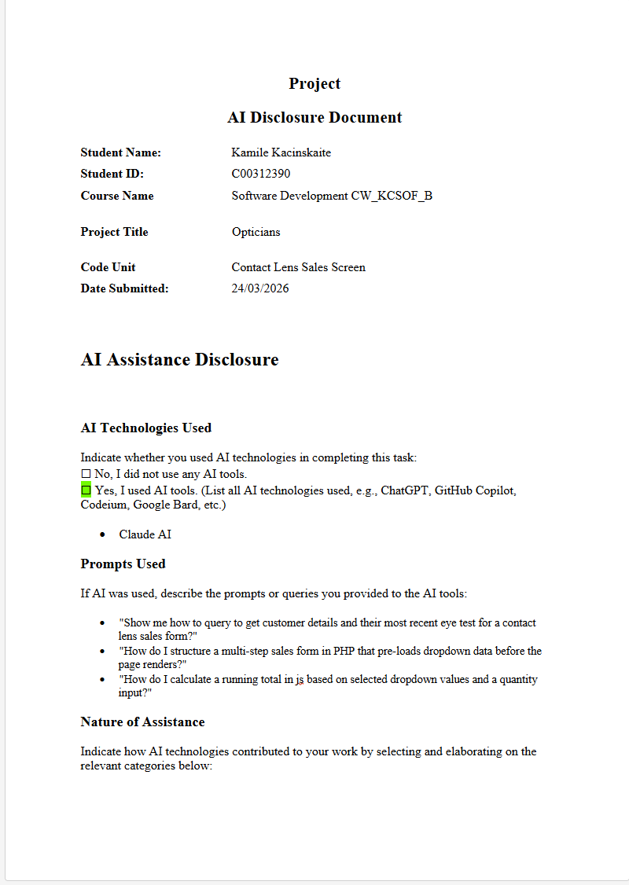

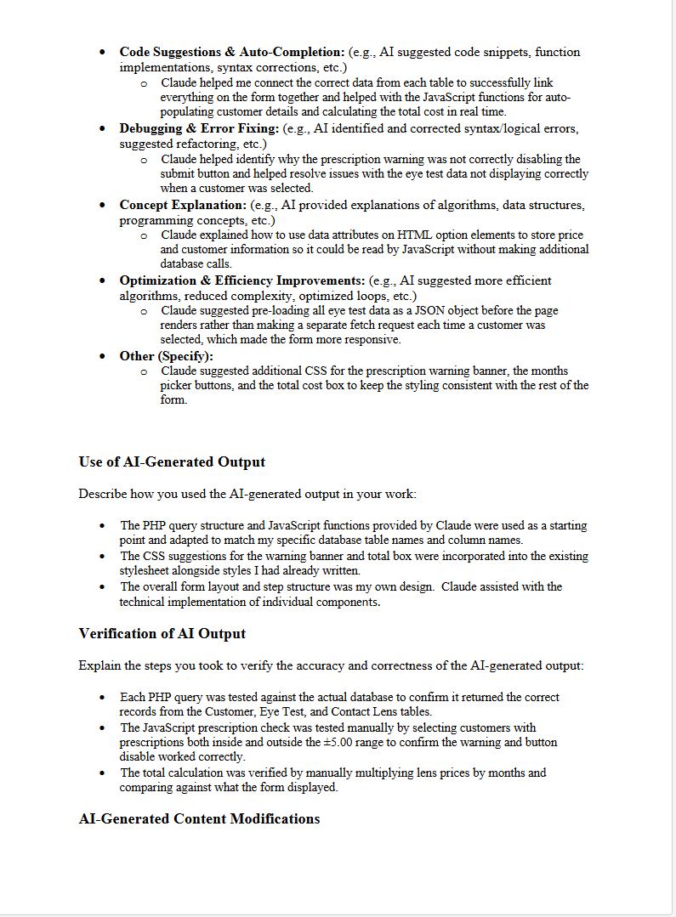

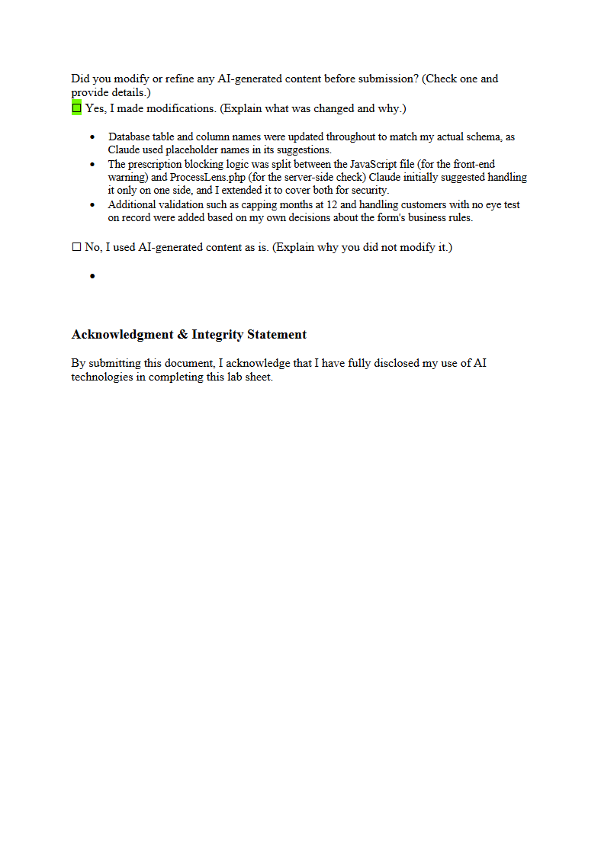

Contact Lens Sales Screen
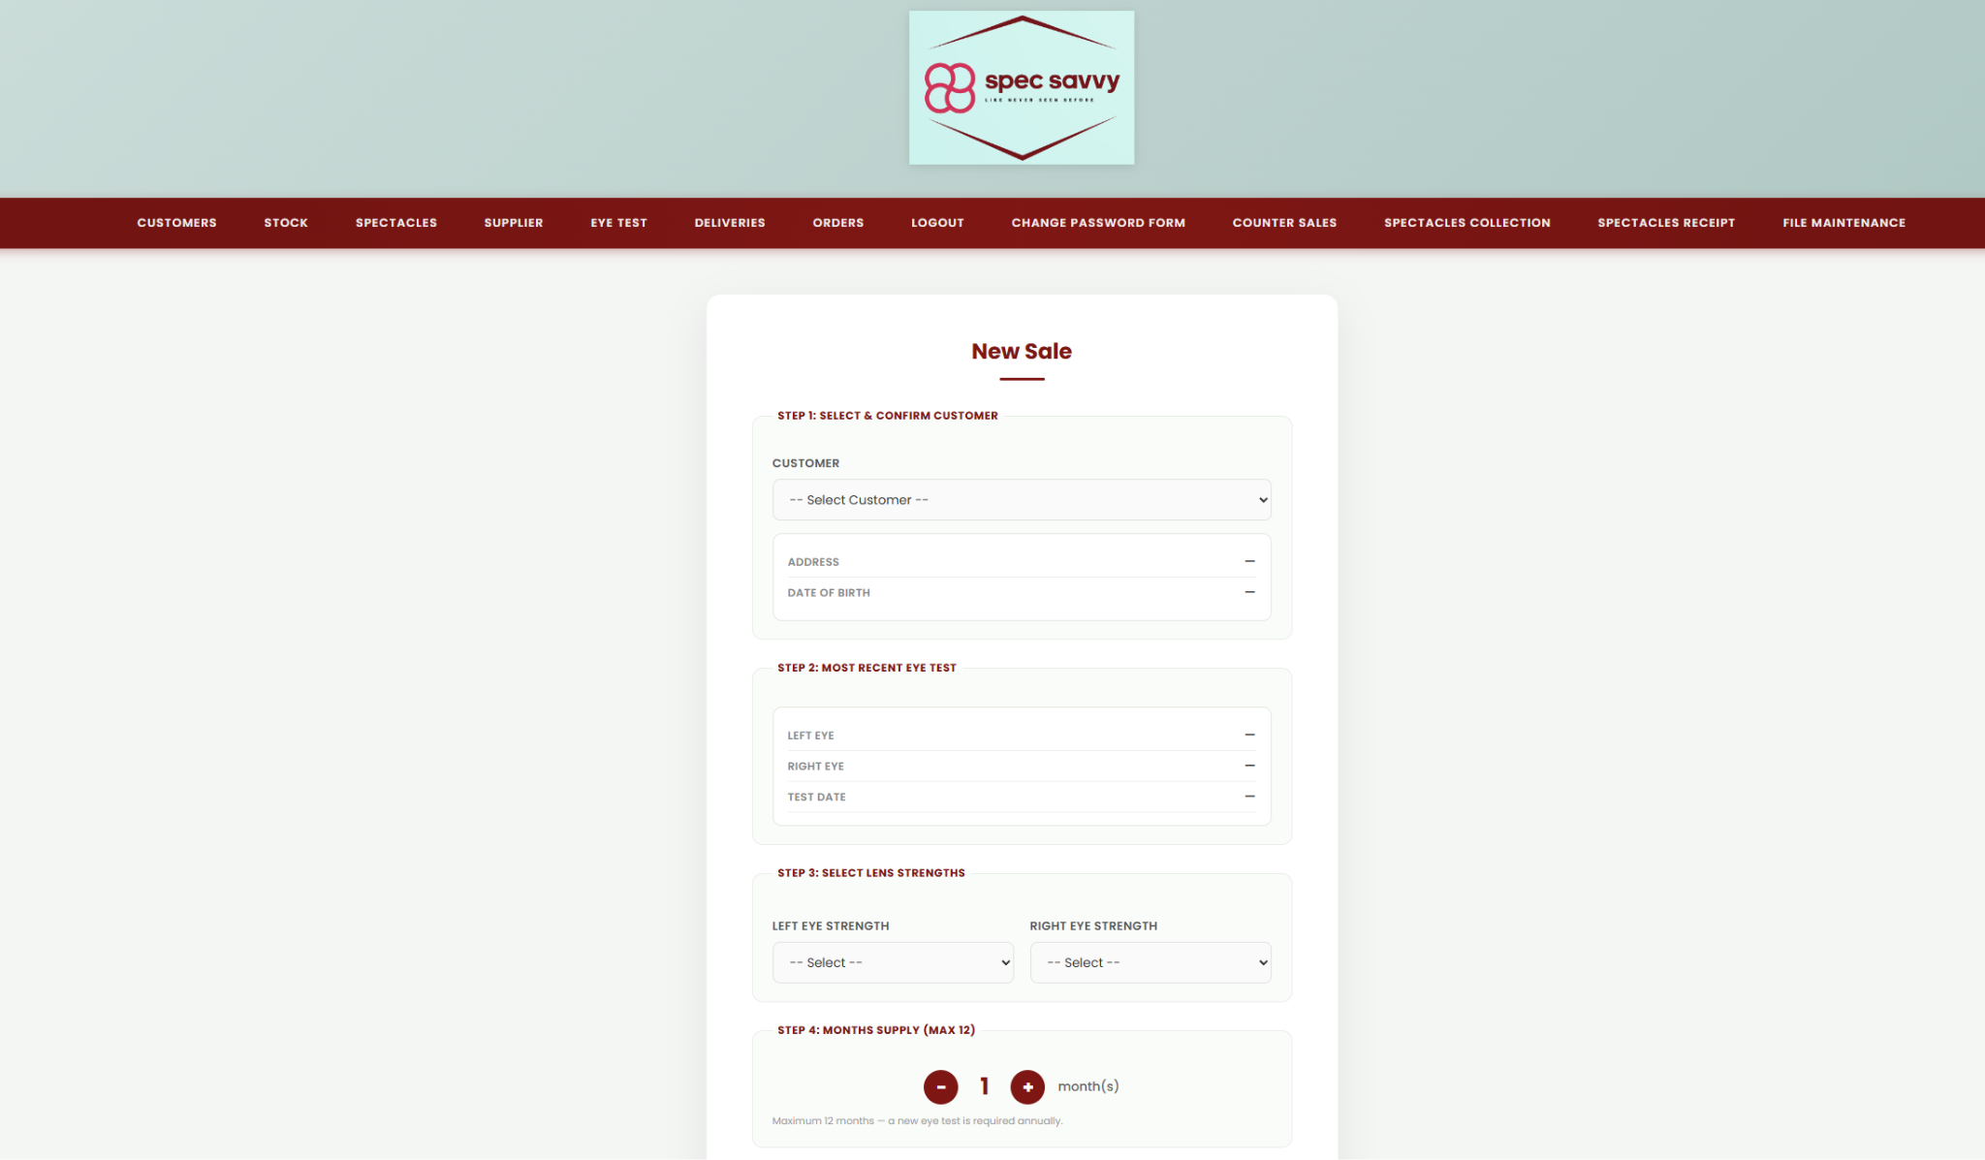
This is a Contact Lens Sales screen where users select a customer (themselves) from a dropdown, which auto-displays their details and most recent eye test. Users then pick left and right lens strengths from a curated Contact Lens table (used instead of the Stock table since Stock held non-lens products), and choose a month's supply up to a maximum of 12. The total cost is calculated automatically, and customers with prescriptions outside the ±5.00 range are blocked from completing the sale. On successful submission, both the Sales and Sales Item tables are updated.

ContactLensSales.html.php
This is a Contact Lens Sales form that does three things on the PHP side: fetches all active customers, fetches the most recent eye test for each customer, and fetches available lens options from the database — all before the page loads. On the HTML side it then presents a 4-step form where the user selects a customer (which auto-fills their details and eye test results via JavaScript), picks left and right lens strengths, chooses how many months supply they want, and sees a running total cost before submitting to ProcessLens.php.

<!-- Kamile Kacinskaite -->
<!-- C00312390 -->
<!-- Project Contact Lens Sales Screen -->
<!-- This form is used when a customer wishes to purchase a supply of disposable contact lenses -->
<!-- 19/02/26 -->
<?php
include 'success.php'; // this file contains the $conn variable for database connection
// selecting the customers using query and storing in array for dropdown
$customers = [];
$custRes = mysqli_query($conn, "SELECT customer_ID, first_name, last_name, dob, address FROM Customer WHERE deleted = 0 ORDER BY first_name");
if ($custRes) {
while ($r = mysqli_fetch_assoc($custRes)) {
$customers[] = $r;
}
}
// eye test selection for each customer with array
$eyeTestData = [];
$etRes = mysqli_query($conn, "SELECT test_ID, left_lens, right_lens, date_of_test, customer_ID, Suitable FROM `Eye Test` WHERE Deleted = 0 ORDER BY date_of_test DESC");
if ($etRes) {
while ($er = mysqli_fetch_assoc($etRes)) {
$cid = $er['customer_ID'];
if (!isset($eyeTestData[$cid])) {
$eyeTestData[$cid] = $er;
}
}
}
// contact lens selection for dropdowns with sql query and storing in array
$lenses = [];
$lensRes = mysqli_query($conn, "SELECT Lens_ID, Lens_Strength, Retail_Price FROM `Contact Lens` ORDER BY Lens_Strength = 0");
if ($lensRes) {
while ($lr = mysqli_fetch_assoc($lensRes)) {
$lenses[] = $lr;
}
}
?>
<!DOCTYPE html>
<html lang="en">
<head>
<meta charset="UTF-8">
<title>Contact Lens Sales - Spec Savvy</title> <!-- page title -->
<link rel="stylesheet" href="style.css">
</head>
<body>
<header class="main-header">
<div class="logo-area">
<img src="spec savvy logo.png" alt="Spec Savvy Logo">
</div>
</header>
<?php require_once 'Includes/nav.php'; // Include navigation bar ?>
<!-- eye test defined before the form so that it can be used in the form -->
<script>
var eyeTests = <?php echo json_encode($eyeTestData); ?>;
</script>
<div class="page-container">
<div class="card">
<h2>New Sale</h2>
<form action="ProcessLens.php" method="POST" id="saleForm">
<!-- selected customer -->
<fieldset class="form-section">
<!-- &amp; is used to display the & symbol in HTML -->
<legend class="section-label">Step 1: Select &amp; Confirm Customer</legend>
<label for="customerSelect">Customer</label>
<select id="customerSelect" name="customer_ID" onchange="loadCustomerDetails()" required>
<option value="">-- Select Customer --</option>
<!-- loop through customers to create dropdown option -->
<?php foreach ($customers as $c): ?>
<!-- using data attributes to store address and dob for display when customer is selected -->
<option value="<?php echo (int)$c['customer_ID']; ?>"
data-address="<?php echo htmlspecialchars($c['address'], ENT_QUOTES, 'UTF-8'); ?>"
data-dob="<?php echo htmlspecialchars($c['dob'], ENT_QUOTES, 'UTF-8'); ?>">
<?php echo htmlspecialchars($c['first_name'] . ' ' . $c['last_name'], ENT_QUOTES, 'UTF-8'); ?>
<!-- showing customer ID in brackets for clarity cast to int for safety -->
(ID: <?php echo (int)$c['customer_ID']; ?>)
</option>
<?php endforeach; ?>
</select>
<!-- display customer details after selection -->
<div class="info-box">
<div class="info-row">
<span class="info-label">Address</span>
<span class="info-value" id="dispAddress">--</span>
</div>
<div class="info-row">
<span class="info-label">Date of Birth</span>
<span class="info-value" id="dispDOB">--</span>
</div>
</div>
</fieldset>
<!-- eye test information -->
<fieldset class="form-section">
<legend class="section-label">Step 2: Most Recent Eye Test</legend>
<div class="info-box">
<div class="info-row">
<span class="info-label">Left Eye</span>
<span class="info-value" id="dispLeft">--</span>
</div>
<div class="info-row">
<span class="info-label">Right Eye</span>
<span class="info-value" id="dispRight">--</span>
</div>
<div class="info-row">
<span class="info-label">Test Date</span>
<span class="info-value" id="dispTestDate">--</span>
</div>
<div class="info-row" id="suitableRow" style="display:none;">
<span class="info-label">Suitable for Lenses</span>
<span class="info-value" id="dispSuitable">--</span>
</div>
</div>
</fieldset>
<!-- lens strength selection -->
<fieldset class="form-section">
<legend class="section-label">Step 3: Select Lens Strengths</legend>
<!-- if no lenses found in database show message instead of dropdowns -->
<?php if (empty($lenses)): ?>
<p style="color:#8B000F;font-size:13px;margin-top:10px;">
No lenses found in Contact Lens table.
</p>
<?php else: ?>
<div class="two-col">
<div>
<!-- loop through lenses to create dropdown options with data-price attribute for use in total calculation -->
<label for="left_eye_id">Left Eye Strength</label>
<select id="left_eye_id" name="left_eye_id" onchange="calculateTotal()" required>
<option value="">-- Select --</option>
<?php foreach ($lenses as $l): ?>
<option value="<?php echo (int)$l['Lens_ID']; ?>"
data-price="<?php echo number_format((float)$l['Retail_Price'], 2, '.', ''); ?>">
<?php echo htmlspecialchars($l['Lens_Strength']); ?>
(€<?php echo number_format((float)$l['Retail_Price'], 2); ?>)
</option>
<?php endforeach; ?>
</select>
</div>
<div>
<!-- loop through lenses to create dropdown options with data-price attribute for use in total calculation -->
<label for="right_eye_id">Right Eye Strength</label>
<select id="right_eye_id" name="right_eye_id" onchange="calculateTotal()" required>
<option value="">-- Select --</option>
<?php foreach ($lenses as $l): ?>
<option value="<?php echo (int)$l['Lens_ID']; ?>"
data-price="<?php echo number_format((float)$l['Retail_Price'], 2, '.', ''); ?>">
<?php echo htmlspecialchars($l['Lens_Strength']); ?>
(€<?php echo number_format((float)$l['Retail_Price'], 2); ?>)
</option>
<?php endforeach; ?>
</select>
</div>
</div>
<?php endif; ?>
</fieldset>
<!-- months supply selection -->
<fieldset class="form-section">
<legend class="section-label">Step 4: Months Supply (max 12)</legend>
<!-- custom month picker with plus and minus buttons -->
<div class="months-picker">
<button type="button" class="month-btn" onclick="changeMonths(-1)">−</button>
<span id="monthsDisplay">1</span>
<button type="button" class="month-btn" onclick="changeMonths(1)">+</button>
<span class="months-label">month(s)</span>
</div>
<input type="hidden" name="months" id="monthsInput" value="1">
<p class="note">Maximum 12 months -- a new eye test is required annually.</p>
</fieldset>
<!-- total calculation -->
<div class="total-box">
<span class="total-label">Total Cost</span>
<span class="total-amount">€<span id="totalDisplay">0.00</span></span>
</div>
<p class="note" style="margin-bottom:20px;">Payment is required immediately. No credit given.</p>
<!-- hidden div for prescription block message -->
<div id="prescriptionWarning" style="
display:none;
background:#fff0f1;
border:1.5px solid #8B000F;
border-radius:10px;
padding:14px 18px;
color:#8B000F;
font-size:13px;
font-weight:600;
margin-bottom:18px;
text-align:center;
"></div>
<!-- submit and reset buttons -->
<div class="button-group">
<input type="submit" value="Complete Sale">
<input type="button" value="Clear Form" onclick="document.getElementById('saleForm').reset(); resetDisplay();">
</div>
</form>
</div>
</div>
<script src="script.js"></script>
</body>
</html>

ProcessLens.php

This is the processing file that runs after the sales form is submitted. It validates the prescription (blocking the sale if either eye is outside ±5.00), then if cleared it inserts a record into the Sales table and two records into the Sales Item table (one for each lens). It then displays one of three outcomes to the user — a success receipt showing the sale details and total cost, a blocked message if the prescription was out of range, or a generic error message if the database insert failed.

<!-- Kamile Kacinskaite -->
<!-- C00312390 -->
<!-- Project Contact Lens Sales Screen -->
<!-- 19/02/26 -->
<?php
include 'success.php';
$customerID = mysqli_real_escape_string($conn, $_POST['customer_ID']);
$leftLensID = mysqli_real_escape_string($conn, $_POST['left_eye_id']);
$rightLensID = mysqli_real_escape_string($conn, $_POST['right_eye_id']);
$months = (int) $_POST['months'];
// not letting months be less than 1 or more than 12 to prevent invalid orders and ensure prescription validity
if ($months < 1) $months = 1;
if ($months > 12) $months = 12;
// prescription check
// fetch the most recent active eye test for this customer
$etCheck = mysqli_query($conn, "SELECT left_lens, right_lens FROM `Eye Test` WHERE customer_ID = '$customerID' AND Deleted = 0 ORDER BY date_of_test DESC LIMIT 1");
$prescriptionBlocked = false;
if ($etCheck && mysqli_num_rows($etCheck) > 0)
{
$etRow = mysqli_fetch_assoc($etCheck);
$leftVal = (float) $etRow['left_lens'];
$rightVal = (float) $etRow['right_lens'];
if ($leftVal < -5 || $leftVal > 5 || $rightVal < -5 || $rightVal > 5)
{
$prescriptionBlocked = true;
}
}
// fetch customer name for the confirmation receipt
$custName = "";
$custRes = mysqli_query($conn, "SELECT first_name, last_name FROM Customer WHERE customer_ID = '$customerID'");
if ($custRes && $row = mysqli_fetch_assoc($custRes)) {
$custName = htmlspecialchars($row['first_name'] . ' ' . $row['last_name']);
}
// fetch lens strengths for the receipt
$leftStrength = "";
$rightStrength = "";
$leftRes = mysqli_query($conn, "SELECT Lens_Strength, Retail_Price FROM `Contact Lens` WHERE Lens_ID = '$leftLensID'");
if ($leftRes && $lr = mysqli_fetch_assoc($leftRes))
{
$leftStrength = $lr['Lens_Strength'];
$leftPrice = (float)$lr['Retail_Price'];
}
$rightRes = mysqli_query($conn, "SELECT Lens_Strength, Retail_Price FROM `Contact Lens` WHERE Lens_ID = '$rightLensID'");
if ($rightRes && $rr = mysqli_fetch_assoc($rightRes))
{
$rightStrength = $rr['Lens_Strength'];
$rightPrice = (float)$rr['Retail_Price'];
}
$totalCost = ($leftPrice + $rightPrice) * $months;
if ($prescriptionBlocked)
{
$success = false;
$blockedReason = "prescription";
}
else
{
// insert sale record and get the new SaleID for the Sales Item records
$sqlSale = "INSERT INTO `Sales` (customer_ID, Sale_Date) VALUES ('$customerID', CURDATE())";
mysqli_query($conn, $sqlSale);
$saleID = mysqli_insert_id($conn);
$success = ($saleID > 0);
if ($success)
{
// each item is represented as an associative array with 'id' and 'qty' keys
$items = [
['id' => $leftLensID, 'qty' => $months],
['id' => $rightLensID, 'qty' => $months],
];
foreach ($items as $item)
{
if (!empty($item['id']))
{
$id = $item['id'];
$qty = $item['qty'];
// column names in Sales Item table are SaleID, StockID, Quantity
mysqli_query($conn, "INSERT INTO `Sales Item` (SaleID, StockID, Quantity) VALUES ('$saleID', '$id', '$qty')");
if (mysqli_error($conn)) { $success = false; }
}
}
}
} // end prescription check
?>
<!DOCTYPE html>
<html lang="en">
<head>
<meta charset="UTF-8">
<title>Sale Result - Spec Savvy</title> <!-- page title -->
<link rel="stylesheet" href="style.css">
</head>
<body>
<header class="main-header">
<div class="logo-area">
<img src="spec savvy logo.png" alt="Spec Savvy Logo">
</div>
</header>
<!-- main content area -->
<div class="page-container">
<div class="card" style="text-align:center;">
<?php if ($success): ?>
<div style="font-size:48px; margin-bottom:8px;">✅</div>
<h2 style="color:#2e7d32; margin-bottom:4px;">Order Confirmed!</h2>
<p style="color:#888; font-size:13px; margin-bottom:24px;">Thank you -- the sale has been recorded successfully.</p>
<!-- receipt card -->
<div style="
background:#f9fafb; border:1px solid #e0e8df;
border-radius:12px; padding:24px 28px;
text-align:left; margin-bottom:24px;
">
<div style="display:flex; justify-content:space-between; align-items:center; margin-bottom:16px; padding-bottom:12px; border-bottom:2px solid #e0e0e0;">
<span style="font-size:13px; font-weight:700; color:#8B000F; text-transform:uppercase; letter-spacing:0.5px;">Order Receipt</span>
<span style="font-size:13px; color:#888;">Sale ID: <strong style="color:#333;">#<?php echo $saleID; ?></strong></span>
</div>
<div style="display:flex; justify-content:space-between; padding:8px 0; border-bottom:1px solid #f0f0f0;">
<span style="font-size:13px; color:#888; font-weight:600; text-transform:uppercase;">Customer</span>
<span style="font-size:14px; color:#333; font-weight:600;"><?php echo $custName; ?></span>
</div>
<div style="display:flex; justify-content:space-between; padding:8px 0; border-bottom:1px solid #f0f0f0;">
<span style="font-size:13px; color:#888; font-weight:600; text-transform:uppercase;">Sale Date</span>
<span style="font-size:14px; color:#333; font-weight:600;"><?php echo date('d M Y'); ?></span>
</div>
<div style="display:flex; justify-content:space-between; padding:8px 0; border-bottom:1px solid #f0f0f0;">
<span style="font-size:13px; color:#888; font-weight:600; text-transform:uppercase;">Left Eye (<?php echo htmlspecialchars($leftStrength); ?>)</span>
<span style="font-size:14px; color:#333; font-weight:600;"><?php echo $months; ?> box(es) -- €<?php echo number_format($leftPrice * $months, 2); ?></span>
</div>
<div style="display:flex; justify-content:space-between; padding:8px 0; border-bottom:1px solid #f0f0f0;">
<span style="font-size:13px; color:#888; font-weight:600; text-transform:uppercase;">Right Eye (<?php echo htmlspecialchars($rightStrength); ?>)</span>
<span style="font-size:14px; color:#333; font-weight:600;"><?php echo $months; ?> box(es) -- €<?php echo number_format($rightPrice * $months, 2); ?></span>
</div>
<div style="display:flex; justify-content:space-between; padding:12px 0 0;">
<span style="font-size:14px; font-weight:700; color:#333; text-transform:uppercase;">Total Paid</span>
<span style="font-size:20px; font-weight:700; color:#8B000F;">€<?php echo number_format($totalCost, 2); ?></span>
</div>
</div>
<!-- back to sales button -->
<?php elseif (isset($blockedReason) && $blockedReason === "prescription"): ?>
<div style="font-size:48px; margin-bottom:16px;"></div>
<h2 style="color:#8B000F;">Sale Blocked</h2>
<p style="color:#555; margin-top:10px;">This customer's prescription is outside the <strong>±5.00</strong> range.<br>Contact lenses cannot be dispensed for prescriptions stronger than this.</p>
<?php else: ?>
<div style="font-size:48px; margin-bottom:16px;"></div>
<h2 style="color:#8B000F;">Something went wrong</h2>
<p style="color:#555;">Please contact your system administrator.</p>
<?php endif; ?>
<div style="margin-top:30px;">
<a href="ContactLensSales.html.php" style="
display:inline-block; padding:12px 28px;
background:linear-gradient(135deg,#8B000F,#a80012);
color:#fff; border-radius:8px; text-decoration:none;
font-weight:600; font-size:14px;
">← Back to Sales</a>
</div>
</div>
</div>
</body>
</html>

script.js

This is the client-side JavaScript that handles all the live interactivity on the sales form. When a customer is selected it immediately displays their address, eye test results, and a suitability message — disabling the submit button with a warning if their prescription is outside ±5.00. It also handles the month's picker (capped at 1–12) and recalculates the total cost in real time whenever the customer, lens strengths, or months are changed.

// Kamile Kacinskaite
// C00312390
// Project Contact Lens Sales Screen
// 19/02/26
var months = 1;
// returns true if prescription strength is within the allowed range (-5 to +5)
function isPrescriptionEligible(strength)
{
var val = parseFloat(strength);
if (isNaN(val)) return false;
return val >= -5 && val <= 5;
}
// shows or hides the prescription warning banner and enables/disables the submit button
function setPrescriptionWarning(show, leftStrength, rightStrength)
{
var warning = document.getElementById("prescriptionWarning");
var submitBtn = document.querySelector("input[type='submit']");
// if show is true display the warning with details about which eye(s) are ineligible otherwise hide it
if (show)
{
// construct the warning message based on which prescription(s) are ineligible
var msg = " This customer is not eligible for contact lenses. ";
if (!isPrescriptionEligible(leftStrength) && !isPrescriptionEligible(rightStrength)) {
msg += "Both eye prescriptions are outside the ±5.00 limit.";
} else if (!isPrescriptionEligible(leftStrength)) {
msg += "Left eye prescription (" + leftStrength + ") is outside the ±5.00 limit.";
} else {
msg += "Right eye prescription (" + rightStrength + ") is outside the ±5.00 limit.";
}
warning.innerText = msg;
warning.style.display = "block";
submitBtn.disabled = true;
submitBtn.style.opacity = "0.45";
submitBtn.style.cursor = "not-allowed";
} else {
warning.style.display = "none";
submitBtn.disabled = false;
submitBtn.style.opacity = "1";
submitBtn.style.cursor = "pointer";
}
}
// loads customer details and eye test results when a customer is selected from the dropdown
function loadCustomerDetails()
{
var select = document.getElementById("customerSelect");
var option = select.options[select.selectedIndex];
if (option.value === "") {
resetDisplay();
return;
}
// customer details
document.getElementById("dispAddress").innerText = option.getAttribute("data-address") || "--";
document.getElementById("dispDOB").innerText = option.getAttribute("data-dob") || "--";
// eye test details
var custID = option.value;
if (eyeTests && eyeTests[custID]) {
var et = eyeTests[custID];
document.getElementById("dispLeft").innerText = et.left_lens;
document.getElementById("dispRight").innerText = et.right_lens;
document.getElementById("dispTestDate").innerText = et.date_of_test;
var suitableRow = document.getElementById("suitableRow");
var suitableSpan = document.getElementById("dispSuitable");
// check if either eye prescription is outside the ±5.00 range and update the suitability message and warning banner accordingly
var leftOk = isPrescriptionEligible(et.left_lens);
var rightOk = isPrescriptionEligible(et.right_lens);
// if either eye is ineligible show the appropriate message and display the warning banner otherwise show the eligible message and hide the warning
if (!leftOk || !rightOk) {
suitableSpan.innerText = " No -- prescription outside ±5.00 range";
suitableRow.style.display = "flex";
setPrescriptionWarning(true, et.left_lens, et.right_lens);
} else {
suitableSpan.innerText = " Yes -- eligible for contact lenses";
suitableRow.style.display = "flex";
setPrescriptionWarning(false);
}
} else {
document.getElementById("dispLeft").innerText = "No eye test on record";
document.getElementById("dispRight").innerText = "No eye test on record";
document.getElementById("dispTestDate").innerText = "--";
document.getElementById("suitableRow").style.display = "none";
setPrescriptionWarning(false);
}
calculateTotal();
}
// increases or decreases the number of months of supply and updates the display and total cost accordingly
function changeMonths(amount)
{
months += amount;
if (months < 1) months = 1;
if (months > 12) months = 12;
document.getElementById("monthsDisplay").innerText = months;
document.getElementById("monthsInput").value = months;
calculateTotal();
}
// calculates the total cost based on the selected lenses and number of months and updates the display
function calculateTotal()
{
var leftSelect = document.getElementById("left_eye_id");
var rightSelect = document.getElementById("right_eye_id");
var leftPrice = parseFloat(leftSelect.options[leftSelect.selectedIndex]?.getAttribute("data-price")) || 0;
var rightPrice = parseFloat(rightSelect.options[rightSelect.selectedIndex]?.getAttribute("data-price")) || 0;
// price per eye is per month supply
var total = (leftPrice + rightPrice) * months;
document.getElementById("totalDisplay").innerText = total.toFixed(2);
}
// resets all displayed customer and eye test details hides the suitability message and warning banner resets the total cost and months of supply to their default values
function resetDisplay()
{
document.getElementById("dispAddress").innerText = "--";
document.getElementById("dispDOB").innerText = "--";
document.getElementById("dispLeft").innerText = "--";
document.getElementById("dispRight").innerText = "--";
document.getElementById("dispTestDate").innerText = "--";
document.getElementById("suitableRow").style.display = "none";
document.getElementById("totalDisplay").innerText = "0.00";
setPrescriptionWarning(false);
months = 1;
document.getElementById("monthsDisplay").innerText = "1";
document.getElementById("monthsInput").value = "1";
}

style.css
This is the same CSS layout throughout everyone's screens but I added some extra elements to shape my Contact Lens Sales screen, everything is the same I just added extra boxes and a month picker therefore I needed extra CSS elements.

/* Kamile Kacinskaite */
/* C00312390 */
/* Project Contact Lens Sales Screen */
/* 19/02/26 */
/* importing the Poppins font from Google Fonts for use throughout the page */
@import url('https://fonts.googleapis.com/css2?family=Poppins:wght@300;400;500;600;700&display=swap');
* {
margin: 0;
padding: 0;
box-sizing: border-box;
font-family: 'Poppins', Arial, sans-serif;
}
body {
background-color: #f4f6f4; /* light off-white background */
color: #333; /* dark gray text */
}
/* header */
.main-header {
background: linear-gradient(135deg, #c8deda 0%, #a8c8c3 100%); /* white and light teal gradient */
padding: 30px 25px;
text-align: center;
box-shadow: 0 2px 10px rgba(0,0,0,0.08); /* subtle shadow for depth */
}
.logo-area img {
max-width: 320px;
max-height: 170px;
filter: drop-shadow(0 2px 6px rgba(0,0,0,0.12)); /* subtle shadow for depth */
transition: transform 0.3s ease; /* smooth scaling on hover */
}
/* slightly enlarge the logo on hover for a subtle interactive effect */
.logo-area img:hover { transform: scale(1.02); }
/* navbar */
.navbar {
background: linear-gradient(90deg, #7a000d 0%, #8B000F 50%, #7a000d 100%); /* deep red gradient */
width: 100%;
display: flex;
justify-content: center;
padding: 0;
box-shadow: 0 3px 12px rgba(139,0,15,0.35); /* stronger red shadow */
}
/* styling the navbar list to be horizontal with no default list styles and spacing between items */
.navbar > ul { list-style: none; display: flex; padding: 0; margin: 0; }
.navbar > ul > li { position: relative; }
/* styling the navbar links with uppercase text spacing and a bottom border that appears on hover or when active */
.navbar > ul > li > a {
display: flex; align-items: center; gap: 6px;
text-decoration: none; color: rgba(255,255,255,0.92);
font-weight: 600; font-size: 13px; text-transform: uppercase;
letter-spacing: 1px; padding: 18px 26px 15px;
border-bottom: 3px solid transparent; transition: all 0.25s ease;
}
.navbar > ul > li > a:hover,
.navbar > ul > li > a.active {
border-bottom: 3px solid #fff; color: #fff; /* white underline and text on hover/active */
background-color: rgba(255,255,255,0.1); /* subtle white background on hover/active */
}
.dropdown-menu {
display: none; position: absolute; top: 100%; left: 0; /* position below the parent menu item */
background: #fff; min-width: 200px; /* white background and minimum width for dropdown */
border-top: 3px solid #8B000F; border-radius: 0 0 10px 10px; /* red top border and rounded bottom corners for dropdown */
box-shadow: 0 8px 24px rgba(0,0,0,0.12); z-index: 999; /* shadow for depth and ensure it appears above other content */
padding: 8px 0; list-style: none; /* remove default list styles and add vertical padding for dropdown items */
}
/* show the dropdown menu when hovering over the parent menu item */
.navbar .dropdown:hover > .dropdown-menu { display: block; }
.dropdown-menu li a {
display: block; color: #444; font-size: 13.5px; font-weight: 500; /* dark grey slightly larger font size for dropdown items */
text-decoration: none; padding: 11px 20px;
border-left: 3px solid transparent; transition: all 0.15s ease; /* transparent left border that will animate on hover for a sliding effect */
}
.dropdown-menu li a:hover {
background: #fdf0f1; border-left: 3px solid #8B000F; /* light pink background and red left border on hover for dropdown items */
color: #8B000F; padding-left: 24px; /* increase left padding on hover for a sliding effect */
}
/* page container */
.page-container {
padding: 50px 20px;
display: flex;
justify-content: center;
}
.card {
background: white; /* white colour */
padding: 45px 50px;
width: 100%;
max-width: 700px;
border-radius: 16px;
box-shadow: 0 15px 45px rgba(0,0,0,0.08); /* soft shadow for depth */
border: 1px solid rgba(0,0,0,0.05); /* subtle border for definition */
}
.card h2 {
margin-bottom: 10px; color: #8B000F; /* deep red colour for the heading */
text-align: center; font-size: 24px; font-weight: 700; /* larger bold font for the heading */
}
.card h2::after {
content: ''; display: block; width: 50px; height: 3px; /* small underline below the heading */
background: #8B000F; border-radius: 2px; margin: 12px auto 30px; /* small red underline below the heading */
}
/* form sections */
form { display: flex; flex-direction: column; }
.form-section {
border: 1px solid #e8eee8; /* light green border for form sections */
border-radius: 12px;
padding: 20px 22px;
margin-bottom: 22px;
background: #fafcfa; /* very light green background for form sections */
}
.section-label {
font-size: 12px; font-weight: 700; color: #8B000F; /* deep red colour for section labels */
text-transform: uppercase; letter-spacing: 0.6px;
padding: 0 6px;
}
label {
margin-top: 14px; font-weight: 600; font-size: 13px;
color: #555; text-transform: uppercase; letter-spacing: 0.4px; /* dark gray colour for labels and uppercase with spacing for clarity */
display: block;
}
input, select {
margin-top: 7px; padding: 11px 14px; border-radius: 8px; /* rounded corners for inputs and selects */
border: 1.5px solid #e0e0e0; font-size: 14px; color: #333; /* dark gray text colour for inputs and selects */
background: #fafafa; transition: all 0.25s ease; width: 100%; /* full width for better usability */
}
input:focus, select:focus {
border-color: #8B000F; outline: none; background: #fff; /* red border and white background on focus for better visibility */
box-shadow: 0 0 0 3px rgba(139,0,15,0.08); /* subtle red shadow on focus for emphasis */
}
/* info box */
.info-box {
margin-top: 14px; background: #fff; /* white background for the info box */
border: 1px solid #e0e8df; border-radius: 10px; /* light green border and rounded corners for the info box */
padding: 14px 16px;
}
.info-row {
display: flex; justify-content: space-between; align-items: center;
padding: 6px 0; border-bottom: 1px solid #f0f0f0; /* light gray border between rows for separation */
}
/* remove the bottom border from the last info row for a cleaner look */
.info-row:last-child { border-bottom: none; }
.info-label {
font-size: 12px; font-weight: 600; color: #888; /* medium gray colour for info labels */
text-transform: uppercase; letter-spacing: 0.4px;
}
/* slightly larger and darker text for info values to differentiate from labels */
.info-value { font-size: 14px; color: #333; font-weight: 500; }
/* two column layout */
.two-col {
display: grid;
grid-template-columns: 1fr 1fr; /* two equal columns */
gap: 18px;
margin-top: 6px;
}
/* month picker*/
.months-picker {
display: flex; align-items: center; gap: 14px;
margin-top: 14px; justify-content: center;
}
.month-btn {
width: 38px; height: 38px; border-radius: 50%;
background: #8B000F; color: white; border: none; /* circular deep red buttons with white text for month adjustment */
font-size: 20px; font-weight: 700; cursor: pointer;
display: flex; align-items: center; justify-content: center;
transition: background 0.2s ease; /* smooth background transition on hover */
line-height: 1; /* ensure the text is vertically centered within the button */
}
/* slightly darken the month adjustment buttons on hover for better interactivity feedback */
.month-btn:hover { background: #6e000c; } /* darker red on hover for month adjustment buttons */
#monthsDisplay {
font-size: 26px; font-weight: 700; color: #8B000F; /* larger bold deep red text for the month display */
min-width: 30px; text-align: center;
}
.months-label { font-size: 14px; color: #666; font-weight: 500; } /* smaller medium gray text for the months label */
/* note */
.note { font-size: 11px; color: #999; margin-top: 10px; } /* small light gray text for notes and disclaimers */
/* total box */
.total-box {
display: flex; justify-content: space-between; align-items: center;
background: linear-gradient(135deg, #8B000F, #a80012);
color: white; padding: 18px 24px; border-radius: 12px; /* red gradient background with white text for the total cost box */
margin-bottom: 14px;
}
/* smaller label text and larger bold text for the total amount to make it stand out */
.total-label { font-size: 14px; font-weight: 600; letter-spacing: 0.4px; }
/* larger bold text for the total amount to make it stand out */
.total-amount { font-size: 24px; font-weight: 700; }
/* buttons*/
.button-group { display: flex; gap: 12px; }
.button-group input {
flex: 1; padding: 12px; border-radius: 8px;
font-size: 14px; font-weight: 600; cursor: pointer;
border: none; transition: all 0.25s ease; letter-spacing: 0.3px;
}
input[type="submit"] {
background: linear-gradient(135deg, #8B000F, #a80012); /* red gradient background for the submit button */
color: white; box-shadow: 0 4px 12px rgba(139,0,15,0.25);/* subtle red shadow for depth on the submit button */
}
input[type="submit"]:hover {
background: linear-gradient(135deg, #6e000c, #8B000F); /* darker red gradient on hover for the submit button */
transform: translateY(-1px);
box-shadow: 0 6px 16px rgba(139,0,15,0.35); /* stronger shadow on hover for the submit button */
}
input[type="button"] {
background: #f0f0f0; color: #555; border: 1.5px solid #ddd; /* light gray background and border for the reset button */
}
input[type="button"]:hover { background: #e5e5e5; color: #333; } /* slightly darker background and darker text on hover for the reset button */

Group name : Spec Savvy
Project name: Opticians
Studentname: Scott Cardiff
Student ID: C00311728
Date: 24/3/26

Scott Cardiff Screens

Add Eye Test Screen

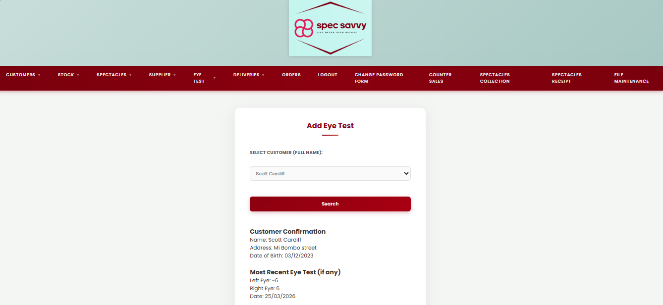

This is the code for the Add screen for adding eye tests. The basic rundown of the functionality is pretty simple by searching an already existing customer within the Customer table to be added up for eye tests. This prints out their details (Name, Address, DOB) and their most recent eye test history. Readings of eye measurements will be taken for both eye and a date of test will be recorded.

add_eye_test.php

<!--Student Name: Scott Cardiff-->
<!--Purpose of Screen: To add a new Eye Test for a customer into the database-->
<!--Student ID: C00311728-->
<!--Name of Screen: Add Eye Test-->
<!--Date: 23/03/2026-->

<link rel="stylesheet" href="style.css">
<?php

include 'db.inc.php';
// Includes the database connection file.
date_default_timezone_set("UTC");

if (!$con) {
die("Connection failed: " . mysqli_connect_error());
// Stops the script if no connection
}

function h($v) {
return htmlspecialchars($v ?? '', ENT_QUOTES, 'UTF-8');
}
// Creates a helper function called h().
// displays text in HTML by converting special characters.
// Selecting customer from listbox only woerks because of this funtion. If not included, customer cannot be selected

$message = "";
// to store a success or status message later
$customer = null;
$latest = null;
// Loading all of the customers in the Customer Table to be viewed in the dropdown menu
// which will load their previous details before an eye test can be submitted
// it will show their most recent eye test history and the date produced

$customers = [];
// Creatign an array to store all customer records for dropdown list

$custListSql = "SELECT customer_ID, first_name, last_name
FROM `Customer`
WHERE deleted = 0
ORDER BY last_name, first_name";
// SQL query
// Only customers where deleted = 0 are shown
// Results are sorted alphabetically

$custListResult = mysqli_query($con, $custListSql);
// Sending the query to the database

if (!$custListResult) {
die("Customer list query failed: " . mysqli_error($con));
// If error present, program stops.
}

while ($row = mysqli_fetch_assoc($custListResult)) {
$customers[] = $row;
}
// Loading the details of the customer if submittion is clicked
// It will either show whether the details from their most recent eye test is in the database or no record found

$selected_customer_ID = $_POST['customer_ID'] ?? '';
// Gets the selected customer from the form
// If nothing was submitted, uses the empty string

if ((isset($_POST['search_customer']) || isset($_POST['add_eye_test'])) && $selected_customer_ID !== '') {
// Runs when the button is clicked and customer selected

$customer_ID = mysqli_real_escape_string($con, $selected_customer_ID);
// This is the customer sql query confrimation showing their full name and adderess and date of birth from the table in db
$customerQuery = "SELECT first_name, last_name, address, dob
FROM `Customer`
WHERE customer_ID = '$customer_ID' AND deleted = 0";

$customerResult = mysqli_query($con, $customerQuery);
// Executes the customer details query
if (!$customerResult) {
die("Customer query failed: " . mysqli_error($con));
}
$customer = mysqli_fetch_assoc($customerResult);
// Fetches the selected customer's row as an associative array.

if ($customer) {
// If a valid customer was found

// Most recent eye test if the customer has any recently and if their deleted = 0 and is still active cusotmer
// Looks in the Eye Test table to see if a histor of an eye test is present
$latestQuery = "SELECT left_lens, right_lens, date_of_test
FROM `Eye Test`
WHERE customer_ID = '$customer_ID' AND Deleted = 0
ORDER BY date_of_test DESC, test_ID DESC
LIMIT 1";

$latestResult = mysqli_query($con, $latestQuery);
// Exxctuting the latest query

if (!$latestResult) {
die("Latest test query failed: " . mysqli_error($con));
}

$latest = mysqli_fetch_assoc($latestResult);
// Stores the latest eye test record in $latest
}
}

// When the submittion is clicked, the new eye test is aadded to the database
if (isset($_POST['add_eye_test'])) {

$customer_ID = mysqli_real_escape_string($con, $_POST['customer_ID']);
$left_lens = mysqli_real_escape_string($con, $_POST['left_lens']);
$right_lens = mysqli_real_escape_string($con, $_POST['right_lens']);
$date_of_test = mysqli_real_escape_string($con, $_POST['date_of_test']);

// confirmation printout of the details that were beofre submitting to the database, name, new eye measurements and date of the test etc
echo "<h3>Confirm Details</h3>";
echo "Customer ID: " . h($customer_ID) . "<br>";
// Displays the customer ID submitted
echo "Left Lens: " . h($left_lens) . "<br>";
echo "Right Lens: " . h($right_lens) . "<br>";
echo "Date of Test: " . h(date("d/m/Y", strtotime($date_of_test))) . "<br><br>";

$sql = "INSERT INTO `Eye Test` (customer_ID, left_lens, right_lens, date_of_test, Deleted)
VALUES ('$customer_ID', '$left_lens', '$right_lens', '$date_of_test', 0)";
// sql INSERT query to add a new record to the Eye Test table.

if (mysqli_query($con, $sql)) {
$message = "Eye test has been added.";
// Saves a success message.
}
else {
// If the INSERT fail
die("Insert failed: " . mysqli_error($con));
}

// Refresh most recent test after inserting a new eye test, so basically replaces their most recent eye test submittion. LIMIT 1 only shows latest result
$latestQuery = "SELECT left_lens, right_lens, date_of_test
FROM `Eye Test`
WHERE customer_ID = '$customer_ID' AND Deleted = 0
ORDER BY date_of_test DESC, test_ID DESC
LIMIT 1";

$latestResult = mysqli_query($con, $latestQuery);
$latest = mysqli_fetch_assoc($latestResult);

}
?>

<!DOCTYPE html>
<html>
<head>
<meta charset="utf-8">
<meta name="viewport" content="width=device-width, initial-scale=1">
<title>Add Eye Test</title>
</head>

<body>
<header class="main-header">
<div class="logo-area">
<!-- Container for the company logo. -->
<img src="SpecSavvyLogo.png" alt="Spec Savvy Logo">
</div>
</header>

<?php require_once 'Includes/nav.php'; ?>
<!-- Includes the navigation menu file once, hence why its require_once. -->
<div class="page-container">
<div class="card">
<!-- Card-style box used to hold content -->
<h2>Add Eye Test</h2>

<form action="add_eye_test.php" method="POST" id="eyeTestForm">
<!-- Form sends data to add_eye_test.php using POST -->
<!-- Customer selection by their fulll name from the Custoemr table -->
<label><b>Select Customer (Full Name):</b></label><br>

<select name="customer_ID" id="customer_ID" required>
<option value="">-- choose customer --</option>
<?php foreach ($customers as $c): ?>
<!-- Loops through every customer loaded from the database. -->

<?php
$id = $c['customer_ID'];
// Stores the current customer's ID.
$fullName = $c['first_name'] . " " . $c['last_name'];
// Creates the customer's full name on the listbox dropdown na dthen further down sets the label
$label = $fullName;
?>

<option value="<?php echo h($id); ?>"
<?php echo ((string)$selected_customer_ID === (string)$id) ? 'selected' : ''; ?>>
<!-- Creates one dropdown option. -->

<?php echo h($label); ?>
<!--Display fukll name of customer -->
</option>
<?php endforeach; ?>
</select>

<br><br>
<input type="submit" value="Search" name="search_customer">
<br><br>

<?php if ($customer): ?>
<h3>Customer Confirmation</h3>

Name: <?php echo h($customer['first_name'] . " " . $customer['last_name']); ?><br>
Address: <?php echo h($customer['address']); ?><br>
Date of Birth: <?php echo h(date("d/m/Y", strtotime($customer['dob']))); ?><br><br>

<h3>Most Recent Eye Test (if any)</h3>

<?php if ($latest): ?>
<!-- If a previous eye test exists... -->

Left Eye: <?php echo h($latest['left_lens']); ?><br>
Right Eye: <?php echo h($latest['right_lens']); ?><br>
Date: <?php echo h(date("d/m/Y", strtotime($latest['date_of_test']))); ?><br><br>

<?php else: ?>
<!-- If no eye test record exists in db -->

No previous eye tests found.<br><br>
<!-- Message shown -->
<?php endif; ?>

<hr>

<input type="text" name="left_lens" id="left_lens" placeholder="Left Lens" required>
<br>
<input type="text" name="right_lens" id="right_lens" placeholder="Right Lens" required>
<br>
<input type="date" name="date_of_test" id="date_of_test"
value="<?php echo date('Y-m-d'); ?>" required>
<br><br>

<div class="button-group">
<input type="submit" value="Submit" name="add_eye_test">
<input type="reset" value="Clear">
</div>

<?php else: ?>
<!-- If no customer has been searched yet -->
<p><i>Select a customer and click Search to view details before adding a new eye test.</i></p>
<?php endif; ?>

</form>
</div>
</div>

<script src="script.js"></script>

</body>
</html>

<?php mysqli_close($con); ?>
<!-- Closes the database connection -->

script.js

//Student Name: Scott Cardiff//
//Purpose of Screen: This si the scripting for the HTML and for validation of correct information//
//Student ID: C00311728//
//Name of Screen: Add Eye Test//
//Date: 24/03/2026//

//
const form = document.getElementById("eyeTestForm"); //form is now stored into the id form the html 'eyeTestForm' and performs code and requirements
const leftLens = document.getElementById("left_lens");
const rightLens = document.getElementById("right_lens");
const dateOfTest = document.getElementById("date_of_test");

form.addEventListener("submit", function (e) { //When the form is submitted, the actual event 'submit', all this requirements is performed when the submit is clicked

const lensPattern = /^[+-]?\d{1,2}(\.\d{1,2})?$/; // [+-]= allows either + or -, ? is optional,
// \d{1,2} = allows up to 2 digits, (\.\d{1,2})? = is the deciaml portion. This pattern was generated by AI to understand
//how the correct pattern can be done.

// This is validating the Left Lens to ensure the patter is correct when putting into db
if (!lensPattern.test(leftLens.value)) { //.value is used to check the actual value inputted in the field is correct, ! is used IF the value is false
alert("Left lens must be a valid number (example: -1.25)");
e.preventDefault() // Stops the form from being submitted
}

// And now validating the Right Lens
if (!lensPattern.test(rightLens.value )) {
alert("Right lens must be a valid number (example: -1.25)");
e.preventDefault()
}

const selectedDate = new Date(dateOfTest.value); //new Date created for inputting the date of the test
const today = new Date();
today.setHours(0,0,0,0);

if (selectedDate < today) {
alert("Date of test must not be in the past.");
e.preventDefault();
}

const clicked = document.activeElement?.name;
if (clicked === "search_customer") return;
});

;

AI DOCUMENTATION FORM NEXT PAGE —-->
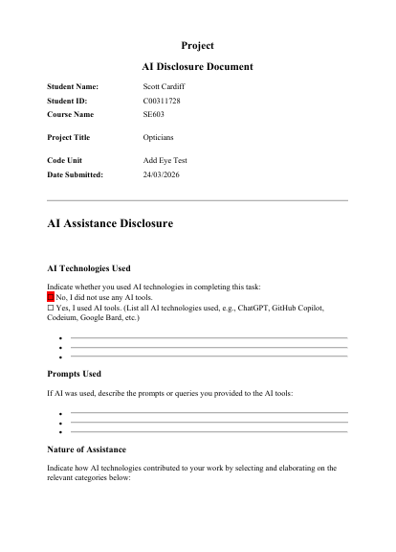
Amend Eye Test Screen

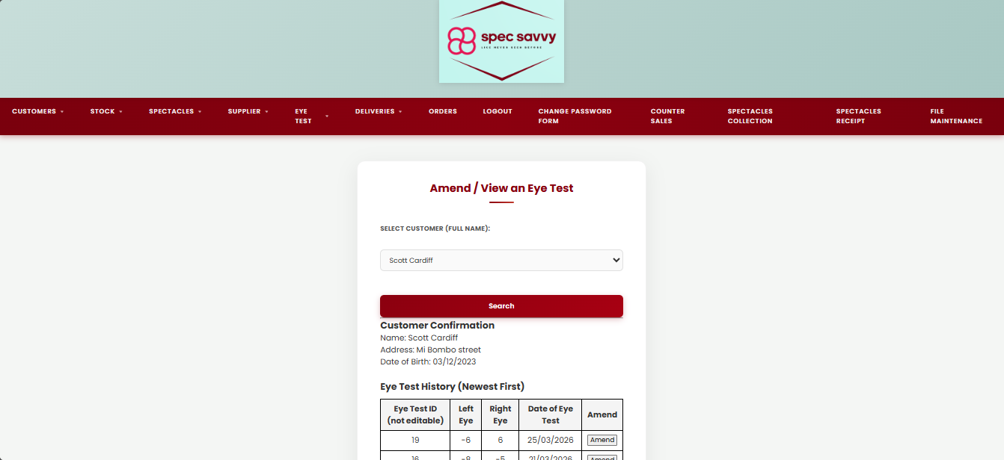

And now, amending the selected customer’s eye test which will have the ability to change eye strength and date, then sent back to the database to update.

amend_eye_test.php

<!--Student Name: Scott Cardiff-->
<!--Purpose of Screen: Amend / View an Eye Test for a customer in the database-->
<!--Student ID: C00311728-->
<!--Name of Screen: Amend / View Eye Test-->
<!--Date: 24/03/2026-->

<link rel="stylesheet" href="style.css">

<?php

include 'db.inc.php';
// Includes the database connection

date_default_timezone_set("UTC");

if (!$con) {
die("Connection failed: " . mysqli_connect_error());
}

function h($v) {
return htmlspecialchars($v ?? '', ENT_QUOTES, 'UTF-8');
}
// Helper function used to safely display values and prevents special characters being treated as HTML.
$message = "";
// Stores success messages
$error = "";
// Stores error messages

//---LOAD CUSTOMERS FOR DROPDOWN---

$customers = [];
$custSql = "SELECT customer_ID, first_name, last_name
FROM `Customer`
WHERE deleted = 0
ORDER BY last_name, first_name";
// sql query to get all active customers from the Customer table.

$custRes = mysqli_query($con, $custSql);
// Executes customer list query.

if (!$custRes) {
die("Customer list query failed: " . mysqli_error($con)); // Error occurred when searching for customer
}

while ($row = mysqli_fetch_assoc($custRes)) {
$customers[] = $row; // Gets each customer row
}

$selected_customer_ID = $_POST['customer_ID'] ?? '';
// These will store the customer + their eye tests after search
$customer = null;
$eye_tests = [];
$edit_test = null;
// Will hold one specific eye test record when the user clicks Amend and it is edited

// ---- SAVE CHANGES ----

if (isset($_POST['save_changes'])) {
// Runs when Save Changes button is clicked

$customer_ID = mysqli_real_escape_string($con, $_POST['customer_ID'] ?? '');
$test_ID = mysqli_real_escape_string($con, $_POST['test_ID'] ?? '');
$left_lens = mysqli_real_escape_string($con, $_POST['left_lens'] ?? '');
$right_lens = mysqli_real_escape_string($con, $_POST['right_lens'] ?? '');
$date_of_test = mysqli_real_escape_string($con, $_POST['date_of_test'] ?? '');

if ($customer_ID === '' || $test_ID === '' || $left_lens === '' || $right_lens === '' || $date_of_test === '') {
$error = "All fields are required to save changes.";
// Checks that none of the required fields are empty, if any are missing, show an error message.
}
else {

// if the eye test record exists
$checkSql = "SELECT test_ID
FROM `Eye Test`
WHERE test_ID = '$test_ID'
AND customer_ID = '$customer_ID'
AND Deleted = 0";

$checkRes = mysqli_query($con, $checkSql);
// Executes the query

if (!$checkRes) {
$error = "Check query failed: " . mysqli_error($con);
// If the check query fails, database error.
}
elseif (mysqli_num_rows($checkRes) == 0) {
$error = "Eye test not found.";
// If it does not match, error.
}
else {
$updateSql = "UPDATE `Eye Test`
SET left_lens = '$left_lens',
right_lens = '$right_lens',
date_of_test = '$date_of_test'
WHERE test_ID = '$test_ID'
AND customer_ID = '$customer_ID'
AND Deleted = 0";

if (mysqli_query($con, $updateSql)) {
$message = "Eye test ID $test_ID has been updated.";
// Updating the message variable
}
else {
$error = "Update failed: " . mysqli_error($con);
}
}
}
}

// -----LOAD SELECTED TEST FOR AMEND FORM ------

if (isset($_POST['amend_eye_test'])) {
// Runs only when the Amend button is clicked
$customer_ID = mysqli_real_escape_string($con, $_POST['customer_ID'] ?? '');
$test_ID = mysqli_real_escape_string($con, $_POST['test_ID'] ?? '');

if ($customer_ID != '' && $test_ID != '') {
// Continues if both IDs are present
$editSql = "SELECT test_ID, left_lens, right_lens, date_of_test
FROM `Eye Test`
WHERE customer_ID = '$customer_ID'
AND test_ID = '$test_ID'
AND deleted = 0
LIMIT 1";

$editRes = mysqli_query($con, $editSql);

if ($editRes) {
$edit_test = mysqli_fetch_assoc($editRes);
}
// If successful, stores that eye test record in $edit_test, filled into amend form
}
}

//------- LOAD CUSTOMER DETAILS AND EYE TEST HISTORY ------------

if (isset($_POST['search_customer']) || isset($_POST['amend_eye_test']) || isset($_POST['save_changes'])) {

if ($selected_customer_ID === '') {
$error = $error ?: "Please select a customer.";
// If no customer was selected, show an error.
// The ?: keeps any earlier error message if one exist
} else {
$customer_ID = mysqli_real_escape_string($con, $selected_customer_ID);

// Customer confirmation details printed to the screen to ensure the customer is correct and the details are correct.
$customerQuery = "SELECT first_name, last_name, address, dob
FROM `Customer`
WHERE customer_ID = '$customer_ID' AND deleted = 0";

$customerResult = mysqli_query($con, $customerQuery);

if (!$customerResult) {
$error = "Customer query failed: " . mysqli_error($con);
}
else {
$customer = mysqli_fetch_assoc($customerResult);
// Fetches the customer row and stores it in $customer variable and all details are eventually shown

if (!$customer) {
$error = $error ?: "Customer not found.";
// If no matching customer exists, error is stored
}
else {

// Load ALL eye tests for this customer (not deleted)
$eyeSql = "SELECT test_ID, left_lens, right_lens, date_of_test
FROM `Eye Test`
WHERE customer_ID = '$customer_ID' AND deleted = 0
ORDER BY date_of_test DESC, test_ID DESC";

$eyeRes = mysqli_query($con, $eyeSql);

if (!$eyeRes) {
$error = "Eye test query failed: " . mysqli_error($con);
}
else {
// This loop gets every eye test row returned from SQL
// and stores it in the $eye_tests array.
// Later we use foreach($eye_tests as $t) to display them in a table.
while ($row = mysqli_fetch_assoc($eyeRes)) {
$eye_tests[] = $row;
}
}
}
}
}
}

mysqli_close($con);
// Closes the db connection

?>

<!DOCTYPE html>

<html>
<head>
<meta charset="utf-8">
<meta name="viewport" content="width=device-width, initial-scale=1">
<title>Amend / View Eye Test</title>
</head>

<body>
<header class="main-header">
<div class="logo-area">
<!-- Container for the logo image. -->
<img src="SpecSavvyLogo.png" alt="Spec Savvy Logo">
</div>
</header>

<?php require_once 'Includes/nav.php'; ?>

<div class="page-container">
<div class="card">
<!-- Card-style box that holds the form and table contents for amending -->
<h2>Amend / View an Eye Test</h2>

<?php if ($message): ?>
<!-- If there is a success message, show it in green. -->
<p style="color:green;">
<b><?php echo h($message); ?></b>
</p>
<?php endif; ?>

<?php if ($error): ?>
<!-- If there is an error message, show it in red. -->
<p style="color:red;">
<b><?php echo h($error); ?></b>
</p>
<?php endif; ?>

<!-- -- ------- SEARCH FORM ------------ -->

<form action="amend_eye_test.php" method="POST" id="searchForm">

<label><b>Select Customer (Full Name):</b></label><br>
<select name="customer_ID" id="customer_ID" required>
<option value="">-- choose customer --</option>

<?php foreach ($customers as $c): ?>
<!-- Loops through the customers array -->

<?php
$id = $c['customer_ID'];
$fullName = $c['first_name'] . " " . $c['last_name'];
?>

<option value="<?php echo h($id); ?>"
<?php echo ((string)$selected_customer_ID === (string)$id) ? 'selected' : ''; ?>>
<!-- Creates one dropdown option and keeps the same customer selected after the form reloads. -->

<?php echo h($fullName); ?>
<!-- Prints full name -->
</option>
<?php endforeach; ?>
</select>

<br><br>
<input type="submit" value="Search" name="search_customer">
<!-- Search button. -->
</form>
<hr>

<!-- -------CUSTOMER DETAILS AND EYE TEST HISTORY -------- -->

<?php if ($customer): ?>
<!-- Only show the customer details and eye test section if a customer was actually found in the db -->

<h3>Customer Confirmation</h3>
Name: <?php echo h($customer['first_name'] . " " . $customer['last_name']); ?><br>
Address: <?php echo h($customer['address']); ?><br>
Date of Birth: <?php echo h(date("d/m/Y", strtotime($customer['dob']))); ?><br><br>

<h3>Eye Test History (Newest First)</h3>

<?php if (count($eye_tests) === 0): ?>
No eye tests found for this customer.<br><br>
<?php else: ?>
<table border="1" cellpadding="8" cellspacing="0">
<!-- Table displaying all eye test records for the selected customer. -->

<tr>
<th>Eye Test ID (not editable)</th>
<th>Left Eye</th>
<th>Right Eye</th>
<th>Date of Eye Test</th>
<th>Amend</th>
</tr>
<!-- Table headings. -->

<?php foreach ($eye_tests as $t): ?>
<!-- Loops through each eye test row in $eye_tests. -->

<tr>
<td><?php echo h($t['test_ID']); ?></td>
<td><?php echo h($t['left_lens']); ?></td>
<td><?php echo h($t['right_lens']); ?></td>
<td><?php echo h(date("d/m/Y", strtotime($t['date_of_test']))); ?></td>
<td>

<form method="POST" action="amend_eye_test.php" style="margin:0;">
<!-- Small form inside the row so the Amend button can actually send this test ID --->

<input type="hidden" name="customer_ID" value="<?php echo h($selected_customer_ID); ?>">
<input type="hidden" name="test_ID" value="<?php echo h($t['test_ID']); ?>">
<button type="submit" name="amend_eye_test">Amend</button>
</form>
</td>
</tr>
<?php endforeach; ?>
</table>
<?php endif; ?>

<!-- -------- AMEND FORM --------- -->
<?php if ($edit_test): ?>

<hr>
<h3>Amend Selected Eye Test</h3>

<form method="POST" action="amend_eye_test.php" id="amendForm">
<input type="hidden" name="customer_ID" value="<?php echo h($selected_customer_ID); ?>">
<input type="hidden" name="test_ID" value="<?php echo h($edit_test['test_ID']); ?>">

<p>
<b>Eye Test ID:</b> <?php echo h($edit_test['test_ID']); ?> (not editable)
</p>

<label>Left Lens Measurement:</label><br>
<input type="text" name="left_lens" id="left_lens"
value="<?php echo h($edit_test['left_lens']); ?>" required>
<br><br>

<label>Right Lens Measurement:</label><br>
<input type="text" name="right_lens" id="right_lens"
value="<?php echo h($edit_test['right_lens']); ?>" required>
<br><br>

<label>Date of Eye Test:</label><br>

<?php
$dateValue = date('Y-m-d', strtotime($edit_test['date_of_test']));
?>

<input type="date" name="date_of_test" id="date_of_test"
value="<?php echo h($dateValue); ?>" required>
<br><br>

<button type="submit" name="save_changes" id="saveBtn">Save Changes</button>
<!-- Save button sends the edited values back to PHP -->
</form>
<?php endif; ?>

<?php endif; ?>

</div>
</div>

<script src="amend_eye_test.js"></script>

</body>
</html>

;

amend_eye_test.js

/* Student Name: Scott Cardiff
// Purpose:
// Student ID: C00311728
// Name of Screen: Amend Eye Test
// Date: 24/03/2026
*/

document.addEventListener("DOMContentLoaded", function () {

const amendForm = document.getElementById("amendForm");
if (!amendForm) return; // not on edit screen

amendForm.addEventListener("submit", function (e) {

const ans = prompt("Are you sure you want to save these changes? (Y/N)");

if (!ans || ans.trim().toUpperCase() !== "Y") {
e.preventDefault();
}
});

});

AI DOCUMENTATION FORM NEXT PAGE —-->
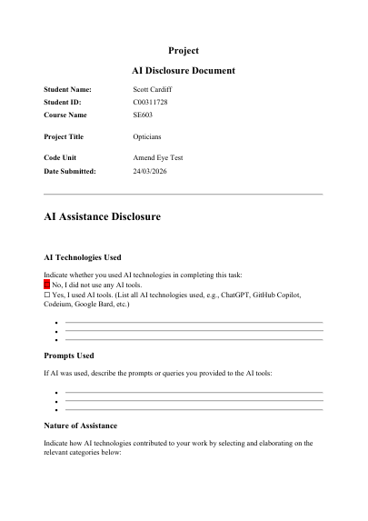
Delete Eye Test Screen

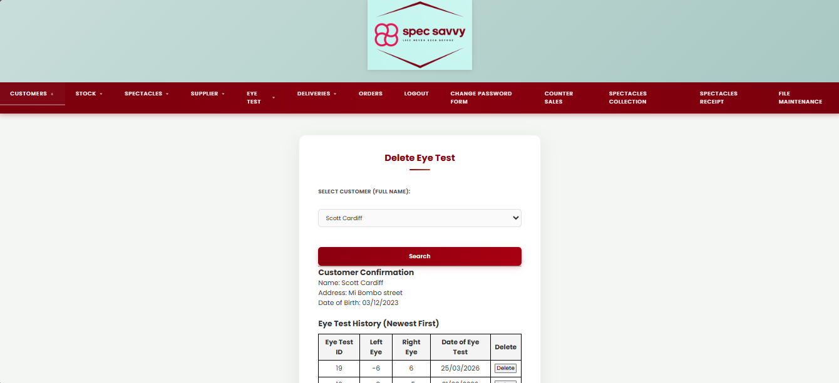

Almost the same thing applies here, a record of a customer’s eye test (upcoming) with the details will be shown on screen with the option to delete from the table altogether.

delete_eye_test.php

<!--Student Name: Scott Cardiff-->
<!--Purpose of Screen: Delete an Eye Test for a customer (HTML+PHP in one file)-->
<!--Student ID: C00311728-->
<!--Name of Screen: Delete Eye Test-->
<!--Date: 24/02/2026-->

<link rel="stylesheet" href="style.css">
<?php
include 'db.inc.php';
date_default_timezone_set("UTC");

if (!$con) {
die("Connection failed: " . mysqli_connect_error());
}

// if any Spectacles row exists for test_ID, do NOT delete
$spectaclesTable = "Spectacles";
$spectaclesTestIdCol = "test_ID";

function h($v) {
return htmlspecialchars($v ?? '', ENT_QUOTES, 'UTF-8');
}

$message = "";
$error = "";

// This is the customer dropdown menu just like from the add eye test menu where it showcases EACH customer in Customer SQL Table
$customers = [];
$custSql = "SELECT customer_ID, first_name, last_name
FROM `Customer`
ORDER BY last_name, first_name AND deleted = 0";

$custRes = mysqli_query($con, $custSql);
if (!$custRes) {
die("Customer list query failed: " . mysqli_error($con));
}
while ($row = mysqli_fetch_assoc($custRes)) {
$customers[] = $row;
}

// When the custoemr is selected then the results show up for what record they have in the database for eye test
$selected_customer_ID = $_POST['customer_ID'] ?? '';
$customer = null;
$eye_tests = [];

// This is the delete section where a custoemr will be flagged for deletion marked as 1 instead of 0
if (isset($_POST['delete_eye_test'])) {

$customer_ID = mysqli_real_escape_string($con, $_POST['customer_ID'] ?? '');
$test_ID = mysqli_real_escape_string($con, $_POST['test_ID'] ?? '');

if ($customer_ID == '' || $test_ID == '') {
$error = "Missing customer or eye test id."; // This is if theres no report of an acrtual customer or an eye test id then the error variable will fill and echo to the screen
}

else {

// So now this time we jump to the spectacles table for the note, if spectacles are on order then the
// eye test cannot be deleted becasue the spectacles are on the way and too late to cancel
$spectaclesCount = 0;

$checkSql = "SELECT COUNT(*) AS cnt
FROM `$spectaclesTable`
WHERE `$spectaclesTestIdCol` = '$test_ID'";

$checkRes = mysqli_query($con, $checkSql);

if (!$checkRes) {
$error = "Could not check Spectacles table. (" . mysqli_error($con) . ")";
}
else {
$row = mysqli_fetch_assoc($checkRes);
$spectaclesCount = (int)($row['cnt'] ?? 0);
}

// If the spectacles exist in the database from the spectacles table then the eye test record cannot be deleted
if ($error == "" && $spectaclesCount > 0) {
$error = "Spectacles are on order for these eye test details. Eye test was NOT deleted.";
}

// This is flagging for deletion
if ($error == "") {
$delSql = "UPDATE `Eye Test`
SET deleted = 1
WHERE test_ID = '$test_ID' AND customer_ID = '$customer_ID'";

if (mysqli_query($con, $delSql)) {
if (mysqli_affected_rows($con) > 0) {
$message = "Deletion complete: eye test ID $test_ID has been flagged for deletion.";
}
else {
$error = "No matching eye test found (or already deleted).";
}
}
else {
$error = "Delete failed: " . mysqli_error($con);
}
}

}
}

// ------ SEARCH / LOAD CUSTOMER -------
if (isset($_POST['search_customer']) || isset($_POST['delete_eye_test'])) {

if ($selected_customer_ID === '') {
$error = $error ?: "Please select a customer.";
} else {
$customer_ID = mysqli_real_escape_string($con, $selected_customer_ID);

// Customer details
$customerQuery = "SELECT first_name, last_name, address, dob
FROM `Customer`
WHERE customer_ID = '$customer_ID'";

$customerResult = mysqli_query($con, $customerQuery);

if (!$customerResult) {
$error = "Customer query failed: " . mysqli_error($con);
}
else {
$customer = mysqli_fetch_assoc($customerResult);

if (!$customer) {
$error = $error ?: "Customer not found.";
}
else {
// Eye test history (reverse chronological), not deleted
$eyeSql = "SELECT test_ID, left_lens, right_lens, date_of_test
FROM `Eye Test`
WHERE customer_ID = '$customer_ID' AND deleted = 0
ORDER BY date_of_test DESC, test_ID DESC";
$eyeRes = mysqli_query($con, $eyeSql);

if (!$eyeRes) {
$error = "Eye test query failed: " . mysqli_error($con);
}
else {
while ($row = mysqli_fetch_assoc($eyeRes)) {
$eye_tests[] = $row;
}
}
}
}
}
}

mysqli_close($con);
?>

<!DOCTYPE html>
<html>
<head>
<meta charset="utf-8">
<meta name="viewport" content="width=device-width, initial-scale=1">
<title>Delete Eye Test</title>

</head>
<body>
<!-- header section that shows the company logo -->
<header class="main-header">
<div class="logo-area">
<!-- logo image for the website -->
<img src="SpecSavvyLogo.png" alt="Spec Savvy Logo">
</div>
</header>

<?php require_once 'Includes/nav.php'; ?>

<div class="page-container">
<div class="card"> <!-- card style box for the form -->
<h2>Delete Eye Test</h2>

<?php if ($message): ?>
<p style="color:green;"><b><?php echo h($message); ?></b></p>
<?php endif; ?>

<?php if ($error): ?>
<p style="color:red;"><b><?php echo h($error); ?></b></p>
<?php endif; ?>

<!-- SEARCH FORM ) -->
<form action="delete_eye_test.php" method="POST" id="searchForm">
<label><b>Select Customer (Full Name):</b></label><br>

<select name="customer_ID" id="customer_ID" required>
<option value="">-- choose customer --</option>
<?php foreach ($customers as $c): ?>
<?php
$id = $c['customer_ID'];
$fullName = $c['first_name'] . " " . $c['last_name'];
?>

<option value="<?php echo h($id); ?>"
<?php echo ((string)$selected_customer_ID === (string)$id) ? 'selected' : ''; ?>>
<?php echo h($fullName); ?>
</option>
<?php endforeach; ?>
</select>

<br><br>
<input type="submit" value="Search" name="search_customer">
</form>

<hr>

<?php if ($customer): ?>
<h3>Customer Confirmation</h3>
Name: <?php echo h($customer['first_name'] . " " . $customer['last_name']); ?><br>

Address: <?php echo h($customer['address']); ?><br>

Date of Birth: <?php echo h(date("d/m/Y", strtotime($customer['dob']))); ?><br><br>

<h3>Eye Test History (Newest First)</h3>

<?php if (count($eye_tests) === 0): ?>
No eye tests found for this customer.<br><br>
<?php else: ?>
<table border="1" cellpadding="8" cellspacing="0">
<tr>
<th>Eye Test ID</th>
<th>Left Eye</th>
<th>Right Eye</th>
<th>Date of Eye Test</th>
<th>Delete</th>
</tr>

<?php foreach ($eye_tests as $t): ?>
<tr>
<td><?php echo h($t['test_ID']); ?></td>
<td><?php echo h($t['left_lens']); ?></td>
<td><?php echo h($t['right_lens']); ?></td>
<td><?php echo h(date("d/m/Y", strtotime($t['date_of_test']))); ?></td>
<td>
<!-- DELETE FORM (separate, no nesting) -->
<form method="POST" action="delete_eye_test.php" class="deleteForm" style="margin:0;">
<input type="hidden" name="customer_ID" value="<?php echo h($selected_customer_ID); ?>">
<input type="hidden" name="test_ID" value="<?php echo h($t['test_ID']); ?>">
<button type="submit" name="delete_eye_test">Delete</button>
</form>
</td>
</tr>
<?php endforeach; ?>
</table>
<?php endif; ?>
<?php endif; ?>
</div>
</div>

<script src="delete_eye_test.js"></script>
</body>
</html>

delete_eye_test.js

// Student Name: Scott Cardiff //
// Purpose: Double-check before deleting an eye test (Y/N)
// Student ID: C00311728
// Name of Screen: Delete Eye Test
// Date: 24/03/2026

document.addEventListener("DOMContentLoaded", function () {

document.querySelectorAll(".deleteForm").forEach(form => { //looks for deleteForm in php and loops for each one submitted

form.addEventListener("submit", function (e) {

const testId = form.querySelector('input[name="test_ID"]').value; //Thus finds the specific input field name and stores the value

const ans = prompt(`Are you sure you want to delete this eye test (ID: ${testId}) ? (Y/N)`);

if (!ans || ans.trim().toUpperCase() !== "Y") {
e.preventDefault(); // stop delete
}
});

});

});

AI DOCUMENTATION FORM NEXT PAGE —-->
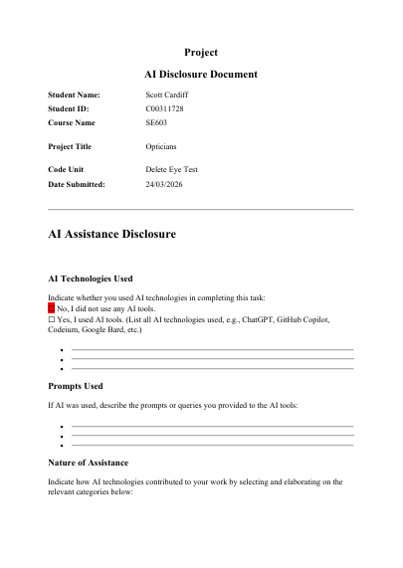

Deliveries Screen

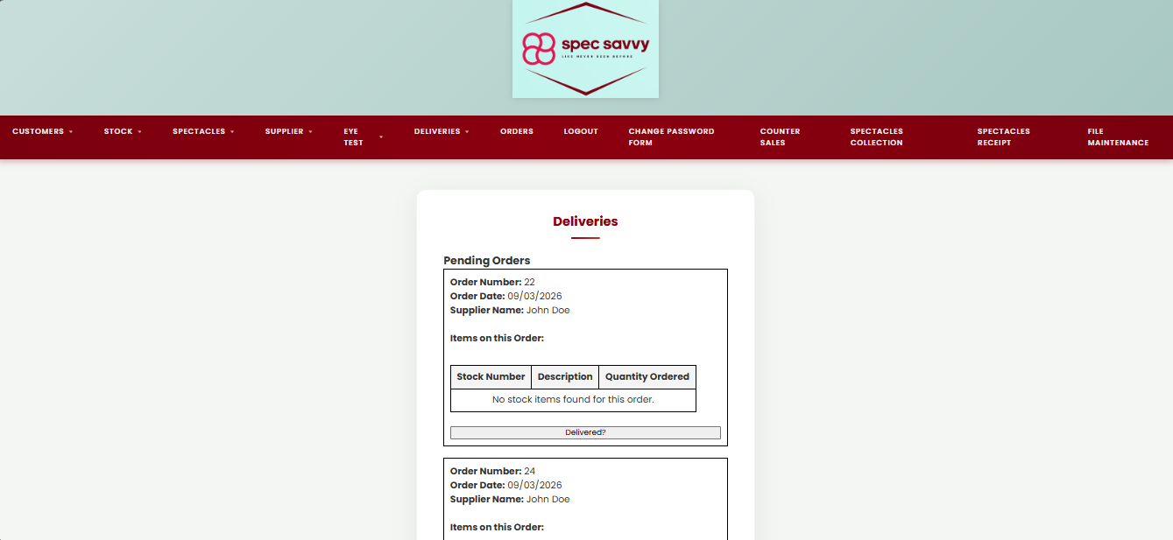

Now we have a totally different screen in terms of the Eye Test pages, a delivery table, This will store information from across multiple tables in the database. For example, we have the Order itself, the supplier and the specific Order Items. User given the option of clicking Delivered? To say that the delivery has arrived and will be soft deleted from the database.

deliveries.php

<link rel="stylesheet" href="style.css">
<?php
include 'db.inc.php';

$message = "";
$error = "";
//This basically checks if the button Delivered? was clicked
if (isset($_POST['mark_delivered'])) {
$order_id = $_POST['order_id'];

// So now this is a query to get all items belonging to this order
// And then we further need a Stock_ID and Qty_ordered so stock levels can be updated in the process
$itemRes = mysqli_query($con, "SELECT Stock_ID, Qty_ordered
FROM `OrderItem`
WHERE Order_ID = '$order_id'");

if (!$itemRes) {
$error = "Could not load order items: " . mysqli_error($con);
}
else {
// Loop through each item in the order
while ($item = mysqli_fetch_assoc($itemRes)) {
$stock_id = $item['Stock_ID'];
$qty = $item['Qty_ordered'];

mysqli_query($con, "UPDATE `Stock`
SET Qty_in_stock = Qty_in_stock + '$qty'
WHERE Stock_id = '$stock_id'");
}
// After updating stock, we suddenly mark the order as Delivered in the db
if (mysqli_query($con, "UPDATE `Orders`
SET order_status = 'Delivered'
WHERE order_id = '$order_id'")) {
$message = "Order ID $order_id has been marked as delivered.";
}
else {
$error = "Could not update order: " . mysqli_error($con);
}
}
}
// Most definitely needed AI assistance on this prompt which i will declare, but this searches ordered that are srill pending
$orderRes = mysqli_query($con, "SELECT o.order_id, o.order_date, s.Supplier_Name
FROM `Orders` o
LEFT JOIN `Supplier` s ON o.SupplierID = s.SupplierID
WHERE o.order_status = 'Pending'
ORDER BY o.order_date ASC, o.order_id ASC");

if (!$orderRes) {
die("Pending orders query failed: " . mysqli_error($con));
}
?>

<!DOCTYPE html>
<html>
<head>
<meta charset="utf-8">
<title>Deliveries</title>
</head>
<body>

<header class="main-header">
<div class="logo-area">
<img src="SpecSavvyLogo.png" alt="Spec Savvy Logo">
</div>
</header>

<?php require_once 'Includes/nav.php'; ?>

<div class="page-container">
<div class="card">

<h2>Deliveries</h2>

<?php if ($message) echo "<p style='color:green;'><b>$message</b></p>"; ?>
<?php if ($error) echo "<p style='color:red;'><b>$error</b></p>"; ?>

<h3>Pending Orders</h3>

<?php if (mysqli_num_rows($orderRes) == 0): ?>
<p>No pending orders found.</p>
<?php else: ?>
<!-- Loop through each pending order -->
<?php while ($order = mysqli_fetch_assoc($orderRes)): ?>
<div style="border:1px solid black; padding:10px; margin-bottom:20px;">

<b>Order Number:</b> <?php echo $order['order_id']; ?><br>
<b>Order Date:</b> <?php echo date("d/m/Y", strtotime($order['order_date'])); ?><br>
<b>Supplier Name:</b> <?php echo $order['Supplier_Name'] ? $order['Supplier_Name'] : 'Unknown Supplier'; ?><br><br>

<b>Items on this Order:</b><br><br>

<table border="1" cellpadding="8" cellspacing="0">
<tr>
<th>Stock Number</th>
<th>Description</th>
<th>Quantity Ordered</th>
</tr>

<?php
// Yet again, had to use ai for this but these are table aliases that shorten the table name and what variable youre getting from that specific table
$lineRes = mysqli_query($con, "SELECT st.Stock_no, st.Description, oi.Qty_ordered
FROM `OrderItem` oi
INNER JOIN `Stock` st ON oi.Stock_ID = st.Stock_id
WHERE oi.Order_ID = '" . $order['order_id'] . "'");

// And finally to print out to the screen, if the item exists in db, display each one in a table row
if ($lineRes && mysqli_num_rows($lineRes) > 0) {
while ($line = mysqli_fetch_assoc($lineRes)) {
echo "<tr>";
echo "<td>{$line['Stock_no']}</td>";
echo "<td>{$line['Description']}</td>";
echo "<td>{$line['Qty_ordered']}</td>";
echo "</tr>";
}
} else {
echo "<tr><td colspan='3'>No stock items found for this order.</td></tr>";
}
?>
</table>

<br>

<form method="POST" action="deliveries.php" class="deliveredForm">
<input type="hidden" name="order_id" value="<?php echo $order['order_id']; ?>">
<button type="submit" name="mark_delivered">Delivered?</button>
</form>

</div>
<?php endwhile; ?>

<?php endif; ?>

</div>
</div>

<script src="deliveries.js"></script>
</body>
</html>

<?php mysqli_close($con); ?>

deliveries.js

// Student Name: Scott Cardiff //
// Purpose: To double check and cofirm whether the order was delivered for Deliveries
// Student ID: C00311728
// Name of Screen: Deliveries
// Date: 24/03/2026

document.addEventListener("DOMContentLoaded", function () {

document.querySelectorAll(".deliveredForm").forEach(form => {

form.addEventListener("submit", function (e) {

const ans = prompt("Has this order been delivered in full? (Y/N)");

if (!ans || ans.trim().toUpperCase() !== "Y") {
e.preventDefault();
}
});

});

});

AI DOCUMENTATION FORM NEXT PAGE —-->
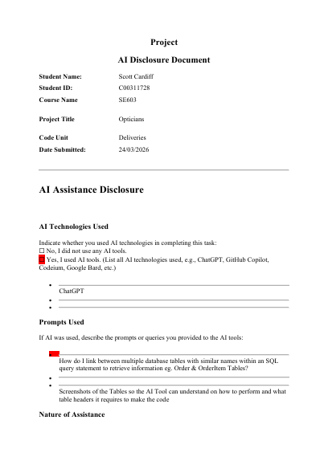
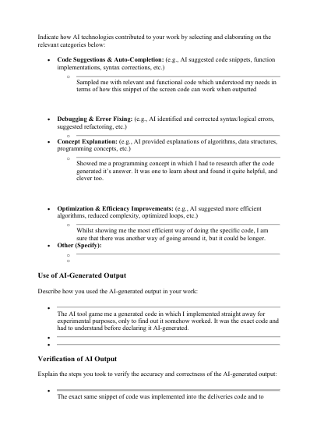
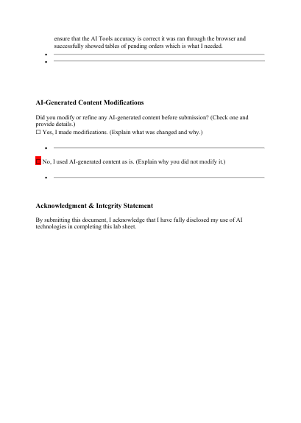

Group name : Spec Savvy
Project name: Opticians
Student name: Lucas Oliveira
Student ID: C00298828
Date: 25/03/26

Lucas Oliveira Screens

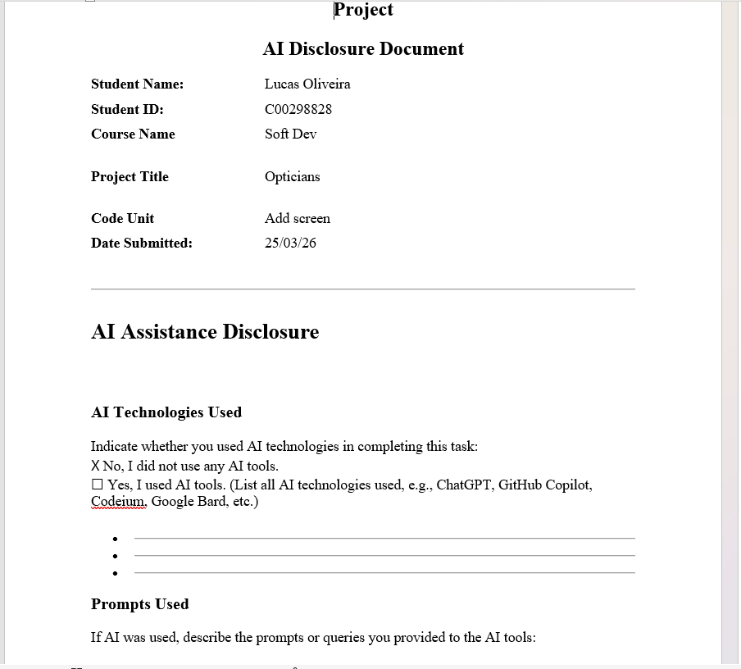

Customer_add.php

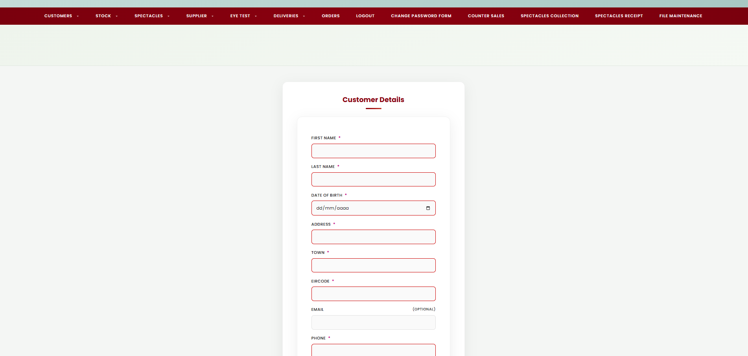

A. Allows the customer to add his details to the main page, triggers a success alert in case of success or in case of missing details/wrong information, and highlights in red what’s wrong for the customer.

<?php
/*
Screen Name: Add Customer
Purpose: Allow users to add a new customer to the database
Student: Lucas Gabriel De Oliveira Lima
Date: March 2026
*/
require_once 'Includes/header.php';
require_once 'Includes/db.inc.php';
require_once 'Includes/nav.php';
$errors = [];
$success = "";
//Fields for user to insert data
$first_name = $last_name = $email = $phone = $eircode = $address = $town = $dob = "";
//Fetch data from table for user input
if($_SERVER["REQUEST_METHOD"]==="POST"){
$first_name = trim($_POST["first_name"] ?? "");
$last_name = trim($_POST["last_name"] ?? "");
$address = trim($_POST["address"] ?? "");
$town = trim($_POST["town"] ?? "");
$eircode = trim($_POST["eircode"] ?? "");
$phone = trim($_POST["phone"] ?? "");
$email = trim($_POST["email"] ?? "");
$dob = trim($_POST["dob"] ?? "");
//Validation for data
if($first_name==="") $errors[] = "First name is required";
if($last_name==="") $errors[] = "Last name is required";
// Only allow letters and spaces in first and last name
if($first_name!=="" && !preg_match('/^[A-Za-z ]+$/', $first_name)){
$errors[] = "First name must contain only letters and spaces";
}
if($last_name!=="" && !preg_match('/^[A-Za-z ]+$/', $last_name)){
$errors[] = "Last name must contain only letters and spaces";
}
if(empty($dob)){
$errors[] = "Date of Birth is required";
}else{
$dob_date=new DateTime($dob);
$today=new DateTime();
if($dob_date>$today){
$errors[]="Date of birth cannot be in the future";
} else{
$age=$dob_date->diff($today)->y;
if($age>120){
$errors[]="Date of birth must be a reasonable date";
}
}
}
if($address==="") $errors[] = "Address is required";
if($town==="") $errors[] = "Town is required";
// Only allow letters and spaces in address and town
if($address!=="" && !preg_match('/^[A-Za-z ]+$/', $address)){
$errors[] = "Address must contain only letters and spaces";
}
if($town!=="" && !preg_match('/^[A-Za-z ]+$/', $town)){
$errors[] = "Town must contain only letters and spaces";
}
if($eircode==="") $errors[] = "Eircode is required";
if($eircode!=="" && !preg_match('/^[A-Za-z0-9 ]{7}$/', $eircode)){
$errors[] = "Eircode must be 7 Characters (letters, digits or space)";
}
if($phone==="") $errors[] = "Phone is required";
if($phone!=="" && !preg_match('/^[0-9]+$/', $phone)){
$errors[] = "Phone number must contain only digits";
}
if($email!=="" && !filter_var($email, FILTER_VALIDATE_EMAIL)){
$errors[] = "Email is not valid";
}
if($email!=="" && !preg_match('/^[A-Za-z0-9._%+-]+@[A-Za-z0-9.-]+\.[A-Za-z]{2,}$/', $email)){
$errors[] = "Email must be in a valid format";
}
//If not error are found Insert data inside database table
if(!$errors){
$sql="INSERT INTO Customer(first_name, last_name, address, town, eircode, phone, email, date_added, dob)
VALUES(?, ?, ?, ?, ?, ?, ?, CURDATE(), ?)";
//prepare to insert, gets data from database
$stmt = mysqli_prepare($con, $sql);
if(!$stmt){
die("Error preparing statement: " . mysqli_error($con));
}
//bind all the parameters together
mysqli_stmt_bind_param($stmt, "ssssssss",
$first_name, $last_name, $address, $town, $eircode, $phone, $email, $dob
);
//execute statement with final data after fetching from table
if(!mysqli_stmt_execute($stmt)){
die("Error executing statement: " . mysqli_stmt_error($stmt));
} else {
$newId = mysqli_insert_id($con); //Fetches Id from table and print a succesful message with add attached to the customer
$success = "Customer added successfully. New Customer ID: " . $newId;
$first_name = $last_name = $email = $phone = $eircode = $address = $town = $dob = "";
}
mysqli_stmt_close($stmt);
}
}
?>
<!-- ================= HERO SECTION ================= -->
<section class="hero">
<h1>Add New Customer</h1>
<p>Create a new customer record</p>
<div class="cta-buttons">
<!-- <a href="/Opticians/Opticians/Eye Test(Scott)/add_eye_test.html" class="button">Book an eye test</a> --->
</div>
</section>
<!-- ================= CONTENT ================= -->
<div class="page-container">
<div class="card">
<h2>Customer Details</h2>
<!--Alert with succesful message if details are added -->
<?php if($success): ?>
<script>alert('<?php echo htmlspecialchars($success); ?>');</script>
<?php endif; ?>
<!--Error if is not added succesfully-->
<?php if($errors): ?>
<div class="error-box">
<ul>
<?php foreach($errors as $error): ?>
<li><?php echo htmlspecialchars($error); ?></li>
<?php endforeach; ?>
</ul>
</div>
<?php endif; ?>
<!--Form to insert data for customer-->
<form method="post" class="card-form"
onsubmit="return confirm('Are you sure you want to add this customer to the database?');">
<label>First name <span class="req">*</span></label>
<input type="text" name="first_name" required value="<?php echo htmlspecialchars($first_name); ?>">
<label>Last name <span class="req">*</span></label>
<input type="text" name="last_name" required value="<?php echo htmlspecialchars($last_name); ?>">
<label>Date Of Birth <span class="req">*</span></label>
<input type="date" name="dob" required value="<?php echo htmlspecialchars($dob); ?>">
<label>Address <span class="req">*</span></label>
<input type="text" name="address" required value="<?php echo htmlspecialchars($address); ?>">
<label>Town <span class="req">*</span></label>
<input type="text" name="town" required value="<?php echo htmlspecialchars($town); ?>">
<label>Eircode <span class="req">*</span></label>
<input type="text" name="eircode" required value="<?php echo htmlspecialchars($eircode); ?>">
<label>Email <span style="float:right; font-size:0.9em; color:#666;">(Optional)</span></label>
<input type="email" name="email" value="<?php echo htmlspecialchars($email); ?>">
<label>Phone <span class="req">*</span></label>
<input type="text" name="phone" required value="<?php echo htmlspecialchars($phone); ?>">
<div class="button-group">
<input type="submit" value="Save">
<input type="reset" value="Clear" onclick="return confirm('Are you sure you want to clear the page? Any entered data will be lost.');">
</div>
</form>
</div>
</div>
<?php require_once 'Includes/footer.php'; ?>

The add screens in the optician system use a clean and consistent layout designed to make data entry simple and clear for the user. The screen begins with a large hero section at the top containing the page title “Add New Customer” and a brief description explaining the purpose of the screen. A call-to-action button is also included in this area to provide quick navigation to a related function.
The screen uses validation to ensure accurate data entry. Required fields must be completed before submission: the date of birth cannot be in the future, the postcode must follow the expected length and format, the phone number must contain digits only, and the email address is checked for valid format if entered. If errors occur, a message is displayed on screen to inform the user of the problem.
The buttons are positioned together at the bottom of the form for clarity and ease of use. The Save button submits the record to the database, while the Clear button allows the user to reset the form. Confirmation messages are used before actions are completed so that the user does not accidentally save or clear data. When a customer is added successfully, the system displays a success message showing the new customer ID.

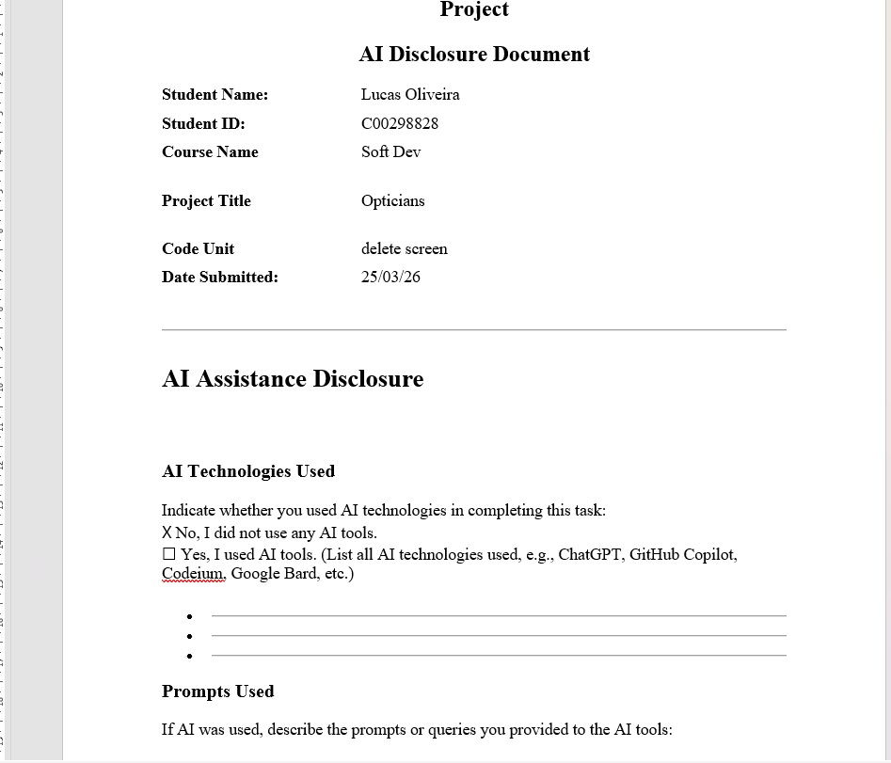

2.Customer_Delete.php

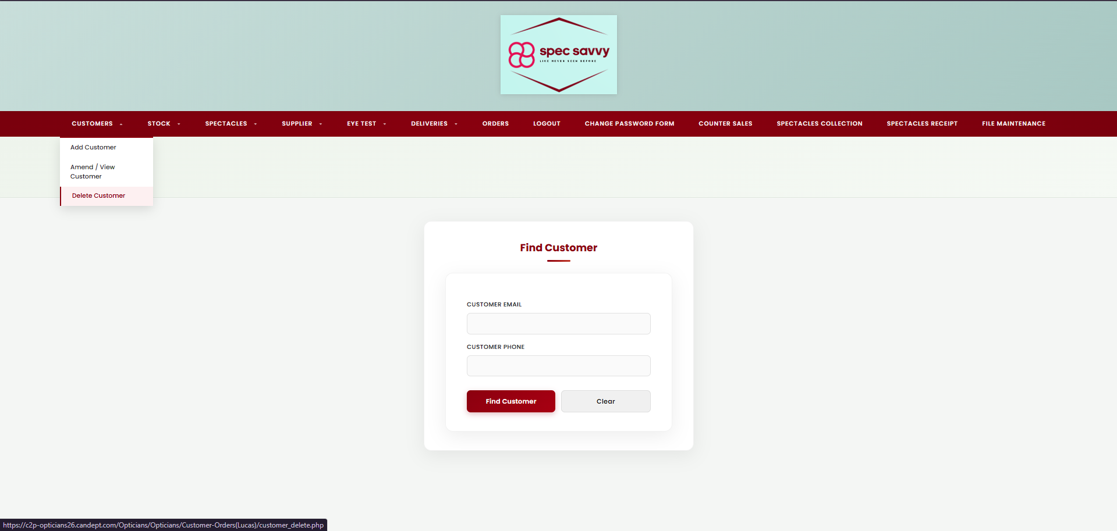
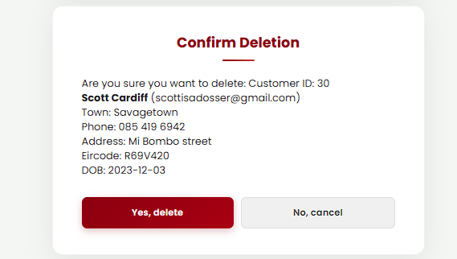

B. The delete customer screen allows the user to search for a customer using either an email address or phone number.
The interface provides a simple form where the user enters the search criteria and submits the request.

Once a matching customer is found, the system displays the customer’s details, including name, address, and contact information.
The user is then asked to confirm the deletion.
A confirmation button is also in the design to prevent the user from accidentally deleting.

<?php
/*
Screen Name: Delete Customer
Purpose: Search for a customer by email or phone, display details, and allow deletion if they have no eye test records
Student: Lucas Gabriel De Oliveira Lima
Date: March 2026
*/
require_once 'Includes/header.php';
require_once 'Includes/db.inc.php';
require_once 'Includes/nav.php';
$errors = [];
$success = "";
// user inputs
$email = "";
$phone = "";
// searched customer
$customer = null;
if($_SERVER["REQUEST_METHOD"] === "POST"){
$email = trim($_POST["email"] ?? "");
$phone = trim($_POST["phone"] ?? "");
$action = $_POST["action"] ?? "search";
// Validate: must provide at least one
if($email === "" && $phone === ""){
$errors[] = "Email or Phone are required";
}
// Validate email if provided
if($email !== "" && !filter_var($email, FILTER_VALIDATE_EMAIL)){
$errors[] = "Email is not valid";
}
// Validate phone if provided (7-15 digits)
if($phone !== "" && !preg_match('/^\d{7,15}$/', $phone)){
$errors[] = "Phone number is not valid (7 to 15 digits).";
}
// Decide which field to use for deletion
$field = "";
$value = "";
if(!$errors){
if($email !== ""){
$field = "email";
$value = $email;
} else {
$field = "phone";
$value = $phone;
}
}
// SEARCH
if(!$errors && $action === "search"){
// Only allow safe columns
$where = ($field === "email") ? "email" : "phone";
$sql = "SELECT customer_id, first_name, last_name, address, dob, town, eircode, phone, email
FROM Customer
WHERE $where = ? AND deleted = 0
LIMIT 1";
$stmt = mysqli_prepare($con, $sql);
mysqli_stmt_bind_param($stmt, "s", $value);
mysqli_stmt_execute($stmt);
$result = mysqli_stmt_get_result($stmt);
$customer = mysqli_fetch_assoc($result);
mysqli_stmt_close($stmt);
if(!$customer){
$errors[] = "No customer found with that " . ($field === "email" ? "email" : "phone");
}
}
// DELETE (SOFT DELETE)
if(!$errors && $action === "delete"){
$where = ($field === "email") ? "email" : "phone";
// Find customer
$sqlFind = "SELECT customer_id FROM Customer WHERE $where = ? AND deleted = 0 LIMIT 1";
$stmt = mysqli_prepare($con, $sqlFind);
mysqli_stmt_bind_param($stmt, "s", $value);
mysqli_stmt_execute($stmt);
$result = mysqli_stmt_get_result($stmt);
$customerRow = mysqli_fetch_assoc($result);
mysqli_stmt_close($stmt);
if(!$customerRow){
$errors[] = "No active customer found.";
} else {
$custId = (int)$customerRow["customer_id"];
// Check if customer has eye tests
$sql = "SELECT 1 FROM `Eye Test` WHERE customer_ID = ? LIMIT 1";
$stmt = mysqli_prepare($con, $sql);
mysqli_stmt_bind_param($stmt, "i", $custId);
mysqli_stmt_execute($stmt);
$result = mysqli_stmt_get_result($stmt);
if(mysqli_fetch_assoc($result)){
$errors[] = "Cannot delete this customer because they have eye test records.";
} else {
// Soft delete
$sql = "UPDATE Customer SET deleted = 1 WHERE customer_id = ?";
$stmt = mysqli_prepare($con, $sql);
mysqli_stmt_bind_param($stmt, "i", $custId);
mysqli_stmt_execute($stmt);
if(mysqli_stmt_affected_rows($stmt) > 0){
$success = "Customer deleted successfully.";
$email = "";
$phone = "";
$customer = null;
} else {
$errors[] = "Customer could not be deleted.";
}
}
mysqli_stmt_close($stmt);
}
}
}
?>
<!-- ================= HERO SECTION ================= -->
<section class="hero">
<h1>Delete Customer</h1>
<p>Search by email or phone, then confirm deletion</p>
<div class="cta-buttons">
<!-- <a href="Home_Page.php" class="button">Back to Home</a> -->
</div>
</section>
<!-- ================= CONTENT ================= -->
<div class="page-container">
<div style="width:100%; max-width:580px; display:flex; flex-direction:column; gap:22px;">
<!-- SEARCH CARD -->
<div class="card">
<h2>Find Customer</h2>
<?php if($success): ?>
<script>alert('<?php echo htmlspecialchars($success); ?>');</script>
<?php endif; ?>
<?php if($errors): ?>
<p class="muted"><?php echo htmlspecialchars(implode(" ", $errors)); ?></p>
<?php endif; ?>
<form class="card-form" method="post">
<label>Customer Email</label>
<input type="text" name="email" value="<?php echo htmlspecialchars($email); ?>">
<label>Customer Phone</label>
<input type="text" name="phone" value="<?php echo htmlspecialchars($phone); ?>">
<input type="hidden" name="action" value="search">
<div class="button-group">
<input type="submit" value="Find Customer">
<input type="reset" value="Clear">
</div>
</form>
</div>
<!-- CONFIRM CARD -->
<?php if($customer): ?>
<div class="card">
<h2>Confirm Deletion</h2>
<p>
Are you sure you want to delete:
Customer ID: <?php echo htmlspecialchars($customer["customer_id"]); ?><br>
<strong><?php echo htmlspecialchars($customer["first_name"] . " " . $customer["last_name"]); ?></strong>
(<?php echo htmlspecialchars($customer["email"]); ?>)
</p>
<p class="muted">
Town: <?php echo htmlspecialchars($customer["town"]); ?><br>
Phone: <?php echo htmlspecialchars($customer["phone"]); ?><br>
Address: <?php echo htmlspecialchars($customer["address"]); ?><br>
Eircode: <?php echo htmlspecialchars($customer["eircode"]); ?><br>
DOB: <?php echo htmlspecialchars($customer["dob"]); ?>
</p>
<form method="post"
onsubmit="return confirm('Are you sure you want to delete this customer from the database?');">
<!-- Keep same search key for deletion -->
<input type="hidden" name="email" value="<?php echo htmlspecialchars($email); ?>">
<input type="hidden" name="phone" value="<?php echo htmlspecialchars($phone); ?>">
<input type="hidden" name="action" value="delete">
<div class="button-group">
<input type="submit" value="Yes, delete">
<a class="btn-cancel" href="customer_delete.php"
style="text-align:center; padding:12px; border-radius:8px; display:block; text-decoration:none;">
No, cancel
</a>
</div>
</form>
</div>
<?php endif; ?>
</div>
</div>
<?php require_once 'Includes/footer.php'; ?>

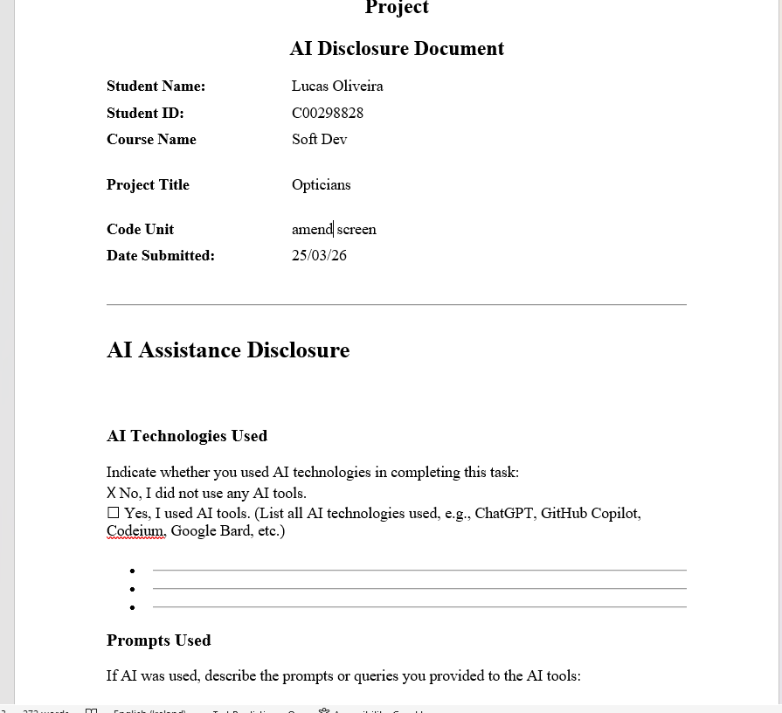

3.Amend/View Screens
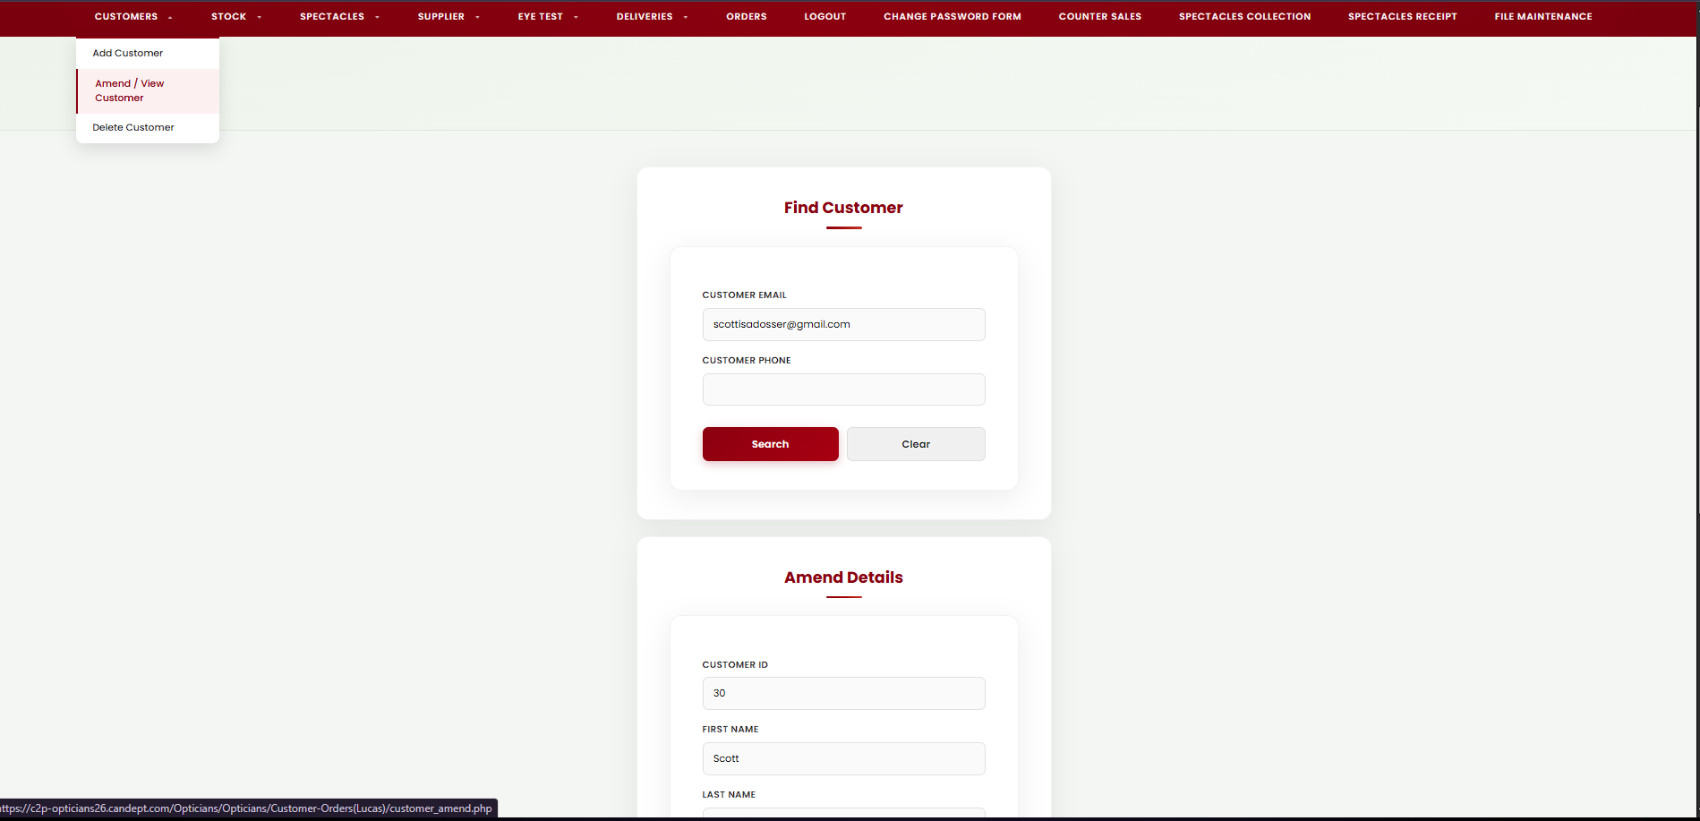
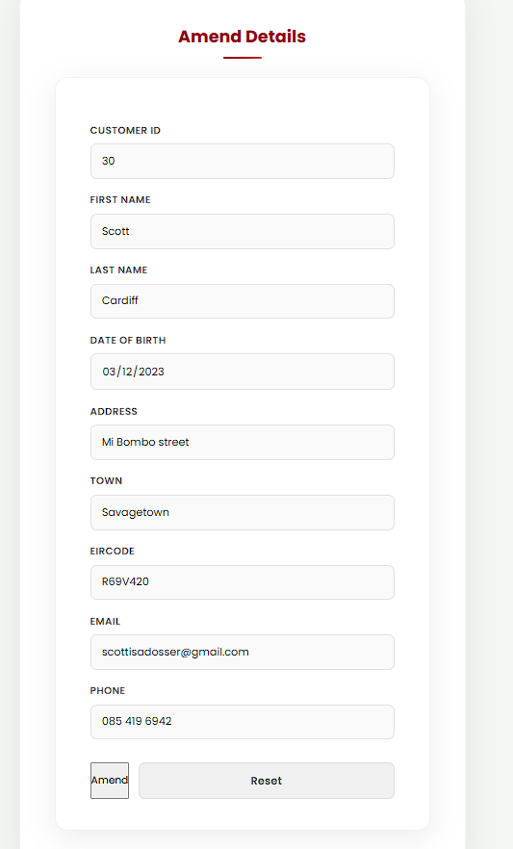

C. The Amend/View screen allows the user to search for a customer using an email or phone number. Once found, the customer’s details are displayed in a structured form. Initially, all fields are locked to prevent accidental changes.
The user must click the “Amend” button to enable editing, after which the fields become editable except for the Customer ID, which remains read-only.
The layout uses a clear card-based design with labeled fields and organized buttons for Amend, Update, and Reset.
Validation is applied to ensure correct input, and a confirmation message is shown before saving any changes to the database.

<?php
require_once 'Includes/header.php';
require_once 'Includes/db.inc.php';
require_once 'Includes/nav.php';
$locked = true; // controls whether inputs are editable
$found = false; // controls whether amend form is shown
$errors = [];
$success = "";
// Editable fields
$customer_id = "";
$first_name = "";
$last_name = "";
$email = "";
$phone = "";
$eircode = "";
$address = "";
$town = "";
$dob = "";
// Search inputs + original lookup key (used for update)
$search_email = "";
$search_phone = "";
$search_field = "";
$search_value = "";
if($_SERVER["REQUEST_METHOD"] === "POST"){
// UPDATE
if(isset($_POST["update"])){
$search_field = $_POST["search_field"] ?? "";
$search_value = trim($_POST["search_value"] ?? "");
$customer_id= trim($_POST["customer_id"] ?? "");
$first_name = trim($_POST["first_name"] ?? "");
$last_name = trim($_POST["last_name"] ?? "");
$address = trim($_POST["address"] ?? "");
$town = trim($_POST["town"] ?? "");
$eircode = trim($_POST["eircode"] ?? "");
$phone = trim($_POST["phone"] ?? "");
$email = trim($_POST["email"] ?? "");
$dob = trim($_POST["dob"] ?? "");
// keep form visible after update, but lock again
$found = true;
$locked = true;
// Validate required fields
if($first_name==="") $errors[]="First name is required";
if($last_name==="") $errors[]="Last name is required";
if($dob==="") $errors[]="Date of Birth is required";
if($address==="") $errors[]="Address is required";
if($town==="") $errors[]="Town is required";
if($eircode==="") $errors[]="Eircode is required";
if($phone==="") $errors[]="Phone is required";
// Validate email if provided
if($email!=="" && !filter_var($email, FILTER_VALIDATE_EMAIL)){
$errors[]="Email is not valid";
}
// Validate phone format if provided
if($phone!=="" && !preg_match('/^\d{7,15}$/', $phone)){
$errors[]="Phone number is not valid (7 to 15 digits).";
}
// Validate search key
if(!in_array($search_field, ["email", "phone"], true) || $search_value===""){
$errors[]="Missing Email or Phone. Please search again.";
}
// Update
if(!$errors){
$where = ($search_field === "email") ? "email" : "phone";
$sql = "UPDATE Customer
SET first_name=?, last_name=?, address=?, town=?, eircode=?, phone=?, email=?, dob=?
WHERE $where = ?
LIMIT 1";
$stmt = mysqli_prepare($con, $sql);
if(!$stmt){
die("Error preparing statement: " . mysqli_error($con));
}
mysqli_stmt_bind_param(
$stmt,
"sssssssss",
$first_name, $last_name, $address, $town, $eircode, $phone, $email, $dob, $search_value
);
mysqli_stmt_execute($stmt);
if(mysqli_stmt_affected_rows($stmt) > 0) {
$success = "Customer updated successfully";
} else {
$errors[] = "No changes were made or customer not found";
}
mysqli_stmt_close($stmt);
}
} else {
// SEARCH
$search_email = trim($_POST["search_email"] ?? "");
$search_phone = trim($_POST["search_phone"] ?? "");
if($search_email==="" && $search_phone===""){
$errors[] = "Email or Phone are required";
}
if($search_email!=="" && !filter_var($search_email, FILTER_VALIDATE_EMAIL)){
$errors[] = "Email is not valid";
}
if($search_phone!=="" && !preg_match('/^\d{7,15}$/', $search_phone)){
$errors[] = "Phone number is not valid (7 to 15 digits).";
}
if(!$errors){
if($search_email!==""){
$search_field = "email";
$search_value = $search_email;
} else {
$search_field = "phone";
$search_value = $search_phone;
}
$where = ($search_field === "email") ? "email" : "phone";
$sql = "SELECT * FROM Customer WHERE $where = ? AND deleted = 0 LIMIT 1";
$stmt = mysqli_prepare($con, $sql);
mysqli_stmt_bind_param($stmt, "s", $search_value);
mysqli_stmt_execute($stmt);
$result = mysqli_stmt_get_result($stmt);
if($customer = mysqli_fetch_assoc($result)){
$customer_id = $customer["customer_ID"] ?? "";
$first_name = $customer["first_name"];
$last_name = $customer["last_name"];
$address = $customer["address"];
$town = $customer["town"];
$eircode = $customer["eircode"];
$phone = $customer["phone"];
$email = $customer["email"];
$dob = $customer["dob"];
$found = true; // SHOW amend form
$locked = true; // but keep fields locked until Amend
} else {
$errors[] = "No customer found with that " . ($search_field==="email" ? "email" : "phone");
}
mysqli_stmt_close($stmt);
}
}
}
?>
<section class="hero">
<h1>Amend Customer</h1>
<p>Search by email or phone, then update customer information</p>
<div class="cta-buttons">
<!-- <a href="Home_Page.php" class="button">Back to Home</a> -->
</div>
</section>
<div class="page-container">
<div style="width:100%; max-width:580px; display:flex; flex-direction:column; gap:22px;">
<div class="card">
<h2>Find Customer</h2>
<?php if($errors): ?>
<script> alert('<?php echo htmlspecialchars(implode(" ", $errors)); ?>');</script>
<?php endif; ?>
<?php if($success): ?>
<script> alert('<?php echo htmlspecialchars($success); ?>');</script>
<?php endif; ?>
<form id="amendForm" method="post" class="card-form">
<label>Customer Email</label>
<input type="text" name="search_email" value="<?php echo htmlspecialchars($search_email); ?>">
<label>Customer Phone</label>
<input type="text" name="search_phone" value="<?php echo htmlspecialchars($search_phone); ?>">
<div class="button-group">
<input type="submit" value="Search">
<input type="reset" value="Clear">
</div>
</form>
</div>
<?php if($found): ?>
<div class="card">
<h2>Amend Details</h2>
<form method="post" class="card-form" id="amendDetailsForm" onsubmit="return confirm('Save changes to this customer?');">
<input type="hidden" name="search_field" value="<?php echo htmlspecialchars($search_field); ?>">
<input type="hidden" name="search_value" value="<?php echo htmlspecialchars($search_value); ?>">
<label>Customer ID</label>
<input type="text" name="customer_id" value="<?php echo htmlspecialchars($customer_id); ?>" readonly>
<label>First name</label>
<input type="text" name="first_name" value="<?php echo htmlspecialchars($first_name); ?>" <?php if($locked) echo "disabled"; ?> required>
<label>Last name</label>
<input type="text" name="last_name" value="<?php echo htmlspecialchars($last_name); ?>" <?php if($locked) echo "disabled"; ?> required>
<label>Date Of Birth</label>
<input type="date" name="dob" value="<?php echo htmlspecialchars($dob); ?>" <?php if($locked) echo "disabled"; ?> required>
<label>Address</label>
<input type="text" name="address" value="<?php echo htmlspecialchars($address); ?>" <?php if($locked) echo "disabled"; ?> required>
<label>Town</label>
<input type="text" name="town" value="<?php echo htmlspecialchars($town); ?>" <?php if($locked) echo "disabled"; ?> required>
<label>Eircode</label>
<input type="text" name="eircode" value="<?php echo htmlspecialchars($eircode); ?>" <?php if($locked) echo "disabled"; ?> required>
<label>Email</label>
<input type="text" name="email" value="<?php echo htmlspecialchars($email); ?>" <?php if($locked) echo "disabled"; ?>>
<label>Phone</label>
<input type="text" name="phone" value="<?php echo htmlspecialchars($phone); ?>" <?php if($locked) echo "disabled"; ?> required>
<div class="button-group">
<button id="btnAmend" type="button" onclick="enableEdit()" <?php if(!$locked) echo 'style="display:none"'; ?>>
Amend
</button>
<input id="btnUpdate" type="submit" name="update" value="Update"
<?php if($locked) echo 'style="display:none"'; ?>>
<input type="reset" onclick="disableEdit()" value="Reset">
</div>
</form>
</div>
<?php endif; ?>
</div>
</div>
<script>
function enableEdit(){
const inputs = document.querySelectorAll("#amendDetailsForm input[type=text], #amendDetailsForm input[type=date]");
inputs.forEach(input => {
if(input.name !== "customer_ID"){
input.disabled = false;
}
});
document.getElementById("btnAmend").style.display = "none";
document.getElementById("btnUpdate").style.display = "inline-block";
}
function disableEdit(){
const inputs = document.querySelectorAll("#amendDetailsForm input[type=text], #amendDetailsForm input[type=date]");
inputs.forEach(input => {
if(input.name !== "customer_ID"){
input.disabled = true;
}
});
document.getElementById("btnUpdate").style.display = "none";
document.getElementById("btnAmend").style.display = "inline-block";
}
</script>
<?php require_once 'Includes/footer.php'; ?>

4.Orders.php
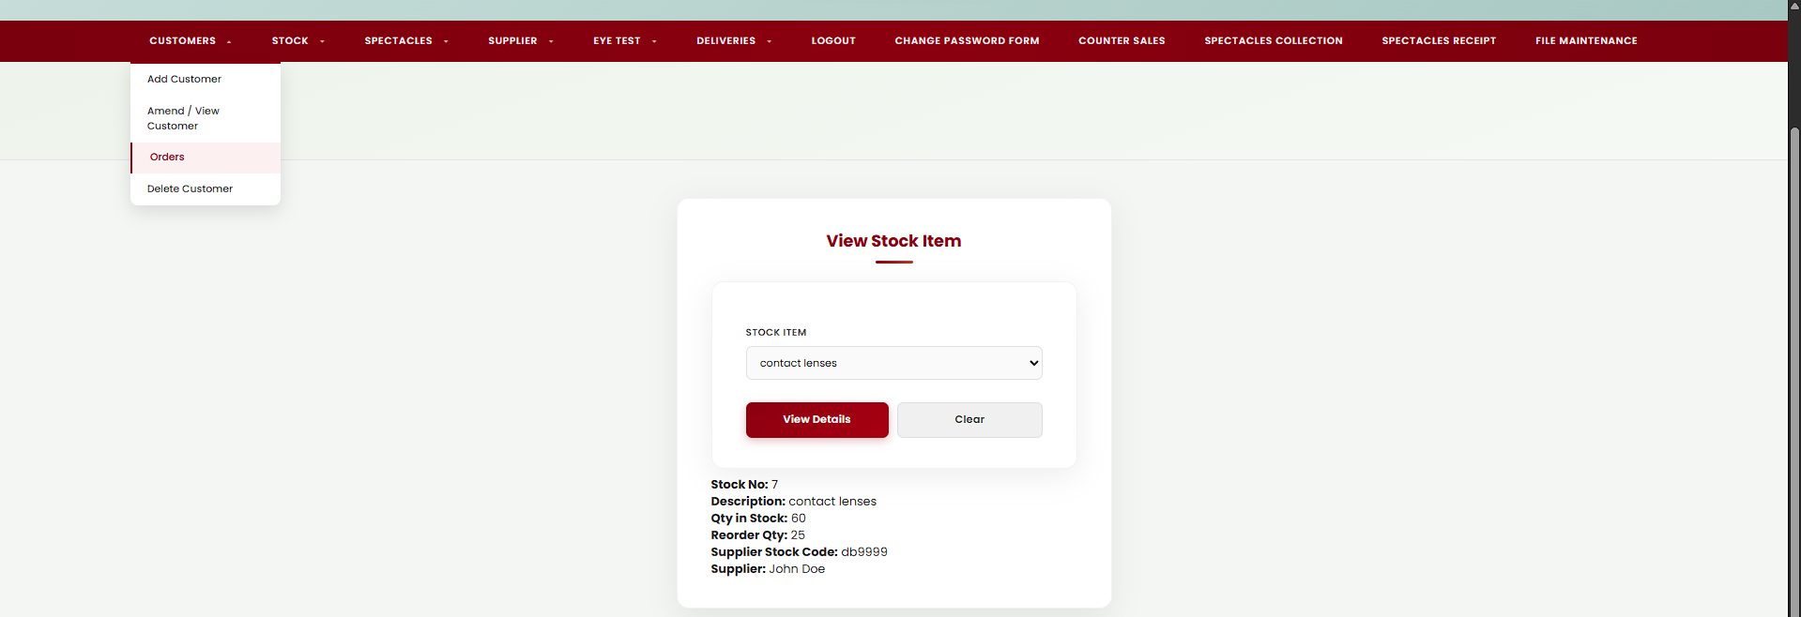

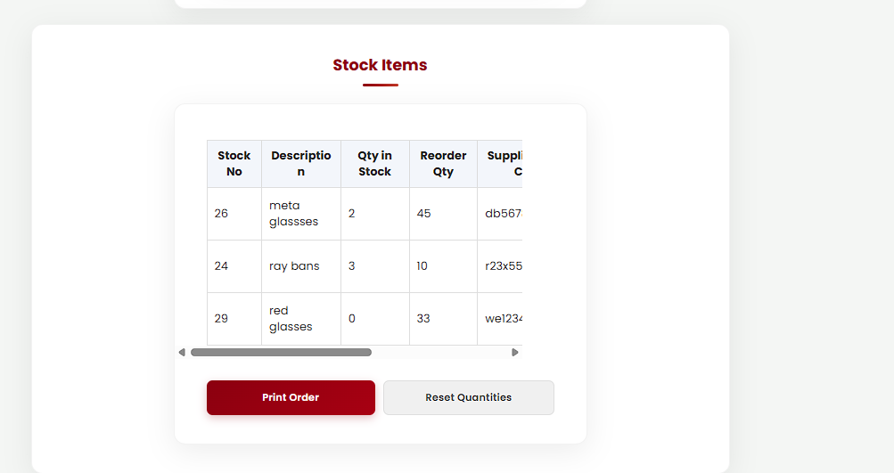

D. The Orders screen allows the user to select a supplier and view all stock items associated with that supplier. The interface includes dropdown menus to select suppliers and individual stock items for viewing details.
Once a supplier is selected, a table is displayed showing stock information, such as description, quantity in stock, and reorder levels. The user can enter quantities to order directly in the table.
The layout uses a clear card-based design with structured tables and labeled fields to improve usability.
A “Print Order” button allows the user to submit the order, with a confirmation message displayed before processing. The screen ensures a simple and organized process for managing stock orders.

<?php
/*
Screen Name: Orders
Purpose: Select a supplier, view their stock items, enter quantities to order, and print the order details
Student: Lucas Gabriel De Oliveira Lima
Date: March 2026
*/
require_once 'Includes/db.inc.php';
require_once 'Includes/header.php';
require_once 'Includes/nav.php';
/* -----------------------------
PAGE DATA
------------------------------ */
$suppliers = [];
$allStock = [];
$stockItems = [];
$viewStockRow = null;
/* -----------------------------
GET VALUES FROM URL
------------------------------ */
$supplier_id = isset($_GET["supplier_id"]) ? (int)$_GET["supplier_id"] : 0;
$view_stock_id = isset($_GET["view_stock_id"]) ? (int)$_GET["view_stock_id"] : 0;
/* -----------------------------
LOAD ALL SUPPLIERS
Used in supplier dropdown
------------------------------ */
$sqlSuppliers = "SELECT SupplierID, Supplier_Name
FROM Supplier
ORDER BY Supplier_Name";
$resSuppliers = mysqli_query($con, $sqlSuppliers);
while($row = mysqli_fetch_assoc($resSuppliers)){
$suppliers[] = $row;
}
/* -----------------------------
LOAD ALL STOCK ITEMS
Used in stock viewer dropdown
------------------------------ */
$sqlAllStock = "SELECT Stock_id, Description
FROM Stock
ORDER BY Description";
$resStock = mysqli_query($con, $sqlAllStock);
while($row = mysqli_fetch_assoc($resStock)){
$allStock[] = $row;
}
/* -----------------------------
VIEW ONE STOCK ITEM
Shows stock details card
------------------------------ */
if($view_stock_id > 0){
$sqlView = "SELECT
s.Stock_id AS stock_number,
s.Description,
s.Qty_in_stock,
s.Reorder_qty,
s.Supplier_stock_code,
sup.Supplier_Name AS supplier_name
FROM Stock s
JOIN Supplier sup ON sup.SupplierID = s.SupplierID
WHERE s.Stock_id = ?
LIMIT 1";
$stmtView = mysqli_prepare($con, $sqlView);
if(!$stmtView){
die('Error preparing stock view statement: ' . mysqli_error($con));
}
mysqli_stmt_bind_param($stmtView, "i", $view_stock_id);
mysqli_stmt_execute($stmtView);
$resView = mysqli_stmt_get_result($stmtView);
$viewStockRow = mysqli_fetch_assoc($resView);
mysqli_stmt_close($stmtView);
}
/* -----------------------------
VIEW STOCK ITEMS FOR SUPPLIER
Shows stock table for selected supplier
------------------------------ */
if($supplier_id > 0){
$sqlSupplierStock = "SELECT
s.Stock_id,
s.Stock_id AS stock_number,
s.Description,
s.Qty_in_stock AS qty_in_stock,
s.Reorder_qty AS reorder_qty,
s.Supplier_stock_code AS supplier_stock_code,
sup.Supplier_Name AS supplier_name
FROM Stock s
JOIN Supplier sup ON sup.SupplierID = s.SupplierID
WHERE s.SupplierID = ?
ORDER BY s.Description";
$stmt = mysqli_prepare($con, $sqlSupplierStock);
if(!$stmt){
die('Error preparing supplier stock statement: ' . mysqli_error($con));
}
mysqli_stmt_bind_param($stmt, "i", $supplier_id);
mysqli_stmt_execute($stmt);
$result = mysqli_stmt_get_result($stmt);
while($row = mysqli_fetch_assoc($result)){
$stockItems[] = $row;
}
mysqli_stmt_close($stmt);
}
?>
<!-- ================= HERO SECTION ================= -->
<section class="hero">
<h1>Orders</h1>
<p>Select a supplier, choose quantities, and print the order</p>
<div class="cta-buttons">
<a href="Home_Page.php" class="button">Back to Home</a>
</div>
</section>
<!-- ================= PAGE CONTENT ================= -->
<div class="page-container">
<div style="width:100%; max-width:980px; display:flex; flex-direction:column; gap:22px;">
<!-- ================= VIEW STOCK ITEM ================= -->
<div class="card" style="max-width:580px;">
<h2>View Stock Item</h2>
<form class="card-form" method="get">
<label>Stock Item</label>
<select name="view_stock_id">
<option value="">-- Choose stock item --</option>
<?php foreach($allStock as $stock): ?>
<option value="<?php echo (int)$stock["Stock_id"]; ?>"
<?php if((int)$stock["Stock_id"] === $view_stock_id) echo "selected"; ?>>
<?php echo htmlspecialchars($stock["Description"]); ?>
</option>
<?php endforeach; ?>
</select>
<div class="button-group">
<input type="submit" value="View Details">
<a class="btn-cancel" href="orders.php"
style="text-align:center; padding:12px; border-radius:8px; display:block; text-decoration:none;">
Clear
</a>
</div>
</form>
<?php if($viewStockRow): ?>
<p class="muted" style="margin-top:10px;">
<strong>Stock No:</strong> <?php echo htmlspecialchars($viewStockRow["stock_number"]); ?><br>
<strong>Description:</strong> <?php echo htmlspecialchars($viewStockRow["Description"]); ?><br>
<strong>Qty in Stock:</strong> <?php echo htmlspecialchars($viewStockRow["Qty_in_stock"]); ?><br>
<strong>Reorder Qty:</strong> <?php echo htmlspecialchars($viewStockRow["Reorder_qty"]); ?><br>
<strong>Supplier Stock Code:</strong> <?php echo htmlspecialchars($viewStockRow["Supplier_stock_code"]); ?><br>
<strong>Supplier:</strong> <?php echo htmlspecialchars($viewStockRow["supplier_name"]); ?>
</p>
<?php endif; ?>
</div>
<!-- ================= SELECT SUPPLIER ================= -->
<div class="card" style="max-width:580px;">
<h2>Select Supplier</h2>
<form class="card-form" method="get">
<label>Supplier</label>
<select name="supplier_id" required>
<option value="">-- Choose supplier --</option>
<?php foreach($suppliers as $supplier): ?>
<option value="<?php echo (int)$supplier["SupplierID"]; ?>"
<?php if((int)$supplier["SupplierID"] === $supplier_id) echo "selected"; ?>>
<?php echo htmlspecialchars($supplier["Supplier_Name"]); ?>
</option>
<?php endforeach; ?>
</select>
<div class="button-group">
<input type="submit" value="View Stock">
<a class="btn-cancel" href="orders.php"
style="text-align:center; padding:12px; border-radius:8px; display:block; text-decoration:none;">
Clear
</a>
</div>
</form>
</div>
<!-- ================= STOCK TABLE ================= -->
<?php if($supplier_id > 0): ?>
<div class="card" style="max-width:980px;">
<h2>Stock Items</h2>
<?php if(!$stockItems): ?>
<p class="muted">No stock items found for this supplier.</p>
<?php else: ?>
<form method="post" action="orders_print.php" class="card-form"
onsubmit="return confirm('Print order with the quantities you entered?');">
<!-- pass selected supplier to print page -->
<input type="hidden" name="supplier_id" value="<?php echo (int)$supplier_id; ?>">
<div class="table-wrap">
<table class="simple-table">
<tr>
<th>Stock No</th>
<th>Description</th>
<th>Qty in Stock</th>
<th>Reorder Qty</th>
<th>Supplier Stock Code</th>
<th>Supplier Name</th>
<th>Qty Ordered</th>
</tr>
<?php foreach($stockItems as $item): ?>
<tr>
<td><?php echo htmlspecialchars($item["stock_number"]); ?></td>
<td><?php echo htmlspecialchars($item["Description"]); ?></td>
<td><?php echo htmlspecialchars($item["qty_in_stock"]); ?></td>
<td><?php echo htmlspecialchars($item["reorder_qty"]); ?></td>
<td><?php echo htmlspecialchars($item["supplier_stock_code"]); ?></td>
<td><?php echo htmlspecialchars($item["supplier_name"]); ?></td>
<td>
<input
type="number"
name="qty_ordered[<?php echo (int)$item["Stock_id"]; ?>]"
min="0"
value="0"
style="width:90px;"
>
</td>
</tr>
<?php endforeach; ?>
</table>
</div>
<div class="button-group">
<input type="submit" value="Print Order">
<a class="btn-cancel"
href="orders.php?supplier_id=<?php echo (int)$supplier_id; ?>"
style="text-align:center; padding:12px; border-radius:8px; display:block; text-decoration:none;"
onclick="return confirm('Clear all quantities?');">
Reset Quantities
</a>
</div>
</form>
<?php endif; ?>
</div>
<?php endif; ?>
</div>
</div>
<?php require_once 'Includes/footer.php'; ?>

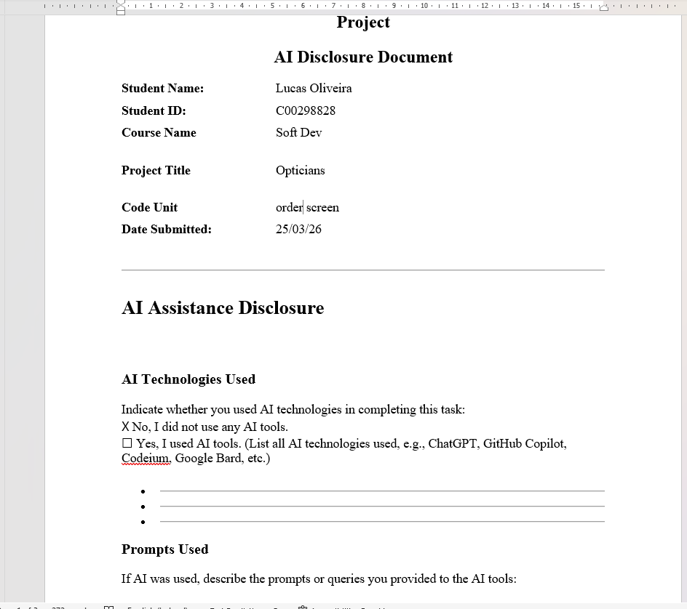

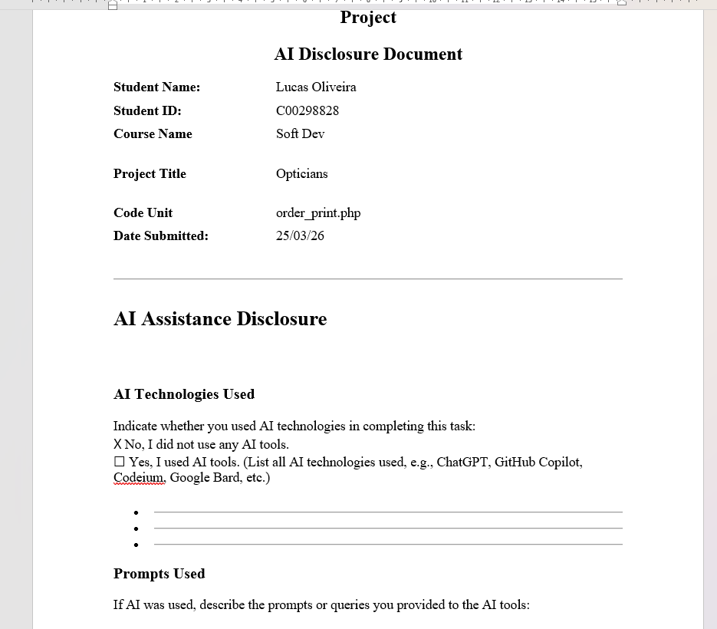

5.Orders.php
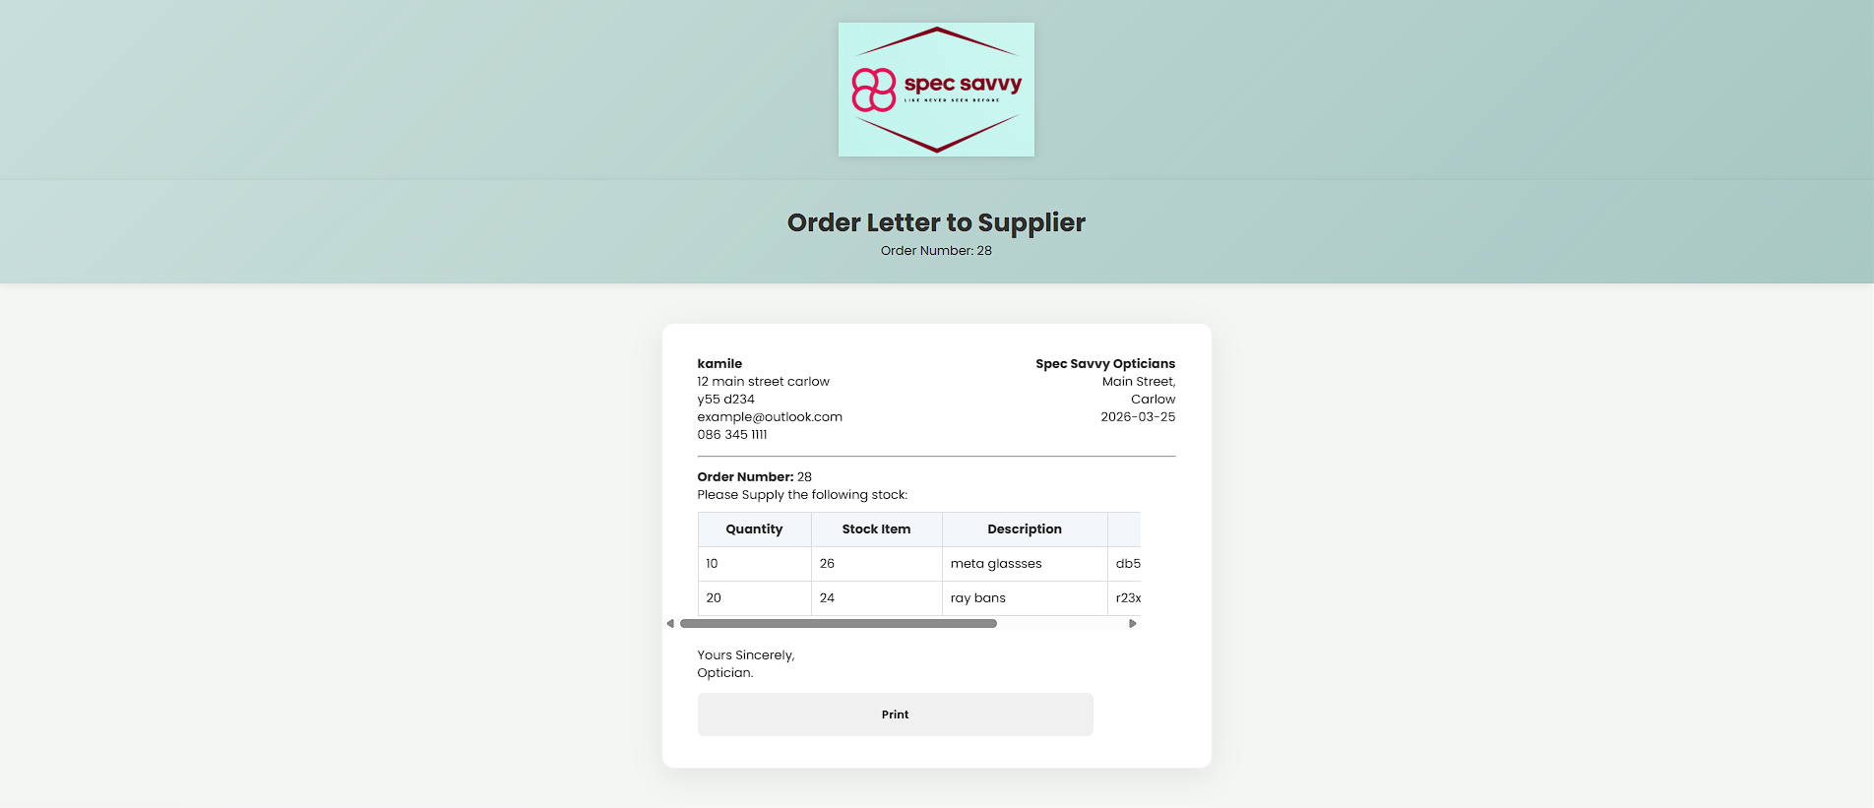

E. The Orders Print screen displays a formatted order letter after the user submits an order. It shows supplier details, order number, date, and a table of ordered stock items with quantities and descriptions.
The layout is designed to resemble a professional order document, using a structured table and clearly aligned sections.
The system inserts the order into the database, including both the order header and individual order items, using secure prepared statements.
A transaction is used to ensure that all data is saved correctly or rolled back if an error occurs.
The screen includes a print button to allow the user to generate a physical copy of the order, along with a navigation option to return to the previous page.

<?php
/*
Screen Name: Print Order
Purpose:
1. Receive selected supplier and order quantities
2. Insert order header into Orders table
3. Insert order lines into OrderItem table
4. Display printable order letter
Student: Lucas Gabriel De Oliveira Lima
Date: March 2026
*/
require_once 'Includes/db.inc.php';
require_once 'Includes/nav.php';
require_once 'Includes/header.php';
/* -----------------------------
PAGE VARIABLES
------------------------------ */
$errors = [];
$order_id = 0;
$supplier = null;
$orderRows = [];
/* -----------------------------
GET POSTED VALUES
------------------------------ */
$supplier_id = isset($_POST["supplier_id"]) ? (int)$_POST["supplier_id"] : 0;
$qty_ordered = isset($_POST["qty_ordered"]) ? $_POST["qty_ordered"] : [];
$items = [];
/* -----------------------------
HELPER FUNCTION
Fallback method to find the
latest order id for a supplier
------------------------------ */
function fetch_last_order_id($con, $supplier_id, &$errors){
$possibleColumns = ["order_id", "Order_ID", "OrderID"];
foreach($possibleColumns as $column){
$sql = "SELECT $column AS order_id
FROM Orders
WHERE SupplierID = ?
ORDER BY $column DESC
LIMIT 1";
$stmt = mysqli_prepare($con, $sql);
if(!$stmt){
$errors[] = "Prepare failed (header lookup $column): " . mysqli_error($con);
continue;
}
mysqli_stmt_bind_param($stmt, "i", $supplier_id);
if(!mysqli_stmt_execute($stmt)){
$errors[] = "Header lookup failed ($column): " . mysqli_stmt_error($stmt);
mysqli_stmt_close($stmt);
continue;
}
$result = mysqli_stmt_get_result($stmt);
$row = mysqli_fetch_assoc($result);
mysqli_stmt_close($stmt);
if($row && isset($row["order_id"])){
return (int)$row["order_id"];
}
}
return 0;
}
/* -----------------------------
VALIDATE INPUT
------------------------------ */
if($supplier_id <= 0){
$errors[] = "Invalid supplier selected";
}
if(!is_array($qty_ordered)){
$errors[] = "Invalid quantity data";
}
/* -----------------------------
BUILD VALID ORDER ITEMS ARRAY
Only keep items with qty > 0
------------------------------ */
if(!$errors){
foreach($qty_ordered as $stock_id => $qty){
$stock_id = (int)$stock_id;
$qty = (int)$qty;
if($stock_id > 0 && $qty > 0){
$items[] = [
"stock_id" => $stock_id,
"qty" => $qty
];
}
}
if(empty($items)){
$errors[] = "No valid items selected";
}
}
/* -----------------------------
INSERT ORDER HEADER + LINES
Transaction used so all data
saves together or rolls back
------------------------------ */
if(!$errors){
mysqli_begin_transaction($con);
/* ---------- INSERT ORDER HEADER ---------- */
$sqlHeader = "INSERT INTO Orders (SupplierID, Order_date, Order_Status, Notes)
VALUES (?, CURDATE(), 'Pending', '')";
$stmtHeader = mysqli_prepare($con, $sqlHeader);
if(!$stmtHeader){
$errors[] = "Prepare failed (header): " . mysqli_error($con);
} else {
mysqli_stmt_bind_param($stmtHeader, "i", $supplier_id);
if(!mysqli_stmt_execute($stmtHeader)){
$errors[] = "Header insert failed: " . mysqli_stmt_error($stmtHeader);
} elseif(mysqli_stmt_affected_rows($stmtHeader) <= 0){
$errors[] = "Could not create order (no rows inserted).";
} else {
$order_id = mysqli_insert_id($con);
// fallback in case insert id is not returned
if(!$order_id){
$order_id = fetch_last_order_id($con, $supplier_id, $errors);
if(!$order_id){
$errors[] = "Order header inserted but order_id is still 0. Check Orders primary key and auto-increment.";
}
}
}
mysqli_stmt_close($stmtHeader);
}
/* ---------- INSERT ORDER LINES ---------- */
if(!$errors && $order_id > 0){
$sqlLine = "INSERT INTO OrderItem (Order_ID, Stock_id, Qty_ordered)
VALUES (?, ?, ?)";
$stmtLine = mysqli_prepare($con, $sqlLine);
if(!$stmtLine){
$errors[] = "Prepare failed (lines): " . mysqli_error($con);
} else {
foreach($items as $item){
mysqli_stmt_bind_param(
$stmtLine,
"iii",
$order_id,
$item["stock_id"],
$item["qty"]
);
if(!mysqli_stmt_execute($stmtLine)){
$errors[] = "Insert failed for stock ID: " . $item["stock_id"] . " (" . mysqli_stmt_error($stmtLine) . ")";
continue;
}
if(mysqli_stmt_affected_rows($stmtLine) <= 0){
$errors[] = "No row inserted for stock ID: " . $item["stock_id"];
}
}
mysqli_stmt_close($stmtLine);
}
}
/* ---------- COMMIT OR ROLLBACK ---------- */
if($errors){
mysqli_rollback($con);
} else {
mysqli_commit($con);
}
}
/* -----------------------------
LOAD SUPPLIER DETAILS
Used to build printable letter
------------------------------ */
if(!$errors){
$sqlSupplier = "SELECT Supplier_Name, Supplier_Address, Supplier_Eircode, Supplier_Email, Supplier_Phone
FROM Supplier
WHERE SupplierID = ?";
$stmtSupplier = mysqli_prepare($con, $sqlSupplier);
if(!$stmtSupplier){
$errors[] = "Prepare failed (supplier): " . mysqli_error($con);
} else {
mysqli_stmt_bind_param($stmtSupplier, "i", $supplier_id);
mysqli_stmt_execute($stmtSupplier);
$resultSupplier = mysqli_stmt_get_result($stmtSupplier);
$supplier = mysqli_fetch_assoc($resultSupplier);
mysqli_stmt_close($stmtSupplier);
if(!$supplier){
$errors[] = "Supplier not found for printing.";
}
}
}
/* -----------------------------
LOAD ORDER LINES FOR DISPLAY
------------------------------ */
if(!$errors){
$sqlRows = "SELECT
oi.Qty_ordered,
s.Stock_id,
s.Description AS StockItemDescription,
s.Supplier_stock_code AS YourStockCode
FROM OrderItem oi
JOIN Stock s ON s.Stock_id = oi.Stock_id
WHERE oi.Order_ID = ?";
$stmtRows = mysqli_prepare($con, $sqlRows);
if(!$stmtRows){
$errors[] = "Prepare failed (print rows): " . mysqli_error($con);
} else {
mysqli_stmt_bind_param($stmtRows, "i", $order_id);
mysqli_stmt_execute($stmtRows);
$resultRows = mysqli_stmt_get_result($stmtRows);
while($row = mysqli_fetch_assoc($resultRows)){
$orderRows[] = $row;
}
mysqli_stmt_close($stmtRows);
}
}
?>
<main class="main">
<header class="main-header">
<h1>Order Letter to Supplier</h1>
<span class="Subtittle">Order Number: <?php echo htmlspecialchars($order_id); ?></span>
</header>
<section class="content">
<?php if($errors): ?>
<p class="muted"><?php echo htmlspecialchars(implode(" ", $errors)); ?></p>
<?php else: ?>
<div class="card-form" style="max-width:700px;">
<div style="display:flex; justify-content:space-between; gap:20px;">
<div>
<strong><?php echo htmlspecialchars($supplier["Supplier_Name"]); ?></strong><br>
<?php echo htmlspecialchars($supplier["Supplier_Address"]); ?><br>
<?php echo htmlspecialchars($supplier["Supplier_Eircode"]); ?><br>
<?php echo htmlspecialchars($supplier["Supplier_Email"]); ?><br>
<?php echo htmlspecialchars($supplier["Supplier_Phone"]); ?><br>
</div>
<div style="text-align:right;">
<strong>Spec Savvy Opticians</strong><br>
Main Street,<br>
Carlow<br>
<?php echo date("Y-m-d"); ?>
</div>
</div>
<hr style="margin:14px 0;">
<p><strong>Order Number:</strong> <?php echo htmlspecialchars($order_id); ?></p>
<p>Please Supply the following stock:</p>
<div class="table-wrap">
<table class="simple-table" style="width:100%; margin-top:10px;">
<tr>
<th>Quantity</th>
<th>Stock Item</th>
<th>Description</th>
<th>Your Stock Code</th>
</tr>
<?php foreach($orderRows as $row): ?>
<tr>
<td><?php echo htmlspecialchars($row["Qty_ordered"]); ?></td>
<td><?php echo htmlspecialchars($row["Stock_id"]); ?></td>
<td><?php echo htmlspecialchars($row["StockItemDescription"]); ?></td>
<td><?php echo htmlspecialchars($row["YourStockCode"]); ?></td>
</tr>
<?php endforeach; ?>
</table>
</div>
<div style="margin-top:20px;">
<p>Yours Sincerely,</p>
<p>Optician.</p>
</div>
<div class="form-actions" style="margin-top:14px;">
<button type="button" onclick="window.print()">Print</button>
<a class="menu-item" href="orders.php?supplier_id=<?php echo (int)$supplier_id; ?>">Back</a>
</div>
</div>
<?php endif; ?>
</section>
<footer class="main-footer">
<p>&copy; 2026 Spec Savvy Opticians</p>
</footer>
</main>

